Doing Field Research with Animals
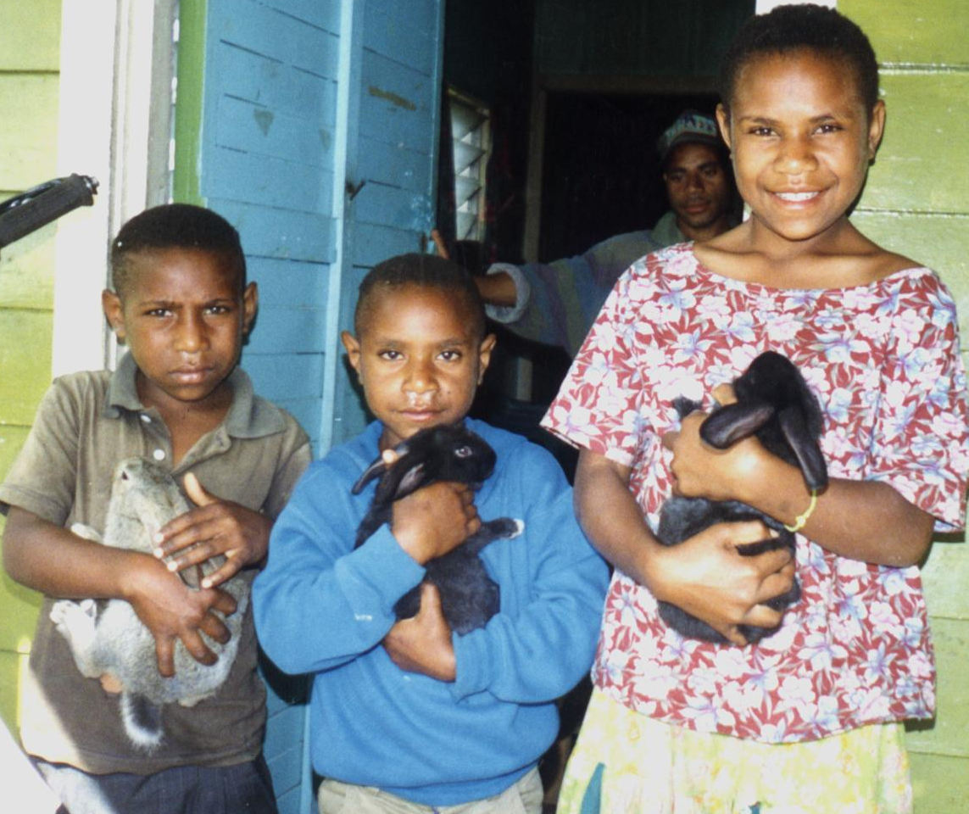

David Askin
April 2011

 |  | 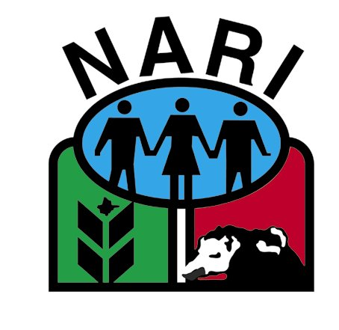

Table of Contents
Doing Field Research with Animals 1
Introduction 4
Providing for the Welfare of Animals 5
Handling animals safely 6
Healthy Versus Sick Animals 7
Cages and Fences 10
Choosing the Animals for an Experiment 11
Feeding Animals in Cages 13
Animals That Die or Need to be Removed 14
Recording Sheets 14
On-farm Animal Experimentation 17
Choosing the Treatments and Animals 17
Identifying Animals on Farms 17
Assessing the Animals and Results 18
Recording of Information 18
Economic analysis 18

Table of Tables
Table 1 Data sheet for use in animal experiments where pre-trial weights are being recorded. 15
Table 2 Data recording sheet for an animal experiment 16

Acknowledgements and Dedication
Thanks to Dr Ian Grant and Dr Alan Quartermain who contributed in various ways to this chapter- when first written some years ago. This is a fully revised version of that information. Thanks to Dr Workneh Ayalew for helpful comments recently.
The photo on the front page is of some members of the Taul family. Peter and his family, David and Anna Kulimbao and Andrew Thomas of NARI were key farmer/NGO contributors to the process of developing rabbit farming in Papua New Guinea. Rabbits are just one of the animals worthy of research in PNG. My thanks to these men and women and others like them.

Learning Objectives
- Understand the need for humane and careful practices in all aspects of working with animals.
- Be able to choose animals appropriately so that blocks in experiments are as uniform as possible.
- Be able to do a good job of managing animal related research, recording results of experiments in a competent manner.
PracticalExercises
- Take a walk around your village or research station. Look critically at the animals, keeping in mind the issues relating to sickness and health detailed on page 6.
- Tattoo some young animals or mark them in some other way that is appropriate and humane.
- Working with an existing experiment on a research station- evaluate the information that was available to the researchers prior to animals being allocated to treatments and blocks. How would you have allocated animals to the experiment.
- Comment on the design used- is it the best way of answering the question?
- Working with an existing experiment on a research station- plan the data recording system, weigh or otherwise record information on animals, and manage the data appropriately to calculate growth rate.
- With farmers develop an experiment relating to animals. Prepare a trial proposal and after gaining appropriate permission, complete the experiment- involving at least some farmers in the day to day management of the experiment- even if the experiment is totally run on your research station. (This may happen after you return to your research station).
- Remember to report back to the farmers, including men and women in any discussion relating to the meaning of the results. Do the farmers have useful input into the analysis/thinking about what the results mean? Of course they do.

Introduction
Farming families want to know what the best feed is for their animals, and how they can improve profitability. These questions are often best answered by working with small groups of animals in cages or fields where they are fed different foods. Growth rate is calculated from weights taken both before and during an experiment. As researchers and extension officers we need to know research principles that will help us design and manage effective research. This module aims to provide you with these principles.
Remember in Melanesia farmers are particularly interested in chickens, pigs and to a lesser extent ducks, fish, cattle, goats and sheep. Live weight and growth on various feeds are important research topics as farmers continually strive to grow animals profitably without having to rely on imported feed.
The value of manure produced by these livestock should not be underestimated. There is room for crop and livestock integration- particularly as stock graze on crop residues and return manure to the cropping system.
Remember the focus is the farming families. There are many small experiments that we can do with farmers and their animals. The second part of this chapter focuses on research on animals done directly with farmers.

Time for Group Discussion-
- Think about the animals farmers look after. What are the questions they are asking (perhaps about feeds) that you could help them answer? Remember most of our research should be a partnership between farmers and researchers, so we seek to work together to find answers to farmer’s problems.
- Who has these answers? Where can the information be found? Remember there is no point in starting a new experiment if the information is available. You may like to list the places where information is stored, then consider how you can get hold of that information. Your colleagues or those contacts you made at a workshop may be high on your list.
- Only after you have worked on question 2 can you start a new experiment.
- Are there other questions that farmers who manage animals could be asking in years to come that you as a researcher need to be considering now?

Research must never be divorced from the lives of these farming families. There are many issues to consider. These include:--
- their time availability,
- their management skills, including financial management, ensuring cash is available to buy feed or new growing stock (esp. in broiler chicken enterprises),
- the way ownership of animals is managed in the family,
- the way they share tasks, especially when a primary manager is away from the home,
- their ability to manage pressures from wantoks (relatives).
All of these may be more important than the physical research answers developed during research.

Providing for the Welfare of Animals
World-wide there is a growing recognition that all research involving animals needs to be done in appropriate and humane ways. Sadly animals are often treated very poorly. All Research must conform to best practise and be managed in ways that cares for animals needs. There are a number of web sites which provide useful background to this important topic- refer to:-
http://www.cpa.ca/guide7.html and
http://www.uiowa.edu/~vpr/research/animal/esalt.htm).
Proficiency in the handling and restraint of animals makes it easier to perform a variety of routine procedures with minimal distress to the animals involved. Animals are creatures of habit and when handled properly, the degree of distress caused by the things we do is minimized. All animals we currently use in research respond positively to what we call TLC - tender loving care! It's inexpensive, readily portable, safe even at the highest doses and spreads rapidly!! Use it- TLC. The issue of careful handling cannot be stressed enough. It is not good enough to pick up animals roughly- this causes distress, which in turn may cause physical pain to the animal. That is bad in itself. It is also bad in that it harms our research. We want to assess feeds etc on healthy, quiet animals, not on distressed, thirsty, bleeding or bruised animals. Take care.
Bennet’s online statement (http://www.uiowa.edu/~vpr/research/animal/esalt.htm) also discusses issues such as animal sharing, improved statistical design, and the use of better quality animals as ways of reducing the number of animals used in research- particularly where medical research designed to improve the lot of humans is the primary interest.
This manual deals with more traditional animal research, where our goal is to improve the productivity of animals. Clearly the first issue relates to providing all animals with best practise in terms of food, management, handling, water, protection from the elements.

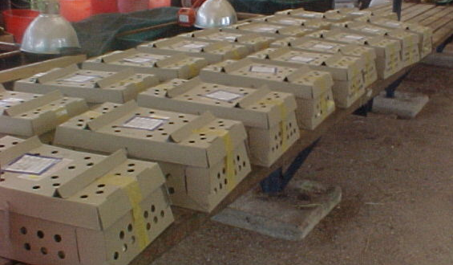
Plate 1 Chickens, day olds in boxes- require immediate attention following shipping from the supplier.

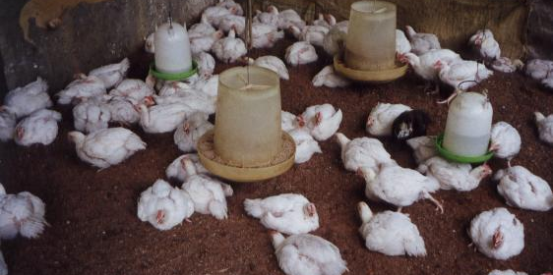
Plate 2 Six week old chickens with space, clean water and feeders.

Handling animals safely

The pointers below will help to keep you and your animals safe.
- Animals that are handled quietly and confidently tend to be safe to work with.
- Seek advice from others with more experience- watch the way they move around their animals.
- Don’t tease animals- this makes them cross and aggressive.
- Don’t allow others to tease or irritate animals- see above!
- Cull- that is, sell or kill animals that are nasty.
- For some kinds of animals, darkened sheds help to quieten the animals- eg deer.
- When working with pigs- a sheet of plywood can be useful especially when you are weaning young pigs from the sow.
- Castrating piglets is often a noisy business- consider using ear muffs to protect your hearing.

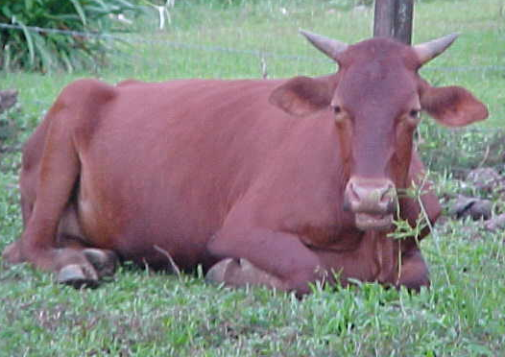 | Plate 3 Cow with dangerous horns.  This cow in Rumginae, Western Province, Papua New Guinea is developing a dangerous set of horns- that could be used against people or other animals in the future. She should have had her horns removed as a young calf.

Healthy Versus Sick Animals
Animals should not be included in experiments if they are clearly different from the rest in some way such as being obviously sick, stunted in growth or even much larger than all of the others.
If an animal becomes sick it is no longer any use in the experiment. Only good husbandry and daily care can prevent this happening. The important point is that the groups of animals should remain comparable except for the experimental treatment.
Researchers need a clear mental picture of what a normal healthy animal should look like and how it should behave. Behaviour differs with species but all healthy animals should eat readily or in a regular pattern, rest contentedly, be alert and move quickly and easily. Quiet, much handled animals may sometimes appear lethargic but their eyes will be bright and their natural inquisitiveness easily aroused. The natural functions of breathing, ruminating, defecating and urinating will be normal.

Plate 4 Mud in this duck shed may be tolerated by adult birds, but this is not acceptable conditions for good research.  Consider providing water in an area with some concrete to allow more hygienic conditions.  At the very least the water must be changed daily, and note that bamboo troughs will need regular replacement. | 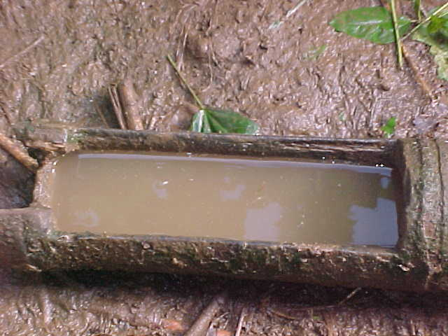
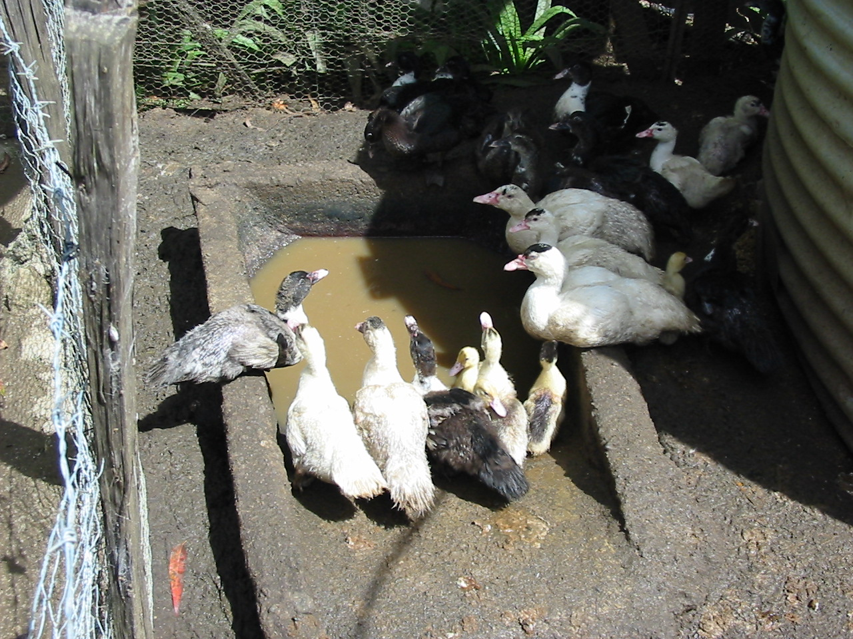 |  |  | Plate 5 Markus Muntwiler, EHP, Papua New Guinea provided these facilities for his ducks  It is useful to have a portion of the duck area covered to stop rain making it excessively muddy..
Plate 6 Ducks will breed happily in conditions like these provided by David Wissink’s team at Ok Tedi Mining Ltd.  Researchers however will need to consider carefully all the issues relating to husbandry if they were to set up an experiment working with ducks and their young. |  | 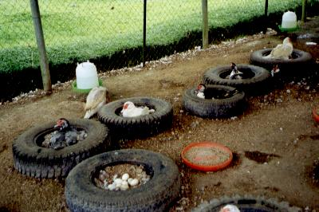

Healthy versus sick animals→Things to look out for:-
- Loss of weight or condition (fatness).
- hard breathing;
- grinding of teeth for ruminants;
- rough hair;
- lethargy
- Wounds, external parasites, dry and scaly skin.
- Lameness.
- Scratching, biting and rubbing.
- Unusual discharges from the mouth, eyes, nose or vagina.
- Difficult breathing/hard breathing-
- Abnormal faeces; especially discolouration (white or yellow colour) and diarrhoea (runny faeces).
- Fever; high body temperature.
- Anaemia; pale colour of the lining of the eyelids.
- Harsh feel or excessive shedding of coat.
- Pot bellies, especially in pigs.
- Dry, hard or shrivelled vents in hens.
- Pale, shrivelled or dry combs in chickens.
The signs above are best learned by working with experienced livestock managers and researchers. They are learned also by being involved with healthy animals, watching, listening and above all – enjoying the animals. That way, you will notice behaviour changes that occur with illness and discomfort.

Cages and Fences
Cages and fences are needed to protect animals, control their movement and sometimes to exclude rain, wind, cold or excess heat.

Cages must provide a safe environment for animals to move freely in, eat and sleep. If cages are too big, the costs of the research become too great. If the cages are too small, animals will be stressed, and if together, increased fighting will occur. Any stress that occurs will reduce the validity of the research.
Fences, likewise need to be strong enough to keep animals in and problems out. Sadly you may need strong locks on doors so that thieves find it difficult to enter.
Manuals are available to help you in designing electric fencing – this manual does not seek to duplicate them.
Refer to http://www.gallaghergroup.co.nz/ for further information. Beware- An electric fence is a specially designed unit, which generates very high voltage spikes with very low current. The shock generated does not cause harm when used properly. Never connect any fence directly to the mains. Gallager mains units are very common in some countries and provide a way of controlling goats, sheep, cattle and pigs. They will often provide about 5000V. This quite safe as it is very low amps.
Holes in cages are a problem because rats or snakes will be able to enter a cage causing, at the very least stress, but possibly injury or death. Regular maintenance is a must.
Maintain cages and fences in good condition- this is a first step towards excellent research with animals.
Holes are also a problem because of the sharp pieces of wire that can cause injury- to the animals or the researcher.
From a research point of view, it is important that all cages or fenced areas are of the same size and are made of the same materials. This isn’t always possible- and if you have to establish an experiment in less than ideal circumstances- then make sure that all cages in each replicate are of the same kind.
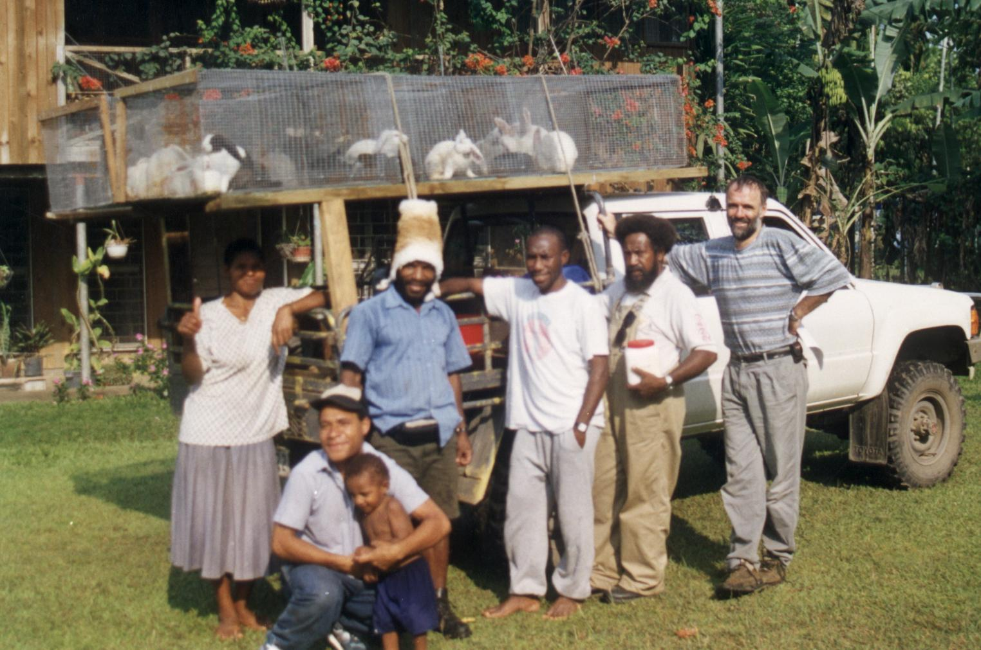
Plate 7 Cages may need to be portable! These rabbits were part of the Morobe Show, Papua New Guinea
.

Good cage design will also ensure that animals find it difficult to chew the cage and destroy it. Protect vulnerable portions of cages with wire. Consider providing animals with something to play with or chew. Rabbits and pigs can benefit from a dangling chain to play with (pigs) or a piece of salty wood to chew (rabbits).

Choosing the Animals for an Experiment

Remember there are some key differences between crop research and research with livestock. When working with livestock the researcher is working with →
  - a live animal that requires very specific care,
  - normally fewer experimental units than is common in plant based research,
  - variable animals – while trying to block in ways that reduce that variability and allow treatment differences to be found,
  - animals that breed and grow – possibly requiring expensive housing and time before research can start.

Planning is the key to managing trials that will help to answer the questions raised by farming families. Follow the steps below:
- Effective, high quality livestock research starts with more animals than you need, allowing you to choose a set of experimental animals that are uniform. Aim to have about 50% more animals than will be required for the experiment. This is not always possible, of course, but you will greatly improve the overall experiment if you can remove all animals that don’t fit into a uniform group. Remember that the experiment costs money- it is best to wait until you have plenty of animals, rather than going ahead and finding nothing because the animals were too variable.
- If assessing growth on different feeds is the primary reason for the experiment, then make sure the animals are young with plenty of growth potential. (You won’t get useful differences if your animals are all too close to adult weight. But if they are just weaned- eg young goats or sheep, and a trial is started, their lack of weight gain may relate to a weaning check, rather than the different feeds).
- Make sure each animal is complete and healthy. Check each animal carefully, looking out for those standing apart in a group, or just acting differently to their neighbours.
- Tattoo or in some other way permanently identify each animal. Large plastic ear tags are best for larger animals like sheep and goats. Small numbers tattooed into the ear of an animal are nowhere near as good as large plastic tags, but remember a tattoo cannot be lost in the ear, whereas a plastic tag can sometimes fall out. Record information about each animal in a spreadsheet for later allocation to treatments. Our class training sessions will provide further examples and spreadsheets to work on.
- Page 15 gives a possible data recording sheet for use during the set up phase of an animal experiment, where individual animals will be weighed.
- Weigh each animal. (Weights are best taken at the same time each day- for example prior to feeding in the morning). If possible starve the animals overnight, allowing access to water only, weigh in the morning, then feed the animals on a standard ration for a period of two weeks and weigh again. This will allow you to block animals on three parameters- liveweight, growth rate from birth to first weight and growth rate during the two weeks settling in period. Having this information is really helpful and will greatly improve your experiment. In other words, quality research starts well before the trial!
- Remove animals that have grown much more quickly or slowly than the others.
- It is normal practise to block so that small animals are kept together and larger animals are allocated to a different block or replicate. Where possible researchers seek to block experimental animals to balance them for different attributes of animals: age, sex, genotype.

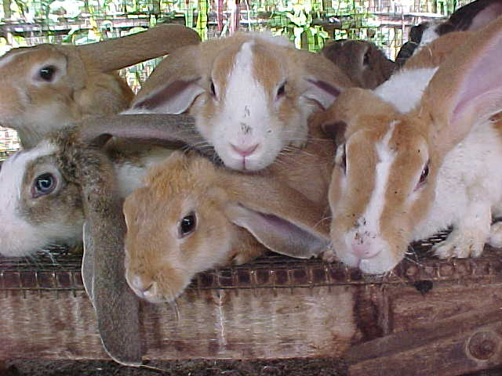 | Plate 8 A group of animals (siblings = same parents) that could be split into the treatments in one of the replicates of a weaner rabbit experiment.

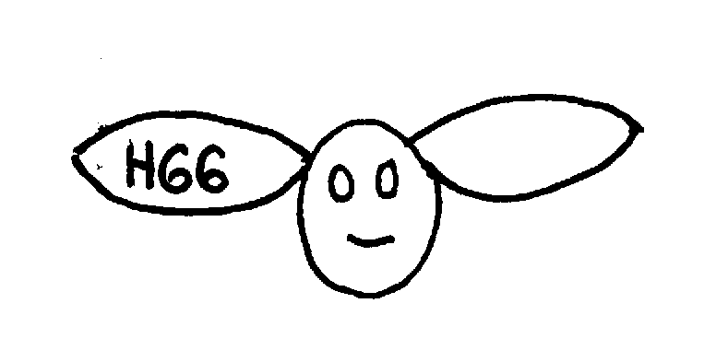 | 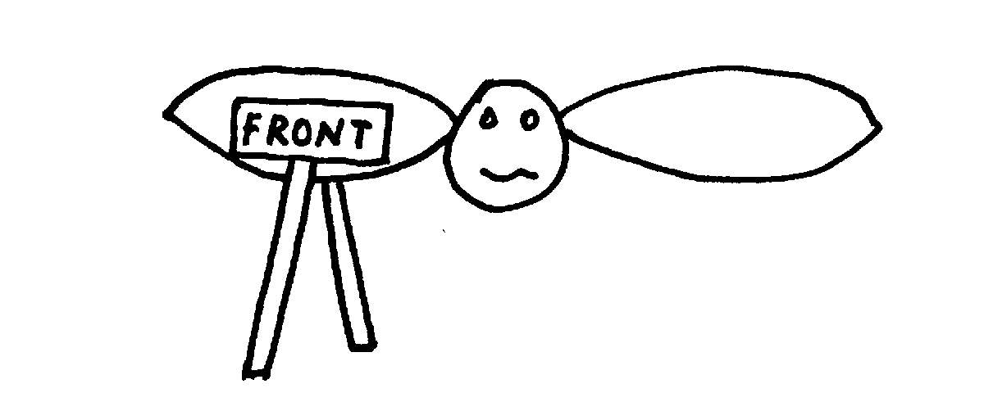
Figure 1 Use a simple picture on data sheets to make sure that tattoos are read correctly- relevant to cattle, sheep, goats and pigs.
This is H66 not 99H. The diagram on the right also helps to make sure that tattoo instruments are held correctly. Use this diagram on recording sheets where tattooing is being done, or keep a simple picture like this in the tattoo box to make sure no wrong tattoos are done. Write ‘front’ using a permanent marker, on the correct side of the tattoo pliers.

Where possible work with animals that you know lots about- parents, date of birth, live weight at birth. This knowledge will allow you to reduce random variability. For example you may be able to block effectively during replication so that small animals are in block one, medium sized in block 2 and the largest in block 3.
Sometimes you have to go to a saleyard and just buy a line of animals where you know nothing of their history. If you have planned ahead you should still be able to follow many of the steps above to ensure your experiment is set up and blocked as well as possible. Refer to Doing Field Research General for more information on effective blocking in experiments.

Feeding Animals in Cages

During the research animals that are being fed different rations need to have everything else kept constant. Perhaps treatments are designed to assess the effect on live weight gain of adding small amounts of concentrate to feed. If there are groups of say three or four animals together then perhaps the small amount of feed will be eaten by just one or two dominant animals. In this kind of trial it may be important to house each of the animals separately so that the trial is not damaged by between animal competition.

Remember:-
- Make sure each animal gets its share of the food (This may be easier said than done!).
- Do not waste feed. Valuable feed is often trampled into the dirt, soiled, played with or left to waste. Do not feed more than the animals can eat in about 20 minutes at any one time, except of course for feed in self-feeders and for grazing or browsing. Use containers of adequate size that can’t be tipped over. There’s no point in doing research on animals where the feed is on the ground because some animals were able to tip over or spill much of the precious feed.
- Make sure that all animals have access to clean drinking water at all times, even young animals that are still suckling. Sheep and goats however may only need water in the night house.
- During weekends animals need the same daily care as at other times. Make sure this happens.
- Prepare solutions for problems. For example the water runs out. Have a large drum ready, full of water so that animals still get water.
Failure to attend to these matters may ruin your experiment.

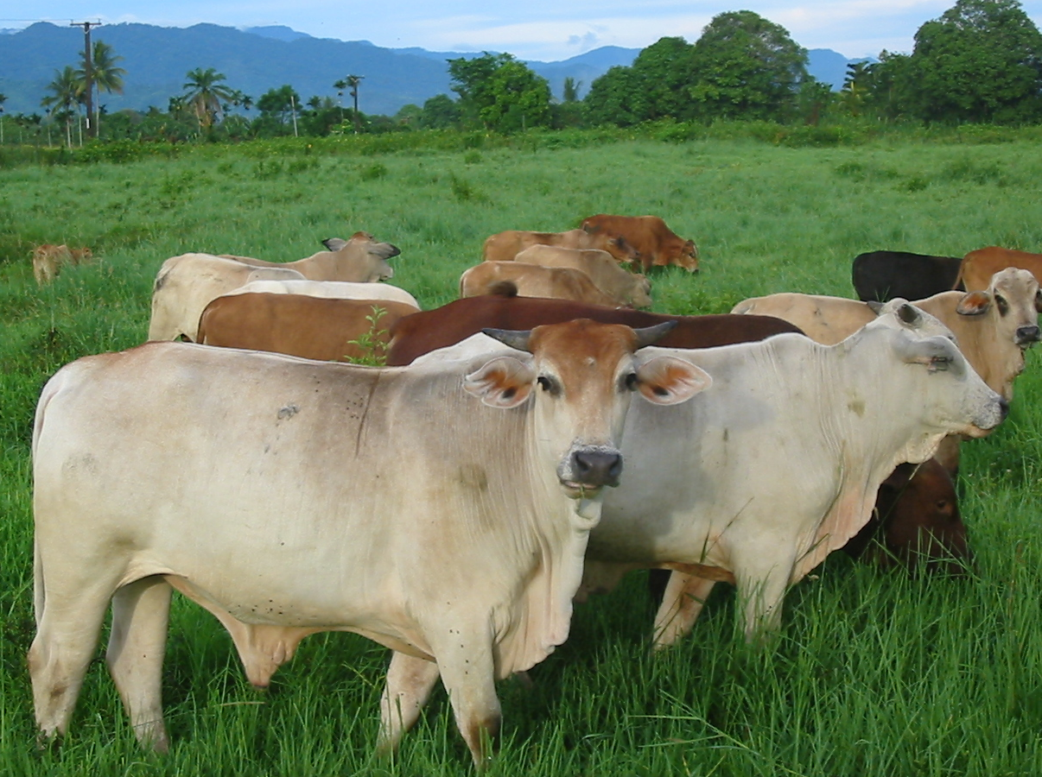 | Plate 9 Remember that feed is always the most important issue in livestock health whether the animals are in pens or fenced in paddocks. Well fed cattle at Vudal University, ENB, Papua New Guinea.

Animals That Die or Need to be Removed
Before the trial starts, discuss with a biometrician what you will do if animals get sick, die or are stolen.
Having spare animals that are managed appropriately is always wise. These can then be put into a pen of animals if death occurs. Make sure that good records, including dates, are kept so that you know which animals are replacements for other animals. These animals will be used to keep the trial running properly but are unlikely to form part of the final analysis.

Recording Sheets
Good data recording practices start right at the beginning of the experiment with

the trial protocol- refer to Doing Field Research General.
This data sheet below would be used during the setting up of the trial- prior to choosing animals and allocating them to blocks and treatments.

Table 1 Data sheet for use in animal experiments where pre-trial weights are being recorded.
Trial title
Trial Code
Location of trial
Experimenter/ Person recording data
ID. no. of each animal | Date of birth |  | Male parent id no. | Female parent id no. | Colour or other identifying features | Weight in g or kg- (cross one out)  Date-  _/__/_ | Comments

Note that this sheet is designed to help you collect information that will be used in allocating the animals to blocks and treatments. It is designed for trials where animals like sheep, goats, pigs, rabbits are being researched. It is unlikely to be used in a broiler chicken experiment where larger numbers of very uniform birds may be used.

Table 2 Data recording sheet for an animal experiment
Trial title
Trial Code
Location of trial
Experimenter/ Person recording data
Cage No. | Treatment no. | Id. no. of each animal | Identifying features, colour. | Weight in g or kg- (cross one out)  Date-  _/__/_ | 2nd weight  Date-  _/__/_ | Comments
1 | 5 | eg H76
1 | 5 | H34
1 | 5 | N23
1 | 5 | N43
1 | 5
2 | 2
2 | 2
2 | 2
2 | 2
Note that the shaded columns (the first five columns) can be stored in an excel spreadsheet and printed out for use during each weighing- appropriately updated of course. It helps when weighing animals to have basic information, including their last weight and colour etc to help ensure weights are continually being checked. The first thing to do once the data has been entered into the computer is to subtract last weeks weight from today’s weight and look for outliers in the data.
Set up this process in your spreadsheet so that as you enter the data, you will see the new value.

On-farm Animal Experimentation

On-farm experiments in animal husbandry by farmers will usually take the form of a simple comparison between animals or groups of animals cared for in the normal way and animals or groups cared for in some new or modified way. The change or modification would be an innovation designed to increase the output from the animals or reduce inputs either in cost or amount of work. Some examples could be –
- Adding some protein rich concentrate to a largely sweet potato pig diet.
- Introducing a means to control internal parasites in sheep such as using medicated blocks.
- Testing a new garden fencing method to control goats with less labour.
- Comparing different combinations of available feeds for the evening supplementary feeding of scavenging chickens.
- Testing a new way of feeding broiler chickens with free-choice feeding or a combination of available pellets.

The comparison can be set up in several different ways –
- Animals on the farm can be divided into two equal groups such as would happen if the farmer divided a broiler shed into two rooms with half of the chickens in each room.
- Animals on the farm can be paired with one member of each pair being treated in the new way.
- Less effective but still possible would be to pair farms or farmers as equally as possible and have one farmer of each pair using the new method.

The comparison must be repeated or replicated as many times as possible in order to be confident about the result. This can be done by having a number of farmers or pairs of farmers carrying out the testing or by repeating the comparison several times on the same farms.

Choosing the Treatments and Animals
The most important thing to remember is that all animals must be treated exactly the same except for the change or innovation under test. While it is true that animals in different halves of a shed or on different farms are not being treated exactly the same, the effects of such differences can be minimised with careful planning, careful husbandry or good choice of pairs. Animals being paired must be of the same sex and equivalent age, weight and health while groups being compared should contain equal numbers of animals with the same size and sex combinations.

Identifying Animals on Farms
With just a few animals on a single farm or with animals housed in cages (rabbits/pigs) or rooms (broiler chickens) it is not necessary to mark the animals in any way provided the farmer is clear as to which animals or groups are to receive the new treatment. All information on this must be recorded in a field diary or notebook. With larger numbers of free ranging animals it may be necessary to mark or identify them in some way. Ear tags are usually the most convenient means for individual numbering but are expensive. The insides of animal ears can be tattooed using local technology. Pigs can be identified by notches cut into the ear and chickens by clipping of toes. However, such cutting or clipping should be avoided if at all possible. Spray cans of coloured water-based paint can be used to mark animals – but these colours only last a short time.

Assessing the Animals and Results
Think carefully about what animal characteristics and input items are going to be measured and recorded. Do not expect the farmer to collect unnecessary or irrelevant data or information that is of no immediate use. Weighing of animals (except cattle and buffalo) is not difficult but farmers may require training or assistance. See Figure 1 for some suggested ways for weighing medium size animals. Smaller animals such as rabbits and poultry can be weighed in a small box or bucket. Remember always to allow for the weight of the empty bag, box or bucket.
Days to a convenient market weight or size may be easier to record and be more meaningful than actual measured weight or growth rate.
Reproductive events should be recorded as they occur in a diary or calendar of events.
Visual observations with respect to behaviour and health have already been discussed.
The time involvement by farm family members in the animal husbandry, recorded for each involved individual identified by age and sex and for each treatment group, would be most useful information, even if only recorded perhaps on one day of each week.

Dealing with and interpreting the various types of data after collection are discussed elsewhere (refer to relevant section) in this manual. Always remember that for the results to be useful to the farmer and other farmers they must be clear and the benefits obvious. They should then be easy to extend to other farming communities.

Recording of Information
All of the animals should be observed regularly/frequently and observations recorded in a daily diary or notebook entry. All changes in behaviour or signs of sickness should be noted. It is possible that some observed changes may be a consequence of the treatment or new method of husbandry and hence will be included in the assessment of the results.

Economic analysis
Remember farmers are interested in much more than just growth rate. They want to know how much it cost to grow their animals. But what is more important than growth rate? Profitability! Animals on one kind of feed may grow more slowly than animals on a different feed. Farmers, researchers and extension officers need the skills to determine which type of feed, and which management system is most profitable. Time involved (with a gender analysis – who does the work), feed availability, costs, transport – all of these issues are important. Analysis and thinking together with the client is an important part of livestock research.

Take care of animals in a way that will make you feel that they are being well looked after with water, housing, food, and protection from rain and sun, with pens regularly cleaned of manure.
Young animals may lose weight or grow slowly after being forcibly removed from their mothers (dams).
This code can be used in all trial plans and data recording sheets and files on computers to help keep information together and uniform.
Each animal must be able to be identified clearly and easily- ear tattoos can appear upside down depending on the way in which you are looking at the animals, so make sure to use a standard way of checking so that 99 doesn’t become 66!- print a small picture on the data recording sheet, to help you remember.
Date of birth allows a spreadsheet program to calculate age and this can be used to determine growth rate from birth until another date.
Parent information can also be used in helping with blocking animals into uniform blocks. Note that these data would normally be kept in a separate database and in that case won’t need to appear again on this data recording sheet. They will appear in the spreadsheet (or database) where blocking decisions are being made.
Normally today’s weight.
Each row is one animal. Each animal is weighed separately, but all of the first group of animals belong in one cage.

