NZMFAT Climate change adaptations –

Enga and Simbu Provinces, PNG

Summary and looking forward

Dave Askin, Ben Heyward, DK and AK Kulimbao
26 August 2016

The problem(s)
Drought causes great hardship to PNG farmer gardeners due to a number of inter-related factors. Long term issues include:-
- Population pressure – Travel a PNG road at 8 in the morning and ponder the number of children heading to school.
- Inadequate village water supplies.
- Minimal understanding of strategies to cope with drought (and frost at high altitudes). This isn’t surprising given that the last truly severe drought was 1997.
Shorter term issues include:-
- Loss of garden productivity due to water stress,
- Significant increase in weevil attack in kaukau during drought caused by soil drying out and cracking, allowing weevils to lay eggs and destroy the tubers in very large numbers.
- Other key issues are developed and briefly discussed below.

Answers in a nutshell, developed by the NZMFAT sponsored Activity

Problem | Strategies | Comments
Sweet Potato Weevil. There are three species in the Highlands.  This has been a primary cause of hunger during the drought, as the weevils flourish during dry conditions, after bare soil in kaukau mounds has cracked allowing adults into mound to lay eggs on roots and tubers and stems. | A two pager statement for Post Courier has been prepared. It is available here.  http://gutpela-png-gaden.net/library/record/view/id/15  The core strategies consist of  - Crop rotation – cassava – including new cultivars provided by NARI, yams (esp. African yam which has been distributed by the NZMFAT sponsored team), banana, corn, bean, taro, pumpkin … - anything food related that isn’t kaukau!  - Crop hygiene. Don’t use old weevil infested material in new kaukau mounds.  - Mulch on top of kaukau mounds. This is a very important and novel strategy. Participants have taken mulching to heart, believing it is having a positive effect on reducing weevil.  - Live fences to help separate weevil infested areas from areas that are clear of weevil.  - Reduce the plants that host the weevil – eg morning glory on fences around homes. | Note mulching plays two roles – firstly directly by reducing erosion, and secondly by protecting mounds from hot sun that cracks the soil during dry periods which open the mound to severe weevil infestation.
Virus load in Sweet Potato | NARI has provided considerable quantities of field grown low virus kaukau vine for planting. These have performed well in villagers gardens, but in cool areas those mounds are yet to be harvested. Gardeners expect to provide their assessment in the coming months. | It seems we were not provided planting material from insect proof screen houses.  The Activity continues to reimburse NARI for receipts relating to increasing their capacity to deliver quality planting material grown in Aiyura and Tambul – their highlands research stations.
Gall mite (Microscopic insect that causes galls on kaukau vine and leaves. It constricts the flow of water and nutrients in the plant, reducing yield/size of tubers. | - Use (only) clean, gall mite free planting material. This is the most important strategy.  - Dip planting material into a mix of Orthene – insecticide to ensure all vines planted are clean.  - Remove any kaukau vines that have galls and burn/feed to pigs. This for times when minimal gall mite is present.  - Use Orthene spray (two sprays one week apart), on young vines where infestation is severe.  - Where severe it is important to operate crop rotation and allow land with lots of gall mite to rest from kaukau.  - If one garden area has mite and another doesn’t, always work in the clean area first, finish in the area with mite and then wash legs and clothing to reduce chance of carrying mite from infected to clean planting material. | This is a severe problem in some gardens and in many places the key strategies for control are not understood.  More awareness training is needed on what is actually a severe problem in many gardens.  A two pager is being prepared for presentation on facebook and in the NZMFAT sponsored web site’s – www.gutpela-png-gaden.net library.
Planting technique | It is surprising to believe that research can teach villagers anything about planting kaukau. However, yield increases are not only possible, but probable with some simple changes to planting technique in kaukau.  Vines should contain just three planted nodes in the mound AND the vine should be planted horizontally, not vertically or in a V shape. | Refer Thecla Guaf, NARI, Aiyura for further detail. Photos supplied by Thecla, with thanks.
Water management and soil loss | This is a key component of the Activity. Many farmers, when asked, mention the issues of soil loss and the useful ways to reduce soil loss they have learned as a primary learning.  More detail is in reports- but includes  - Mulch on top of mounds – the key to reducing soil loss is stop it moving during rain. That means cover soil on mounds. That is a massive cultural shift in thinking, but reduces soil loss AND weevil damage AND reduces weeding as less sun means fewer weed seeds germinate.  - Trash in between mounds to stop soil movement during heavy rain,  - Trash – sticks, leaves - in ditches to slow water flow and collect soil that has started to move in heavy rain. | More discussion is needed with farmer/gardeners around the implications at a cultural/social level.  Some farmers are recording community angst over the untidy look of mounds with mulch.
Alley cropping | Alley cropping is a proven system for improving long term sustainability in mountain gardens. Alley cropping where soil loss prevention contour rows of legumes are planted needs farmer testing and promotion. Talking about this is an insufficient response to the need for change in steep gardens, where soil loss is severe.  Phase two of this Activity (if there is a Phase Two)would logically promote Alley Cropping as the alleys are core providers of  - Mulch for protection of soil from erosion and mounds from weevil attack  - Primary soil erosion control. | Much more to do here. A muku and wild sunflower etc double alley line was established at Desmond and Martha’s garden near Wapenamanda school during close workshop.
Frost | Refer two pager – strategy document for farmers. In English, needs translation and must be made available to CARE team in Kandep.  http://gutpela-png-gaden.net/library/record/view/id/18.
Farmer Experimentation | Farmers have been taught how to establish valid and very simple ‘with and without’ experiments. For example this may be  - with mulch and without mulch on kaukau mounds or  - with manure and without manure on ginger or cabbage or bulb onion etc. | In many instances, farmers believe in something and apply the new technology to all areas, instead of leaving a control.
Rhizobia for healthy legumes | Agricultural extension has largely forgotten the importance of Rhizobia for peanuts, soybeans etc. By providing quality, imported Rhizobia, the activity has increased the effectiveness of Nitrogen fixation in the bean crops, adding value to soil fertility restoration.  Farmers have been taught how to cut open nodules to look for healthy symbiotic relationships. They have been taught how to make their own inoculum from healthy nodules – if they have these. | Rhizobia were imported, with NAQIA approval, for both peanut and soybean during the Activity.
Drought reserve foods. | Farmers have been encouraged to ensure each and every year their garden has drought reserve foods – eg Strong banana, yam, cassava, corn. Everlasting bin, and Dolichos lablab are also drought foods.  Some of these can be stored dry and some training has been given regarding processes for safe and dry storage of dry seed.  Storing potatoes away from light and rats has been mentioned in passing.
Water supplies | Wapenamanda Primary School has received water tanks.  The main water supply effort is being delivered by a separate agency outside the scope of this summary.  There is ongoing need for small to micro level water supplies.  Techniques to manage water in water tanks using a low, locked tap and a higher open to public tap make good use of tank water. Requires further explanation.
Water supplies – village needs | All those attending were focused on the need for water in their village communities. Strategies to achieve this remain unclear. Expert help is needed, and funding remains a key issue.
After drought | Soil nitrogen levels tend to be high after a drought and kaukau responds by producing lots of leaf, with minimal tuber. Removing excess leaf is a reasonable strategy during the first flush of growth after rain starts – providing food for livestock (and people – refer West Papua).  Corn, bean, pumpkin etc can be planted with the kaukau.
After drought insects may become devastating on green leafy crops. | Where fire has destroyed habitat and directly killed birds, snakes, centipedes, lizards – caterpillars and other chewing insects can shift to plague proportions. The ecological understanding around the balance in a healthy ecosystem is something that is taught and being understood. | Alley cropping assists in providing habitat for predators against many of the problem insects.
Fire directly | - Fire is danger for our food crops like sweet potato, cassava, yams and taro. It threatens our trees, people, houses, home and bush animals, birds, snakes and lizards.  - Fire destroys the forest watersheds of our water supplies so that water runs off quickly and the streams dry up quickly.  - Fire burns away the shade that we treasure during a drought.  It will be a step forward for communities to make Agreements for Managing Fire around the Head of their water supply, trees around their village and around their houses, schools and churches. | Uncontrolled fire is a real killer.  Controlling fire takes leadership and discipline right throughout the community.  One stupidly lit match can do an awful amount of damage.  Preparing homes with water containers and simple ladder can make the difference between a house standing tomorrow or burnt today.
Permaculture | Although not mentioned directly, the techniques taught throughout the Activity are based in a wholistic / permaculture approach to garden systems.

The primary goals of the two gatherings in Simbu and Enga Provinces.
- Listen to the various teams sharing of the way the drought impacted their lives, the strategies taught and the effectiveness of those methods in participants gardens.
- Capture key learnings and place those on the website and in facebook.
- Encourage farmer to farmer discussion and learning.
- Offer training and clarify issues around drought and frost, insect pest management and water management/erosion control.
- Offer training in terms of long term garden strategies – beyond the short term cash crop (bulb onion, English potato) focus of government extension officers.

Participants
Further details will be provided. Farmers and DPI Officers who have been part of workshop trainings and follow up visits were the primary focus of the final gatherings. We have also had representatives from Salvation Army, Baptist Union funded women’s group – Kerowaghi and other local level women’s groups.

Why Enga and Simbu?
The Activity started in Enga and we were asked to visit Simbu with an eye towards some input there. For the uninitiated these two provinces are highlands provinces. Em tasol. (Just that). There is much to be learned about the differences in these two provinces. Much of the heavily populated areas of Enga are blessed with deep layers of volcanic ash which dramatically alters the farming possibilities for the better.
Simbu is steep with very fragile topsoils, mostly without volcanic ash. Those fragile top soils are easily eroded and one is left with weathered mud and silt stones – the layering indicating sedimentary rocks as parent material is easily seen in most road cuttings in Simbu.
Simbu farmers face severe challenges around sustainability and erosion.
Our team are based outside Goroka in Safanaka village where pineapple growing is the key cash crop. There are many places where the pineapples are growing poorly with large spaces between, allowing severe erosion of precious top soil. There is much to be done, in partnership with village leaders, NGO’s, churches and government agencies.

Sharing the messages
The NZMFAT sponsored Activity is determined to have a presence beyond the life of this particular input. To that end, Kilu Consulting – lead by Dave and Virginia Askin intend to continue to update and maintain both the facebook and web presence with freely available resources of maps and powerpoints and farmer extension materials for government, church and NGO’s to make use of.

Refer –
www.gutpela-png-gaden.net and
https://www.facebook.com/groups/1535551146756925/?ref=bookmarks or just search facebook for gutpela png gaden.
We expect to continue to update these sites over the next few months, in particular.

Having said that, if NGO’s etc are keen to make real differences with communities struggling with garden issues they must understand the need for on the ground people with understanding and willingness to engage directly with gardeners in their place. We have people able to assist. Please contact us.

For the future
This Activity has shown that significant gains in food security/resilience are achievable when competent, field extension officers work with farmers in an ongoing way. One workshop is not sufficient. Feedback and oversight, with farmers working together is crucial. That’s the essence of traditional farmer field schools and extension processes.
There must be some core messages that are achievable, relevant and cost effective – taking the workload of both men and women into account. Long term sustainability is crucial and is the foundation on which cash crops of onion or potatoes can be grown. Promoting cash crops without considering soil loss and management issues is irresponsible.
The maps available highlight the enormous task. It is easy to forget the many people who live beyond the reach of main roads.

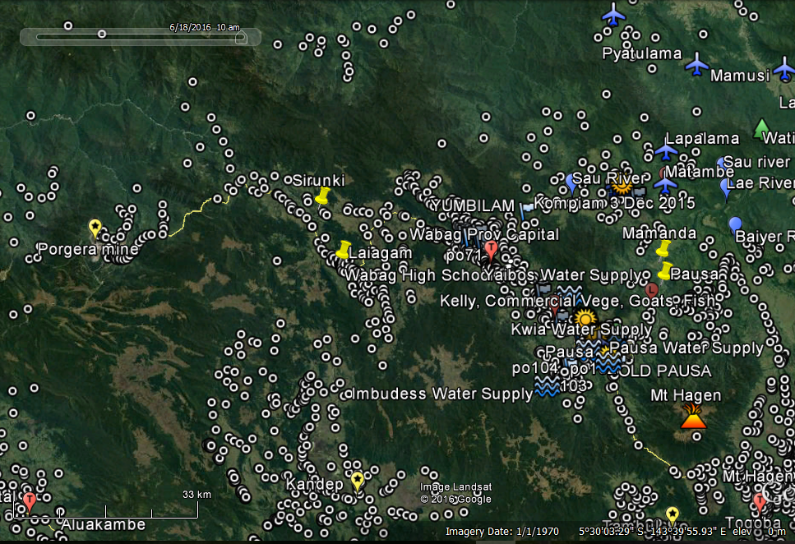
Villages of Enga (Provincial boundaries not shown)
Thanks to NARI for provision of village locations, based on 2000 census.

We look forward to being part of a process of field extension that leads to change and improvement for village families.
Thankyou – Dr Dave Askin - on behalf of the whole team sponsored by NZMFAT.

Dave Askin – dave@davidaskin.org
Virginia Askin – v.askin@scorch.co.nz
Ben Heyward - benhey37@gmail.com
David and Anna Kulimbao dkkulimbao@gmail.com
Appendix – Final workshops in August 2016, working with representatives (normally three) from each main area where training was conducted.
Enga Workshop Participant Names
Suringi | Gender | Birip | Gender | Kopya | Gender
Maebali Meke | w | Paul B | m | David Lero (Monday then sick) | m
Joe Kep | m | Glenda Machel | w
Julie Joe | w | Peter Lipu | m
Kanamanda |  | Kompiam |  | Sari
Michael Limbao | m | Kiap Saka | m | Thomas Kungu | m
Bonn Kundali | m | Janet Saumi | w | John Nisa | m
Willi Karapus | m | Tominame Makeyane | w
Christopher Lagalenge | m | Muniwane Saapungi | w
 |  | Susi Peter | w
 |  | Jona Siki | m
Tsak |  | Lokaipales |  | Baptist Union of PNG Kwinkya, FBO
Helen Jacob | w | Dikson Kia | m | Susan Tapu | w
Singi Saa | w | Nancy Tony | w | Christine Puya | w
Pass Rimbao | w | Kelly Lugupini | m
Beryl Rimbao | w
Mandai Ericito | w
Salvation Army, FBO |  | The Voice of Women, NGO |  | Enga Women in Coffee, NGO
Captain Gaina | m | Janet Kepoli | w | Penny Nathan | w
Jenny Gaina | w | Tanguyame Eteya | w | Pakene Koneyala | m
Self Reliance in Development, FBO |  |  |  | DAL, DPI
Albert Athro | m |  |  | Dorothy Kukum, DAL | w
 |  |  |  | Sampson Fezono, DRDO | m
 |  |  |  | Total women | 20
 |  |  |  | Total Men | 18
Facilitators |  | DA, DK, AK, DeK, BH |  | Total Participants | 38
Simbu Workshop Participant Names
Sinasina | Sex | Gembogl | Sex | Kerowaghi | Sex
Andrew Karl | m | Paul Witne | m | Josephine Wenabo | w
Mol Mua | m | John Umba | m | Morin Gogla | w
Eric Kiap | m | Susan Kagl | w | John Gogla | m
Wariso Matthew | w | Toby Manda | m
Digine |  | Gumine |  | Kerowaghi DPI
Sunnay Palau | m | Susan Tomas | w | Luis Apa, DRDO | m
Tomas Kamane | m | Josephine Judah | w | Royben Aisac, RDO | m
Sunny Philip | m |  |  | Waris Toe, RDO | w
Sunny Dua | m |  |  | Simon, KPFRO | m
 |  |  |  | Wete Ganbe, Officer | m
 |  |  |  | Rebecca Gumo, Cadet | w
 |  |  |  | Moses Mondo, Cadet | m
Salvation Army, FBO |  | Jiwaka Lutheran Women, NGO |  | Kawagl Women in Agriculture, NGO
Captain Steve Lawaki | m | Debbie Kapal | w | Daisy Sailas | w
Lawaki Timothy | m | Maria War | w | Judith Wine | w
 |  | Josephine Wandu | w
 |  | Susie Narewec | w | Kerowaghi Urban Ward
Self Reliance in Development, FBO
Albert Athro Ukaiya | m
 |  |  |  | Total Women | 14
 |  |  |  | Total Men | 19
Facilitators |  | DA, DK, AK, DeK, BH |  | Total Participants | 33

These notes are written with the PNG highlands in mind, but principles around soil fertility loss and strategies to enhance sustainability are relevant to the whole of PNG and beyond.
Kaukau – sweet potato or as New Zealander’s know the crop – kumara – the staple crop of PNG highlands.

