Project Component Report - Strengthening food production capacity and the resilience to drought of vulnerable communities

Component 5: Communication and visibility

Introduction
The report covers activities of Component 5 – Communication and Visibility from July - 2018 to December 2019.

1.0 Training Manuals Development
A total of nine training of trainer (OT) training manuals (Table 1) have been developed during the reporting period and more are planned to be developed where required covering a wide range of areas. These were put together as a result of the engagement of Communication Consultation (Dave Askin, Kilu Consulting) who supported and assisted in the development of training module templates. The manuals developed are in English and suitable for use as Training of Trainers (TOT) documents and the trained could extract necessary content for specific farmer or community level trainings. The manuals were pretested through two TOT workshops (see TOT Workshop below) and feedbacks from participants are being considered to further revise them. The revised materials would be made available for wider use. Other supplementary resources (Table 2) were also identified and compiled to be used along with the training manuals.

Table 1: List of TOT manuals developed during 2018 – 2019 under the EU funded climate resilience Action
No. | Title | Author
1 | Improved poultry production for climate resilience in PNG | Janet Pandi
2 | Pig husbandry in PNG | Michael Dom
3 | Root crops processing and preservation in PNG | Miriam Simin
4 | Propagating food crops in PNG | Jeffrey Waki
5 | Sustainable fish farming | Maima Sine
6 | Sustainable gardens in PNG – Trainers | Dave Askin
7 | Sustainable gardens in PNG – Villager Training | Dave Askin
8 | Nursery Management | Mathew Poienou
9 | Upland rain-fed rice production | Peter Gendua

Table 2: Other Resources identified and compiled for use in TOT trainings in the EU climate resilience Action
No. | Title | Author
1 | Training villagers in PNG | Markus Muntwiler & Dave Askin
2 | Free range chicken farming training manual – English | Markus Muntwiler
3 | Han buk bilong givim skul long lukautim kararuk – Pigin | Markus Muntwiler
4 | Han buk bilong givim skul long lukautim pato – Pigin | Markus Muntwiler
5 | How to construct, install and use biosand filter | NARI (Extension Booklet No. 13)
6 | Solar panel system calculations for PNG | Dave Askin

2. Training of Trainers Workshop

Two Training of Trainers (TOT) workshops have been held to date. The purpose of the workshops were in line with Output 3 (A,c 3.1): Building capacity of Local learning Facilitators (LF, from NGOs, CBOs, GOs or Model farmers) to assist in delivery of Action plans in 8-12 pilot sites. The workshops also provided an opportunity for us to pre-test the trainings manuals in order to further improve the documents and made available for wider use.

Both workshops were held at the Alan Quartermain Hall, Momase Regional Centre, Bubia. The first workshop was held from 10 – 14 December 2018 and the participants were representatives of partners based in the Momase region. At total of 20 representatives (Appendix 1) of partner organizations participated; representing provincial Department of Agriculture and Livestock (PDAL), and NGOs from the region.

The second workshop was held from 13 – 17 May 2019, for representatives of partners from the Southern and Islands regions. A total of 20 participated (Appendix 2), including selected NARI staff from Laloki and Keravat that are engaged in the project in the respective regions.

The workshops ran for a week each with participants taken through a series of theory and practical sessions. The session themes were aligned to the training manuals. The sessions were intensive but inclusive in facilitating active up-skilling through indoor discussions and presentations as well as outdoor hands-on activities and excursions.
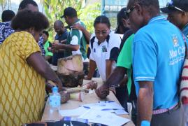
Participants going through the steps of drying methods of processed starch (lelf) and hands on with propagation of taro (mini-setting) during the week long workshop
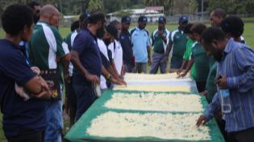
Besides the main sessions; two complementary, up-skilling sessions were held. These included basic solar panels installation skills, and the use of Tablets as a means of enhancing communication. Each participant was presented a Tablet and also created email (gmail) accounts.

3. Learning materials
Capacity building through Training of Trainers (TOT) programs and subsequent roll-out of learning activities in target communities is a key approach in the project to transfer knowledge and skills on new or improved agricultural technologies and practices that can assist communities to adapt to climate change. NARI has released some 29 technologies and produced a range of technical and extension publications. Further to this a number of Training of Trainers (TOT) modules (as reported above) have been developed with the support of this project. A number of learning activities targeting partners (NGOs, CBOs, PDALs) and communities of project sites have been undertaken. In order to further enhance the effectiveness of learning outcomes, we have identified the need to develop relevant learning materials (Appendix 3) that would further supplement the training manuals in a wide range of areas covering crops, livestock and natural resource management. The aim is to take a more systematic approach in developing appropriate learning materials that would support delivery of learning activities with standardized learning materials that are tailored to suit the target audience (TOTs or community members) in terms of their content, structure, format, and language.
Learning Material Development Workshop
A workshop on developing learning materials was organized from 9 – 13 December 2019 aimed at processing various drafts of learning materials that we have developed to ensure each material have a clear key message, contents are clear and easy to understand, and language is appropriate among others. The workshop also included a session on translating these into Tok Pisin. Participants (Appendix 4) included Dr Lilly Sar (University of Goroka) and Abu Daniels (Summer Institute of Linguistics) as external experts and NARI staff from all centres that were involved in preparing drafts of learning materials. A representative from the Provincial Department of Agriculture and two NGOs also participated to provide their experience with use of learning materials at the community level.
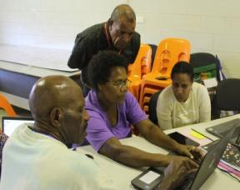
The main topics discussed at the workshop included:
- Identifying key messages – this was to ensure that learning materials did not only consist of the how to do things (scientific content) but also should indicate how the farmer will benefit by doing or adapting such an intervention. Without any useful benefit, the promotion of an intervention or technologies is worthless
Participants undertaking group work at the workshop busy with group work
- Use of terminology – to ensure use of terminology that are appropriate and easy to understand by the users of the materials
- Building content – to ensure contents are clear and easy to understand, language is appropriate, and ensure logical flow.
- Extracting Tok Pisin messages – once a satisfactory English version is developed, the message can be translated to Tok Pisin for the benefit of local communities. Useful Tok Pisin terminologies were identified to ensure all users are using the same including correct spelling. Translating English to Tok Pisin is difficult and any translation would require specialists. We may have to outsource such experts if any attempt for translation is considered under the Action.
- Extracting into formats – depending on the use of the materials, some decision has to taken to decide how and what format to use; either to develop brochures, fliers, posters, etc
- Templates and styles – for uniformity and appeal, having in place a standard template and style in place is useful when developing a series of learning materials
- Building content into Apps – various platforms will be used to share these materials and the use of the Apps is one option. The content of the learning materials will be built into the project App when these materials are finalized for use.

Research gaps identified
The workshop also highlighted some research gaps and the need for further understanding of certain aspects of the various interventions that are being introduced into communities for developing appropriate resilience strategies:
- Economic benefits of livestock and crops
- Improved cultural control of sweetpotato weevils
- Farmer and resource centre seed storage systems
- Maintenance of germplasm collections
- Processing of corn
- Legumes available for improved nutrition and storage capability
- Water shed management - water harvesting and use
- Wider range of irrigation methods
- Managing bushfires
- Frost forecasting and mitigation techniques
4. Sign boards
Sign boards have been placed at a number of sites including the three NARI coordinating centers (Bubia, Laloki, Keravat) and others will go up now that MOUs are in place. Fields are labeled on station and at sites as well.
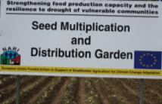
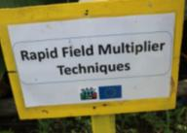
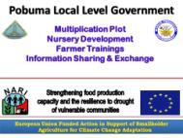
Sign boards and flied labels are important for visibility and indicates the presence of the Action wherever it is being implemented. Above are field Momase regional center - Bubia (left, centre) and a sample of sign boards (right) developed for project sits. Sign boards and field labels will be done for all sites
5. Newsletter
The Institute newsletter (NARI Nius) is being used for publishing news reports related the project. The EU logo and project title are featured on to the front page design of the newsletter for improved visibility starting with the first issue of 2019 (Appendix 5). Three news articles (Appendix 6) of the project activities were covered across four issues of the newsletter during 2019. More project related stories will be featured in the newsletter during 2020.

6. Promotional items
A total of 400 T’ shirts, 250 caps, 100 mugs have been produced and distributed to strengthened visibility. The distribution has been channel through implementing centres and other venues such as workshops, and site visits. More will be ordered as more visits to sites are being planned for 2020.
7. Identity
Various label sizes have been developed and all capitals items purchased through the project are labeled. All implementing centres have been provided with labels to label items purchased at for their use as well as for the in the respective regions.
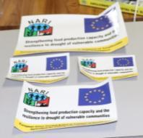
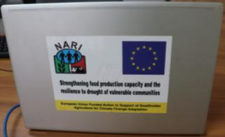
Laptop purchased under the project labeled (left) and the different sizes of labels developed and used (right)

8. Audio visual/video
Three videos have been produced to date (mulching, looking after village chicken, pig silage), though some improvements are required on all of them. More are expected to be produced during 2020 and topics will be aligned with the learning materials that are being developed. A decision would be made soon on this activity, including the options to outsource the service during 2020 to get as many videos done.

9. Online presence
The project is using the PNG Gutplea Gaden (www.gutpela-png-gaden.net) and NARI websites (www.nari.org.pg) to publish news and highlights of project related activities. More frequent use of the both web pages have been lacking due to delayed reporting of site activities and visits. The project Facebook (eucc partners) and NARI Facebook (PNG National Agricultural Research Institute) are also available for use. Both pages still need to be fully utilized.

10. Mobile apps development
Mobile App built using the “Reading App Builder” This framework allows us to use both English and Tok Pisin. It allows content to be built into the app, provided on an SD card, or downloaded from the web. It provides a dictionary popup for words requiring more explanation, and links to web resources. We will be adding the capability for “Push” notifications for new information and alerts. A key feature of the Reading App Building / upgrading system is its ease of use, requiring minimal training. You can get the app link from the Nari website - https://play.google.com/store/apps/details?id=org.nari.gaden.tpi. This is still a fully functional demo app with limited 7 day life.

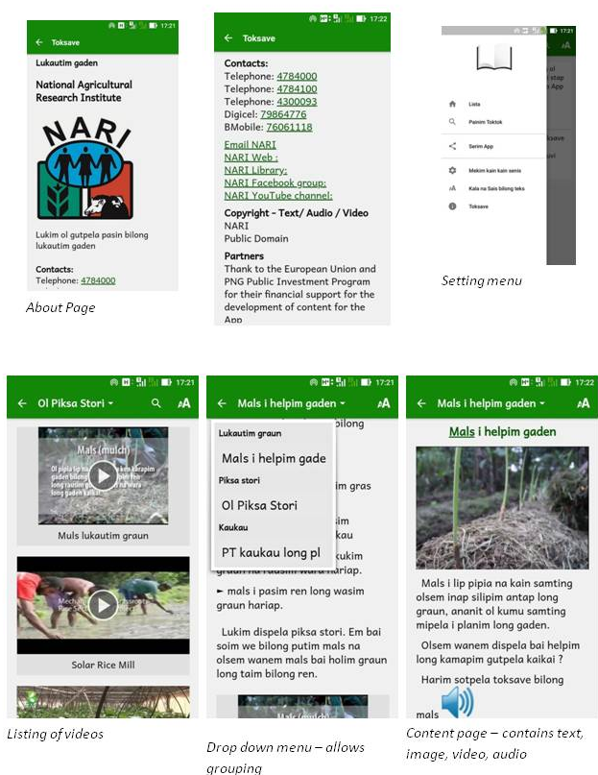
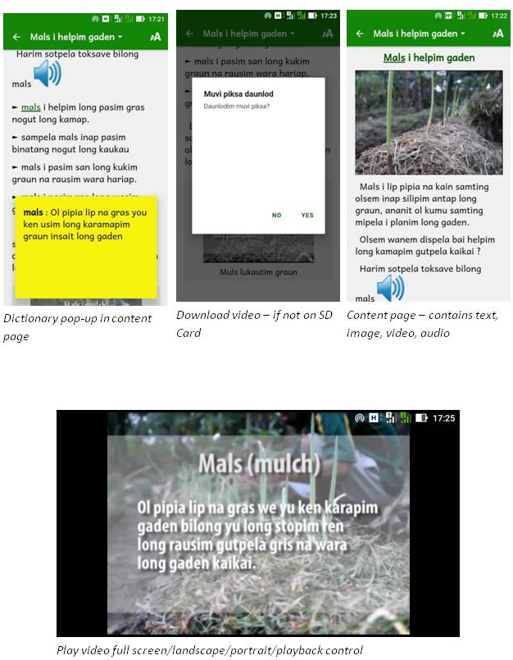
1. Public events
Figure 1: About page
The project team had the opportunity to participate at the Agricultural Innovation Show and Policy Forum (Building Climate Resilient Agricultural Communities in Papua New Guinea) held from 29 – 30 May 2019. The project was also part of the NARI team that participated at the Morobe Agricultural Show from 12 – 13 October 2019. The project will aim to participate in at more events during 2020.
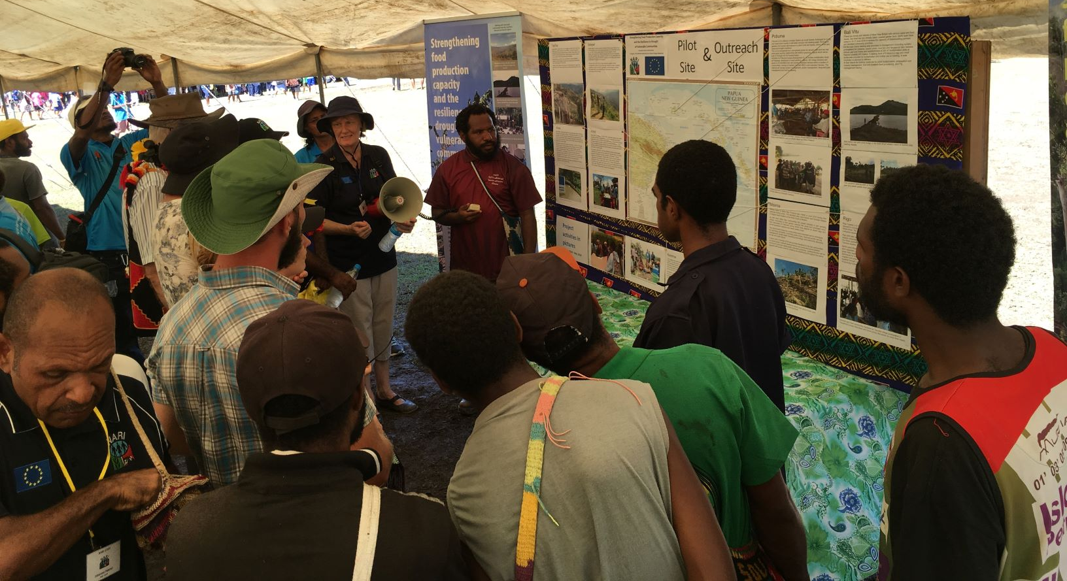
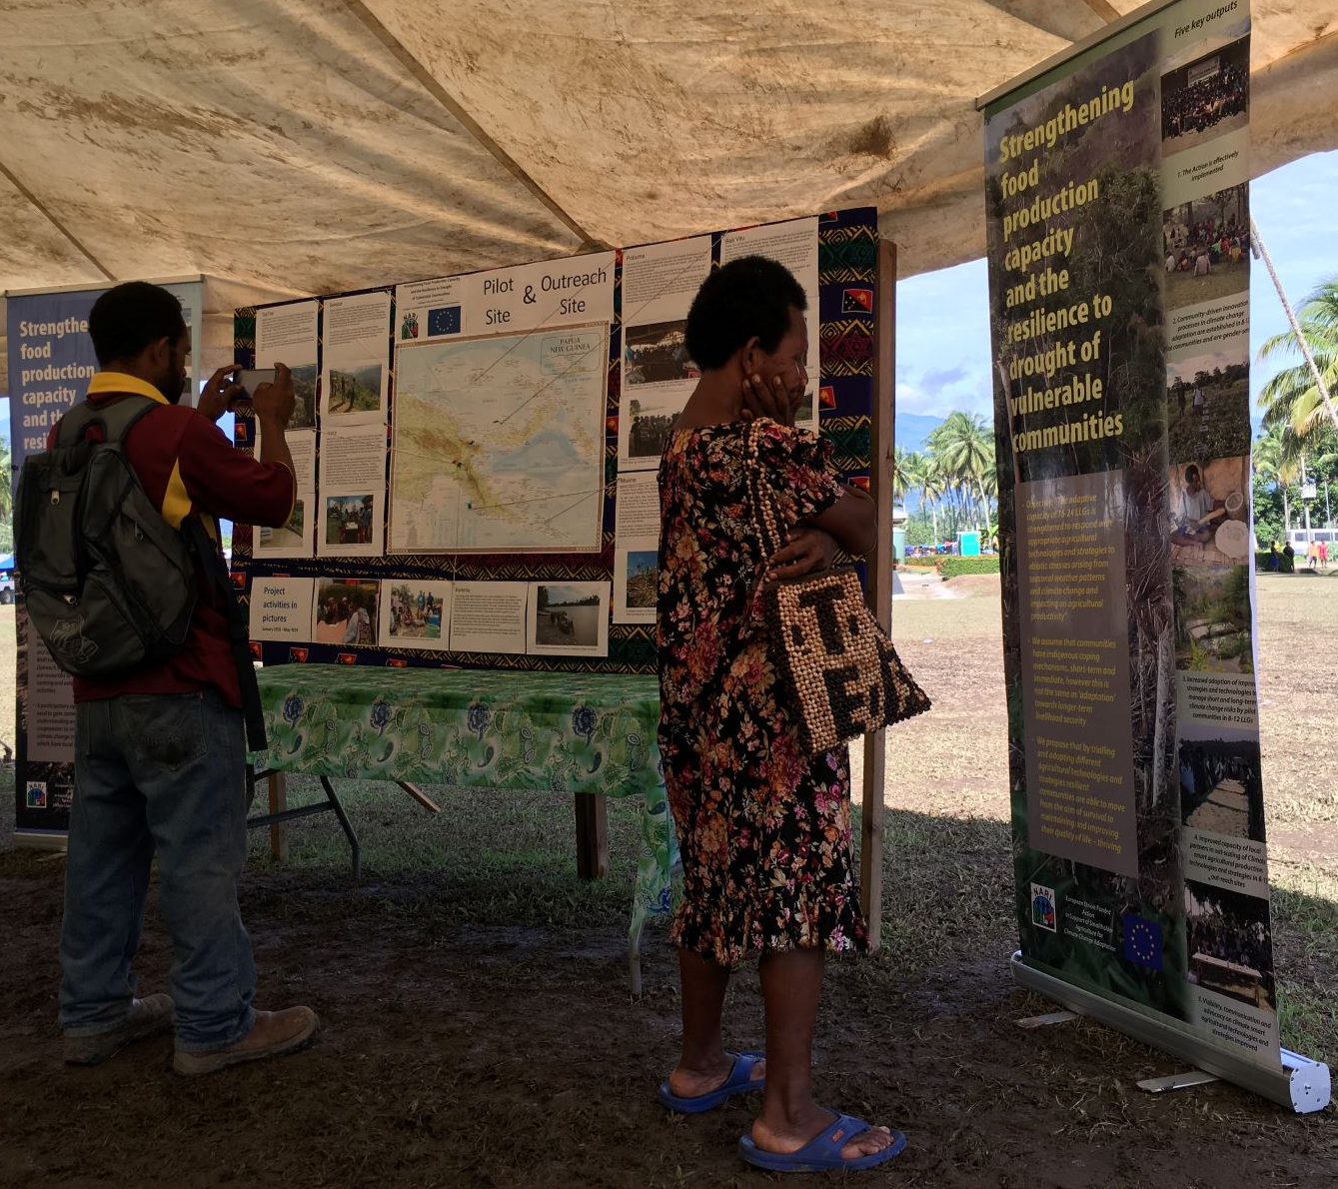
Setup of the project display stall (left) at the event venue and visitors to the stall during the event (right)

12 Research study
A project proposal (Appendix 7) has been developed for the documentation of indigenous study to be undertaken. The proposal is being peer reviewed and will be submitted to the Research and Publications Committee for its consideration during February. This study will be undertaken in 2020 and will cover three pilot sites (Teptep - Momase, Rigo - Southern and Pobuma - Islands).

Appendix 1: List of participants of the TOT workshop for the Momase region from 10 – 14 December 2018
No. | Name | Organisation | Location | Mobile | Email
1 | Barbara Atong | Education | Kabwum | 70202646
2 | Isso Angapesa | PDAL | Menyamya | 71964620 | 74127765
3 | Joe Guaf | PDAL | Vanimo | 73921537 | jnguaf@gmail.com
4 | John Kalan | PDAL | Telefomin | 70257881
5 | Francis Kambual | PDAL | Bogia | 74452122 | franciskambual@gmail.com
6 | Amton Warim | PDAL | Bogia | 74280603
7 | Mary Lilih | PDAL | Madang HQ | 72975716
8 | Jack Govana | PDAL | Bulolo | 73378592
9 | Tomali Wowomi | PDAL | Rai Coast | 79748268
10 | Benny Kium | PDAL | Rai Coast | 73796820
11 | David Lopez | PDAL | Saidor | 71831154 | Davloz.dl@gmail.com
12 | Rhema Droit | Health | Telefomin | 71546564
13 | Pirepa Muta | PDAL | Kabwum | 79557966
14 | Leka Stanley | PDAL | Kabwum | 70756982
15 | Catherine Boina | LDS | Lae | 72420467
16 | Jerry Ososo | NDC | Lae | 73784984
17 | Tulai Warike | PDAL | Vanimo | 71251348 | 79451240
18 | Clement Neingou | PDAL | Wewak | 70405722
19 | Maria Songai | PDAL | Wewak | 70326634
20 | Justin Taper | Baptise Union | Mt Hagen | 71600217 | jtaper@bupng.org,pg
21 | Thomas Muyo | PDAL | Kabwum | 72669013 | thomasmuyo@gmail.com
22 | Jimmy Levi | PDAL | Kabwum | 79625537
23 | Amos Buieba | PDAL | Lae | 71867846 | abuieba@morobe.gov.pg
24 | Salome Zonggesia | PDAL | Markham
25 | Nelson Darina | PDAL | Situm
26 | Bonnie Keoka | LDS | Lae | 72472380 | Bonnie.keoka@gmail.com

Appendix 2: List of participants of TOT workshop for Islands and Southern region from 13 – 17 May 2019
No. | Name | Organisation | Location | Mobile | Email
1 | Enoch Nukvue | PDAL | Bali Vitu | 79594378 | enochnukvue@gmail.com
2 | Evah Pegeti | PDAL | Bali Vitu | 79004578 | evahpegeti@gmail.com
3 | Elias Darius | LM PNG | Boroko | 71835311 | Edarius.k@gmail.com
4 | Paul Jete | PDAL | Pobuma | 71030642 | Pauljete85@gmail.com
5 | Theckla Kanau | PDAL | Pobuma | 79623958 | Kanautheckla24@gmail.com
6 | Au Morea Doko | LM PNG | Boroko | 70339047 | audokom@gmail.com
7 | Annie Gima | PDAL | Alotau | 71410201 | Nniegima37@gmail.com
8 | Elsie Uriah | PDAL | Malalaua |  | ejayuriah@gmail.com
9 | Beriria Ninhili | PDAL | Central HQ | 71490789 | ninihiliberiria@gmail.com
10 | Sega Goruna | PDAL | Central HQ |  | sgoruna@gmail.com
11 | Michael Ravai | PDAL | Tapini | 74899877 | ravaimichael030@gmail.com
12 | Mark Bosco Isai | PDAL | Central HQ | 73901388 | mbosco1993@gmail.com
13 | Thomas Mitase | PDAL | Malalaua | 70145856 | mitasejthomas@gmail.com
14 | Tai Kui | NARI | Aiyura |  | tai.kui@nari.org.pg
15 | Fred Besari | NARI | Keravat |  | fred.besari@nari.org.pg
16 | Gena Kawale | NARI | Laloki | 7437757 | gena.kawale@nari.org.pg
17 | Simon Senge | NARI | Laloki |  | simon.senge@nari.org.pg
18 | Elly Solomon | NARI | Bubia |  | elly.solomon@nari.org.pg
19 | Arthur Roberts | NARI | Bubia |  | arthur.roberts@nari.org.pg
20 | Mathew Poienou | NARI | Keravat |  | mathew.poienou@nari.org.pg

Appendix 3: List of learning materials being developed under the EU climate resilience Action
No. | Title | Category | Type
1 | Yam Mini-sett | Crops | Brochure
2 | Yam Mini-sett | Crops | Video
3 | Yam Mini-sett | Crops | Poster
4 | Taro mini-sett | Crops | Brochure
5 | Taro mini-sett | Crops | Video
6 | Taro mini-sett | Crops | Poster
7 | Banana bit | Crops | Brochure
8 | Banana bit | Crops | Video
9 | Banana bit | Crops | Poster
10 | Cassava mini-stem cutting | Crops | Brochure
11 | Cassava mini-stem cutting | Crops | Poster
12 | Cassava mini-stem cutting | Crops | Video
13 | Sweet potato nodal propagation | Crops | Brochure
14 | Basic nursery management skills | Crops | Brochure
15 | Basic nursery management skills | Crops | Poster
16 | Integrated Pest Management | Crops | Brochure
17 | Integrated Pest Management | Crops | Video
18 | Integrated Pest Management | Crops | Poster
19 | Processing tubers and roots | Crops | Brochure
20 | Processing tubers and roots | Crops | Video
21 | Processing tubers and roots | Crops | Poster
22 | Hygiene of planting materials | Crops | Brochure
23 | Hygiene of planting materials | Crops | Video
24 | Hygiene of planting materials | Crops | Poster
25 | Mulching | Land Use | Video
26 | Mulching | Land Use | Brochure
27 | Mulching | Land Use | Poster
28 | Managing Fallow land | Land Use
29 | Managing Fallow land | Land Use
30 | Managing Fallow land | Land Use
31 | Improving soil fertility | Land Use
32 | Improving soil fertility | Land Use
33 | Sand Filter | Water | Video
34 | Sand Filter | Water | Brochure
35 | Sand Filter | Water | Poster
36 | Integrated fish with poultry | Livestock | Brochure
37 | Integrated fish with poultry | Livestock | Video
38 | Selecting good breeding stock of village chicken | Livestock
39 | Selecting good breeding stock of village chicken | Livestock
40 | Egg managee]ment | Livestock

Appendix 4: List of participants for the learning material development workshop from 9 – 13 December 2019
No. | Name | Organization
1 | Bonnie Keoka | Lutheran Development Service
2 | Abu Daniels | Summer Institute of Linguistics
3 | Dilean Doiki | University of Goroka
4 | Lilly Sar | University of Goroka
5 | David Kulimbao | CDWAI
6 | Naisman Mitio | PDAL – Eastern Highlands
7 | Elly Solomon | Bubia
8 | Maima Sine | Tambul
9 | Jeffrey Waki | Bubia
10 | Miriam Simin | Bubia
11 | Mathew Poienou | Keravat
12 | Gena Kawale | Laloki
13 | Peter Gendua | Laloki
14 | Philma Waken | Laloki
15 | Tai Kui | Aiyura
16 | Rodney Aku | Aiyura
17 | Johannes Pakatul | Aiyura
18 | Kai Lali | Aiyura
19 | Mauro Okrupa | Aiyura
20 | Kud Sitango | Tambul
21 | Barbara Tomi | HQ
22 | Aaron Inamara | HQ
23 | Elizabeth Ling | Keravat
24 | Tio Nevenimo | Keravat
25 | Catherine Boina | Lutheran Development Service

Appendix 5: Cover page of NARI newsletter
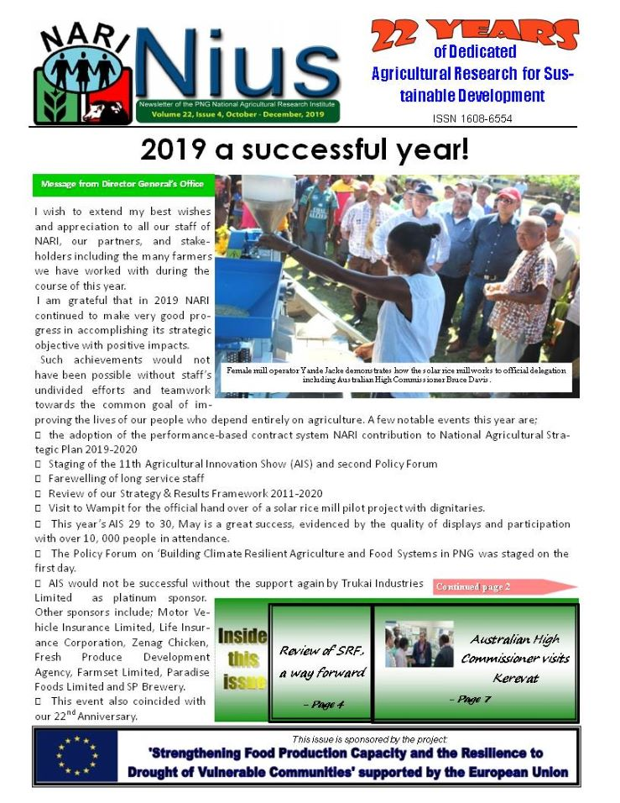

Appendix 6: Project related stories in 2019 issues of NARI Nius 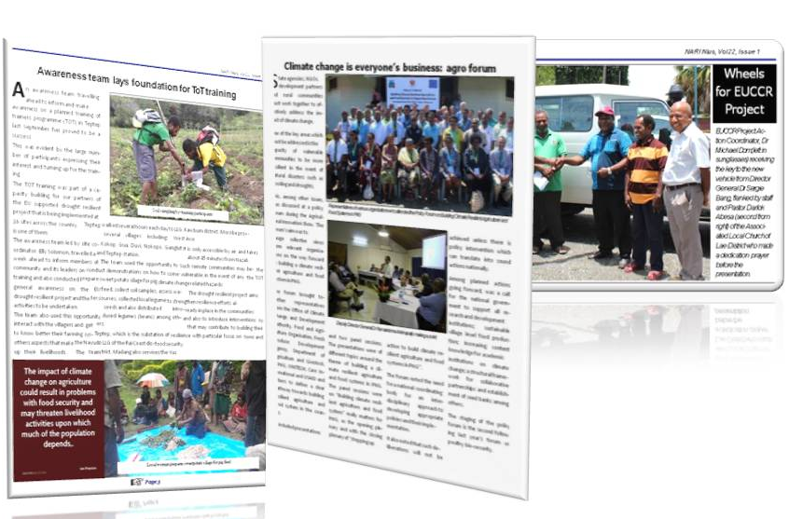

Appendix 7: Draft full project proposal for indigenous knowledge documentation study
NARI Programme/Sub-programme/SPIP project; which ADDs/Clusters |  | Information and Knowledge Program  Agriculture Systems Program (Sub-programme 1.3 Abiotic threats and Climate Change)  EU Drought resilient project document - Output 5: Visibility, communication and advocacy on climate smart agricultural technologies and strategies improved.  Activity 5.2: Documentation of indigenous knowledge and practices in managing climate variability induced risks and emergency situations in pilot sites
Concise but explicit title for the proposed project |  | Documentation of Indigenous knowledge in managing prolonged dry weather situations: The case of Teptep, Rigo and Pobuma communities of Papua New Guinea
Project Leader and other members of research team |  | James Laraki, Jeffrey Waki, Clifton Gwabu, Mathew Poienou
Estimated duration of the project |  | 6 months
Type of proposal () |  | Standard project: | Small study:

Name and Acronyms of Partner organisations working on the proposed project.
a) | DPI Pobuma
b) | DPI Rigo
c) | DPI Teptep

List of target locations in which the proposed project will be implemented.
a) | Rigo Coast LLG - Central
b) | Pobuma LLG – Manus
c) | Teptep - Nayudo LLG, Rai Coast and Yus LLG, Kabwum

- Summary of Research Questions
Briefly summarize in dot-point form the problems/opportunities and associated research questions that the project is attempting to address
Issue/Problems
- Indigenous knowledge has been developed and used in rural communities over a long period of time, including providing resilience during adverse climate events, but these have not been documented and risk being lost.

What are the implications?
- Without knowledge on alternative food sources and environmental management, people become less resilient to adverse events.
- Due to lack of knowledge, life saving food sources could be lost through logging and other poor environmental management practices

Opportunities
- Improved resilience through better understanding of indigenous knowledge
- Sharing of beneficial indigenous knowledge between different areas
- Ensuring that future generations has access to this knowledge
- Better understanding of indigenous knowledge may help in introducing new resilience oriented technologies
- May help with early warning/weather forecasting

Research Questions
Numerous research opportunities exist around the area of indigenous knowledge (IK). Whilst this may be so, this study due to time constraints will only attempt to assess and document IK relevant to how communities cope with adverse situations such as prolonged dry periods at the three sites (Teptep, Rai Coast – Madang; Pobuma – Manus; and Rigo – Central). While it would allow for documenting a wide range of IK used and available at these sites, the primary research question for the study is:
What traditional practices and alternative food sources are used to cope with food shortages due to extended dry weather?

Supplementary questions:

- Is the indigenous knowledge available and used has potential for wider application?
- What level of resilience do these traditional coping mechanisms provide?
- Are they able to predict upcoming adverse events?
- What do they do when food gardens fail? Do they change garden practices to prepare for possible extended dry periods?
- What are some of the challenges faced with in terms of conserving and the use of IK?

- Expanded Background (max 5 pages)
- Consult relevant literature and information to identify Issues, Problems and Opportunities that will be addressed by the proposed project and any work that has already been done in this area. Clearly describe their significance and importance within the context within which the proposed project will be implemented. Expanded background needs to clearly emphasize on the research gaps and which ones will be addressed by the project. The expanded background should include a list of references cited in the text.
The literature has no precise definition, and numerous attempts have been made to define the concept of indigenous knowledge (IK). The UNESCO’s program on Local and Indigenous Knowledge Systems defines indigenous knowledge as “understandings, skills and philosophies developed by societies with long histories of interaction with their natural surroundings” (Hiwasaki et al., 2014). The intergovernmental Platform on Biodiversity and Ecosystem Services defines indigenous knowledge as “the multi-faceted arrays of knowledge, knowhow, practices and representations that guide societies in their innumerable interactions with their natural surroundings” (MoSTE, 2015). Matsika (2012) defines indigenous knowledge as “traditional and local knowledge that exists and is developed through the experiences of the local community in the process of managing the conditions or context that challenge the people’s everyday life” and further identifies its main characteristics. To synthesize these definitions and others in relevant literature, indigenous knowledge can be understood as ‘a body of different types of knowledge and practices of societies accumulated through a continuous interaction with their natural surroundings’ (Brokensha et al., 1980; Fernando, 2003; and Sillitoe, 2000, Mercer, et al, 2009).
It is also noted that the term indigenous and who the indigenous are is heavily debated in literature and practice (Dean and Levi, 2003; Niezen, 2003). In addition the terms ‘local’ and ‘traditional’ are interchangeably used with indigenous, though many scholars argue these terms have different meanings and can result in misconceptions, and would be useful to clarify what indigenous knowledge is and whom it belongs (Srikantaiah and Rueger, 2008). In this context, these terms would be used interchangeably as indigenous knowledge here refers to knowledge held by local people of the communities covered in the study.
With the recent increased interest in indigenous knowledge, numerous studies have been undertaken globally, more so in the areas education, health, research and development (World Bank, 2005). However, studies in PNG on indigenous knowledge are not well established. Few studies relevant to indigenous knowledge and their role in resilience to hazards have been undertaken in PNG, with varying focus. A personal conversation with Kud Sitango revealed that a survey related to indigenous knowledge relevant to coping with prolonged dry periods was conducted by NARI during 2000. He acknowledged that no report was published from this study, however, some of the findings were contributed towards the “Drought Response: On-farm Coping Strategies’”, published as NARI Information Bulletin (NARI, 2001). Other similar studies were conducted by the International Organisation for Immigration (IOM, 2015) and a study on valuing indigenous knowledge in the highlands of PNG by the Charles Sturt University of NSW (Radcliffe, et al. 2016). The IOM study was conducted in collaboration with the National Disaster Centre and covered three communities in Morobe, West New Britain and Oro provinces; whilst the latter was in two communities in the Western Highlands province. The IOM study focused on establishing an understanding of the value of indigenous knowledge for reducing disaster risk for different types of hazards in different environmental and cultural settings. Shaw et al (2008) undertook a similar study, though it looked at the broader perspective of the Asian-Pacific region.
While these studies provides useful tips of the indigenous knowledge and their use in disaster risk reduction in a broader sense, their documentation and what level of traditional coping mechanism such knowledge provide, particularly in relation to food systems requires further attention. There also exist the need to establish and determine what level of resilience these traditional coping mechanisms provide and their potential for wider application.
This study, therefore, provides an opportunity, firstly to document some of the local knowledge available and used a the three sites to sustain themselves during disasters such as prolonged dry periods; and secondly assess how some these could be further be improved to assist them to building resilience to their food systems. The study hopes to make a valuable contribution to drought preparedness and adaption strategies that NARI and other concerned organisations may develop going forward by highlighting the significant roles of indigenous knowledge in these communities and how these could be further integrated with science or external knowledge. The study will also provide an opportunity to strengthening learning relationships through sharing of lessons learned and good practices in dealing with hazards and climate change impacts among these communities and other in PNG.

References
Brokensha, D., D.M. Warren & O. Werner. 1980. Indigenous Knowledge Systems and Development. University Press of America, Lanham, MD.
Coffey, A. and Atkinson, P. (1996). Making sense of qualitative data: Complementary research strategies. Thousand Oks, Calif: Sage Publications.
Dean, B. and Levi, J. M. (Eds.). 2003. At the Risk of Being Heard: Identity, Indigenous Rights, and Postcolonial States. The University of Michigan Press.
Fernando, J.L. 2003. ‘NGOs and production of indigenous knowledge under the condition of Postmodernity’. The Annals of the American Academy. 590. pp. 54–72
Hiwasaki, L., Luna, E., Syamsidik & Shaw, R. 2014. ‘Process for integrating local and indigenous knowledge with science for hydro-meteorological disaster risk reduction and climate change adaptation in coastal and small island communities’, International Journal of Disaster Risk Reduction, 10, pp. 15– 27. doi: 10.1016/j.ijdrr.2014.07.007.
ISDR (2004). Living with Risk. A Global Review of Disaster Reduction Initiatives. Geneva: Inter-Agency Secretariat of the International Strategy for Disaster Reduction (ISDR)
IOM (2015). Indigenous knowledge for disaster risk reduction: documenting community practices in Papua New Guinea, Port Moresby, Papua New Guinea.
Jha, V. and A. Jha. 2011. Traditional Knowledge on Disaster Management: A Preliminary Study of the Lepcha Community of Sikkim, India. Indian Knowledge of Traditional Knowledge. Vol. 10 (1) p. 173.
Matsika, C. 2015. Traditional African Education: Its Significance to Current Education Practices with Special Reference to Zimbabwe, Mambo Press, Gweru.
Mercer, J. et al. 2009. Integrating Indigenous and Scientific Knowledge Bases for Disaster Risk Reduction in Papua New Guinea. Swedish Society for Anthropology and Geography, pp. 157–183.
Merriam, Sharan B. 2009. Qualitative research: A guide to design and implementation (2nd ed.). San Francisco, CA: Jossey-Bass.
MoSTE, 2015. Indigenous and Local Knowledge and Practices for Climate Resilience in Nepal, Mainstreaming Climate Change Risk Management in Development, Ministry of Science, Technology and Environment (MoSTE), Kathmandu, Nepal.
NARI, 2001. Drought Response: On-Farm Coping Strategies. Information Bulletin No. 6, National Agricultural Research Institute,
Niezen, R. 2003. The Origins of Indigenism. University of California Press: Berkley and Los Angeles.
Radcliffe,C; Parissi, C. and Raman, A. 2016. Valuing Indigenous Knowledge in the Highlands of Papua New Guinea: A Model for Agricultural and Environmental Education, Australian Journal of Environmental Education,(32) 3: 1-17
Shaw, R. et al. 2008. Indigenous Knowledge: Disaster Risk Reduction, Policy Note. Bangkok: UNISDR Asia and the Pacific
Sillitoe, P. 2014. The development of indigenous knowledge: a new applied anthropology. Current Anthropology 39 (2): 223–252.
Srikantaiah, D. and Rueger, C. 2008. An Alternative Knowledge System at the World Bank: A Case Study of the Indigenous Knowledge for Development

Target Beneficiaries
Describe the main features of the project beneficiaries’ situation (who they are, what they do, where they live, and their needs for. Show how these relate to the project context and innovation and innovations process.
- The rural communities through documentation and sharing of their IK and in the longer term through identified research opportunities
- NARI and other researchers/organisations with interest in indigenous knowledge and sustainable development
Project Goal
State the Goal of this project – the Goal should be consistent with the NARI Results Framework, i.e. it would reflect the next higher level to where the project is contributing. In most cases this would be the relevant Project (SPIP) objective or Programme Objective in case of large projects.
Smallholder farming and rural communities are better prepared to cope with abiotic stresses due to seasonal weather patterns, climate change or natural disaster
Strategic Objective
State the Strategic Objective – this should be one concise statement expressing what will have been achieved or changed by the successful completion of the project for the target beneficiary group(s)
Indigenous knowledge is documented and integrated with resilience strategies to better manage prolonged dry period risk in targeted rural communities

Project description
Broadly describe:
Expected major outputs of the project
Research methodology, experimental design, survey methodology, analytical techniques, data collection and analysis (whatever is applicable)
Research activities
Role of NARI and other partners
Logical Framework (Annex 1)
Major Outputs
Establish the extend of resilience and abilities to cope with drought incidence by communities
How such knowledge could be integrated with introduced technologies
Document indigenous knowledge of the selected sites
Identify challenges of conserving and using indigenous knowledge

Research Methodology
Introduction
In order to gain an in-depth understanding and insight into how local communities have used indigenous knowledge to manage risk induced by the climate variability, this study will adopt a case-study approach (Merriam, 2009) to investigate how different communities have forged a relationship with their environment for their wellbeing. As a case study, the focus will be on how communities have lived in harmony with their environment, especially their experience during the 1997 and 2015/16 prolonged dry periods.
Since the study is time bound (6 months) and part of the EU climate resilient project, the case-study approach is appropriate, as it will all allow us to assess and document IK across three sites and determine their diversity, commonalities, and different sets of IK available and used in these communities. In doing so will allow us to make comparisons and be able establish areas requiring further improvement and supplement them with outside knowledge.
Data Collection
The proposed study will rely on multiple collection or sources of data. Data will be gathered through semi-structured interviews with open-ended questions. The interview data will be supported by secondary data collected through:
- Focus group discussions
- Field notes – informal discussions
- Observation during site visits
- Photographs

Note: the study covers three sites from some 12 sites where the EU drought resilient project is being implemented. Other IK available and used in other project sites may be documented in the study.

Interview
Sampling Procedure
The participants of the study will include adults (men and women) participants from each site, totalling 105 participants across all sites. Age group of 35 – 50 will participants as this would ensure that participants were young adults (at least 25 years) in 1997. Focus will also be on fair representation gender wise.
Data Analysis
Again due to time factor, analysis will only be by means of coding (Coffey and Atkinson, 1996; Merriam, 2009). Coding will be done to combine the similarities from the data in terms of themes, ideas and categories which will enable retrieving data easier for further comparison and to identify patterns that requires further analysis.

Research Activities
Interview questions
Interview questions prepared and shared with colleagues for feedback. Considering the time limitations, awaiting feedback from all may not be possible. While it would be useful for the finalised interview questions to be tested, this may not be possible given the time available.
Interview schedule
A tentative schedule to cover the three sites developed (see Appendix 5)
At least a week is required at each site – total of 15 working days
All site visits between February and April

Data analysis
Data analysed after all sites are completed.
Detail analysis will not be feasible due to time limitations

Preliminary result/information
Preliminary results compiled and written up
Final report submitted to R&PC
Data may be used to develop research paper in future

Role of NARI and other partners
The study will be undertaken by NARI project team whilst assistance would be sourced from DPI colleagues at the respective LLGs during the study.

Logical Framework (Annex 1)

Monitoring and Evaluation
Discuss what beneficial direct, immediate and medium-term term outcomes are expected from the delivery of the proposed project strategic objective (complete Annex 2 Results Chain)
Identify any sources of baseline data, how you will collect this or how you will achieve a baseline
Explain what indicators you will use to measure outcomes against the baseline
Identify any sources of extra information that will assist you in judging the changes your project might bring about
Refer to Annex 2

Risk Assessment
Identify all of the significant risks associated with the project
Assess the probability and impact for each risk
Give details of the way in which the organisation will manage the risks
Refer to Annex 3 (Risk assessment matrix)

Cross-cutting Issues (Gender)
Conduct a gender analysis for the planned project interventions; consider
the roles of women and men and how their respective activities affect the issue you want to address
the roles of women and men in regards to utilization of outputs
how access of men and women and control over resources would affect implementation and success of the project
how will mobility and access to information of men and women affect implementation and success of the project
any other socio-cultural factors regarding roles of men and women in the target communities
The study is gender sensitive, however, it is also important that women participation is essential in the study to understand how they utilise IK during prolonged dry periods as women are considered as the provider food for many rural communities in PNG

Cross-cutting Issues (HIV / AIDS) – where applicable
Describe how your project will address specific HIV/AIDs needs or take HIV/AIDS needs into consideration
identify the extent to which the rural community is at risk of HIV infection; and
determine whether the community is already impacted by AIDS
***Not applicable***

Cross-cutting Issues (Environment)
a) Briefly describe what environmental impacts (if any) your project will produce and the steps you plan to mitigate them.
***Not applicable***

Project Budget:
Budget summary (Full budget in Annex 4)
 | Q1 | Q2 | Q3 | Total
Salaries & wages | 0 | 0 | 0 | 0
Operating costs | 300 | 0 | 0 | 300
Travel | 13,300 | 0 | 0 | 13,300
Transport | 5320 | 0 | 0 | 5320
Capital Equipment | 0 | 0 | 0 | 0
Total | 18,270 | 0 | 0 | 18,920

Resource needs and sources
What are other major resources required for this project (Human Talent, Facilities, major equipments); indicate the availability or access
Two officers (one each from NARI and local DPI) will be involved to conduct the study at Teptep and Pobuma whilst a third officer (Driver) will be engaged at Rigo site.

Make suggestions and recommendations for funding sources (NARI, international grants, in-country sources etc.)
EU Climate resilient project

The project proposal has been peer reviewed:
Name of colleagues, name of organisation, position within the organisation:
Barbara Tomi and Laurie Fooks
Presentation at Centre seminars and discussion (NARI Centre, date of presentation, staff present
A presentation of the proposal is planned for the MRC in-house seminar series early 2020
Other forms of review:

Date of consultation with Biometrician:

Signatures
Jlaraki |  | 20/01/2020
Project Leader’s Signature |  | Date
James Laraki
Project Leader’s Name

Cooperating Scientists, Partners or Collaborators:
Signature |  | Date
Name and Organisation
Signature |  | Date
Name and Organisation
This Full Proposal has been seen and endorsed by:
Programme Director’s Signature |  | Date
Programme Director’s Name
Programme Director’s Comments:

Research and Publications Committee decision:

Project Code Number (for approved projects):

Please note that unless all required signatures are attached the application will not be considered.

Chairman, Research and Publications Committee Date

