European Union Climate Change Resilience Action

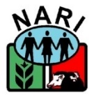

**Strengthening Food Production Capacity and the Resilience to Drought of Vulnerable Communities**

**EU Funded Action in Support of Smallholder Agriculture for Climate Change Adaptation**

“Strengthening food production capacity and resilience to drought on vulnerable communities”

***Technical Report Livestock Component***

***Janet Pandi***

**Introduction**

The following report is an annual Technical report on the activities and achievements undertaken by the Livestock Component under the EU funded Action “Strengthening Food Production Capacity and resilience to drought on vulnerable communities” for the period beginning January 2019 to December 2019.

Pilot sites, the needs and venerability assessments were carried out between February and June 2018 and priority issues where identified with activities aimed at building capacity of primary partners and support them to engage with target communities in selected LLGs to also build their capacity for enhance food production and adaptation to climate change of their agricultural systems.

The site specific interventions on crops, livestock and natural resource management as identified through the Household Needs Vulnerability Survey and identified through Focus Group Discussions for the Pilot sites are presented in Annex 1, with the estimated budget and time of completion as agreed to during the Technical Coordinators meeting held in February 2019. An ‘Implementation schedule of activities for 2019’ as agreed to by the technical team for the Momase sites is presented in Annex 2.

**Livestock Component Activities and Achievements for all project sites**

The major action taken under the Livestock component was that Livestock management practices are enhanced and diversified in the selected sites for food and income during abiotic stresses for Pilot sites. Action untaken for Outreach sites is that the lead partners are supplied with the preferred livestock species breeding stock and training related to the best management practices of these livestock.

**Summary of Livestock Interventions undertaken in Pilot sites for the period in which this report is aimed for is provided in Table**

|  |  |  |  |  |
| --- | --- | --- | --- | --- |
| Region | Site | Livestock Intervention | Progress | Recommendation action Quarter 1 2020 |
| IRC |  |  |  |  |
| WNBP | Bali-vitu | Supply of Poultry stock with training of 40 champion farmers | Not yet | Trip1 March 2020  1. Construction of Poultry house  2. Training of 40 farmers on Family Poultry Technology and feed formulation  3. Supply of 200 village chickens and 200 ducklings |
| Manus | Pobuma | Supply of Poultry stock with training of 40 champion farmers | Delivered training on feed formulation and best management practices for poultry. A total of 51 farmers were trained of which 17 were females.  Supplied 68 village chickens and 15 ducklings. Still need to supply 132 village chickens and 185 ducklings.  Poultry shed constructed on site | Trip 2. April 2020  1. Supply of 132 village chickens and 185 ducklings to the 40 trained Champion farmers in Trip 1. |
| MRC |  |  |  |  |
| Morobe | Kome | Better integrated system of fish and ducks | Trip 1. March 2019: Farmers training capacity and farm sites were successfully evaluated. Farmers were identified and selected to participate in the fish and poultry integration. Two farmers have been selected as model farmers and their farm site will be used as participatory farmers training sites for the upcoming training. 5 model farmers were selected for fish-poultry units. Site selected by DA and RDO for the construction of the Rural Poultry Hatchery at the district.  Delivered training on Poultry raising, aquaculture and feed formulation. A total of 55 farmers were trained of which 16 were females.  Trip 2. November 2019: Conducted monitoring and evaluation of interventions delivered on trip 1 and interacted with interested farmers and models farmers on the fish-poultry integration unit and poultry keeping. The 5 famers identified and selected in Trip one were slow in setting up units however 6 champions farmers (3 participated in the training in trip 1and the other 3 did not but were already farming fish) who took the initiative to construct poultry houses over their ponds following the training delivered in Trip 1. | Trip 3: Feb 17-21-Will deliver chicken and pig wire, nails and nest boxes to the six Champion farmers for their Integrated units  Trip 4. End of March- Will deliver foundation poultry stock and GIFT tilapia fingerlings  The 6 model farmers will each receive 6 ducks, 6 chicken and 180 fingerlings for their unit  Construction of the Rural hatchery at the District by end of March 2020.  Specialised training on running an incubator, egg management and storage and hatchery management April 2020  Financial literacy training specific to running a poultry enterprise to be delivered after the specialised training also in April 2020. |
| Morobe | Selepet | Farmers capacity on best management practices for raising local pigs improved | Trip 1: Delivered training on Pig and Poultry Management practices. A total of 68 farmers participated in the raining of which 29 were women. A of 10 pig farmers were interviewed for on farm work and 5 pig farmers were selected to have model pig houses built on farmer to showcase best management practices. Established women groups volunteered to pilot the family poultry technology.  Site selected for the construction of the Rural Poultry Hatchery. | The 5 Champion farmers will receive 6 ducks, 11 chicken each for their Family Poultry set up –April 2020  Construction of the Rural hatchery at the District by end of April 2020.  Specialised training on running an incubator, egg management and storage and hatchery management May 2020  Financial literacy training specific to running a poultry enterprise to be delivered after the specialised training also in May 2020. |
| Morobe | Watut | Farmers capacity on best management practices for VC/Ducks improved | Trip 1. Training on Keep village chickens and ducks for meat and eggs delivered. A total of 45 people were trained of which 19 were women. Discussion with RDO on selection of 5 model farmers for the Family Poultry Technology. Site for the construction of the Rural Poultry hatchery identified.  Trip 2. 5 Model farmers were selected for the Family Poultry Technology of which two are females.GPS locations were taken and discussions on they type of structure and local materials to be used. | Trip 3 –24-29 February 2020. Delivery of nest boxes, chicken wire to the 5 Champion farmers. Construction of the Model Poultry structure at each farmer site  Trip 4. End of March 2020  1. Distribution of 6 Ducklings and 11 village chickens to each of the Champion farmers.  2. Construction of the Rural Hatchery.  3.Training on hatching eggs using an incubator, Egg storage and management  4. Financial literacy training targeted at raising chickens for meat and eggs for profits. |
| Madang | Teptep | Farmers livestock holdings diversified with sheep, fish and ducks | Trip 1. Delivered training on best management practices for poultry , pigs and fish-duck integration. Construction of an integration unit and discussion on model farmer selections and the construction of the rural hatchery. A total of 36 farmers were trained of which only 4 were females.  Trip 2. Delivered training on sweet potato silage as pig feeds and other basic livestock husbandry practices. A total of 72 farmers were trained of which 32 were females. Model farmers for Family Poultry Technology identified. Farmers decided that they will supply and distribute village chickens and ducklings from their own stock. NARI to supply only 5 water Roosters. The selected farmers were tasked to construct poultry houses and a model house design was shared with these farmers. NARI will also supply 2 rams and 2 bucks as there is already a sheep and goat farmer there to supply these livestock species. Supplied 100m x 25mm water pipe to connect water from a running water pipe to site where the rural hatchery is to be constructed. | Trip 3. End of April  1. Delivery of preferred livestock breeders (5 Roosters, 2 Rams and 2 Bucks)  2. Construction of model poultry structures at the 5 Champion farmers’ sites  3. Construction of Rural hatchery  4. Specialised training on running on egg incubation, egg storage and management.  5. Financial literacy training |
| SRC |  |  |  |  |
| Gulf Province | Kakoro & Titikaini | Livestock holdings (village chicken, local pigs and ducks) of interested farmers in Kakoro and Titikaini communities diversified and capacity for livestock management improved | Trip 1. Delivered training on best management practices for raising pigs and sweet potato silage as pig feed. A total of 24 participants of which 8 were women. | Trip 2. Deliver training on Poultry keeping, feed formulation and supply of foundation stock of village chickens and ducks by end of June 2020. |
| Milne Bay | Misima | Livestock holdings (village chicken, local pigs and ducks) of interested farmers in Hinaota and Narian communities diversified and capacity for livestock management improved | Trip 1. Needs assessment survey of livestock farmers conducted. Pigs farmers wanted a hybrid boar to service local sows and were willing to meet 50% of the cost. Broiler raising was too expensive. Village chicken farmers and duck farmers want foundation stock from NARI and committed to constructing poultry houses first before foundation stock can be supplied. Training needs identified were feed formulation from local ingredients for poultry and health and disease management of intestinal parasites in pigs using medicinal plants.  Trip2. Delivered training poultry feed and sweet potato silage for pigs. Two model farmers were given foundation stock of village chickens and ducks as they had constructed houses for these poultry species. Rewarded with chicken and pig wires.  104 farmers were trained of which 39 were women. | Trip 3. Feb 22-Monitoring and evaluation and interaction with Champion farmers on any technical issues.  Deliver training on feed formulation using local ingredients. |
| Central Province | Rigo | Increased capacity of interested farmers in Rigo Coastal LLG community for using improved chicken and pig feeding and management practices | Yet to visit site | Trip 1. Training on best practices on poultry and pig keep yet to be delivered with foundation stock of village chickens and ducklings  End of June 2020 |
| PILOT SITES | | | | |
| Madang Province | Astrolabe & Almami | Lead partners identified, capacity needs assessed and supply of requested materials to these partners | Lead partner identified as the Provincial DAL with a CBO (Kurakum Mama Group). A poultry model structure was constructed and a total of 24 poultry foundation stock was distributed | Trip 2. March 2020  1. Supply of other preferred livestock species |
| Morobe | Kote | Yet to do | February 2020 |
| West Sepik Province | Teleformin | Yet to do | March 2020 |
| East Sepik Province | Wewak Rural | Yet to do | March 2020 |
|  |  |  |  |  |

**Major Challenges for the period reported**

The major challenged experienced by the Technical team in the action were the disruption and delay of activities due to management decisions in project leadership roles, where major activities such as the drafting and signing of the MoUs were delayed which affected site delivery of major infrastructure to the districts for enhancing their capacity for food and income during abiotic stresses for Pilot sites such as the Rural Nursery and the Poultry hatchery for seed and poultry seed stock multiplication and distribution to farmers in the LLGs. The Technical coordinators in September 2019 took up the role to finalise these documents and were submitted to NARI Senior Management by end of October 2019. The MoUs were accepted by the Office of the DDG in November 2019. The MoUs are currently being signed with respective districts and LLGs.

Another major event that occurred with interfered with scheduled planned trips for the period was the Council elections. Most of the trips planned for June-August were deferred to the last quarter of 2019.

**Some of the highlights of Livestock interventions in 2019**

**(A) Farmer training conducted by IRC, NARI Kerevat**

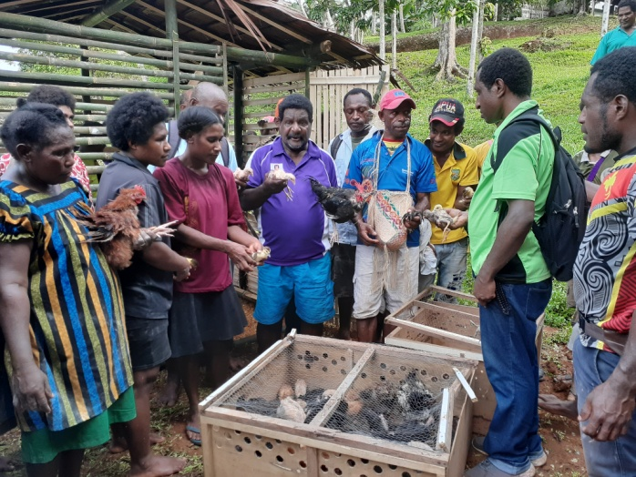

**(B) Fish –Poultry Integrated Unit at Champion Farmer site, MRC, NARI Bubia**

**(C) Farmer training at Misima, SRC, NARI Laloki**

