European Union Climate Change Resilience Action

“Strengthening food production capacity and resilience to drought on vulnerable communities”

Mid-Term Technical Report for Southern Region Component February 2020
Gena Kawale and Peter Gendua
- Introduction
The following report is a Mid-term Technical report presenting the summary of the activities and achievements for the EU funded Action “Strengthening Food Production Capacity and resilience to drought on vulnerable communities” for the period from 1 July 2018 to 31 December 2019 by the NARI Southern Regional Centre at its selected pilot and outreach sites in the southern Region.
- Activities and Achievements in the Southern Region
There were 4 pilot sites and 5 outreach sites selected for the southern region. The pilot sites were; Rigo Coast LLG - Rigo District, Louisiade LLG - Samarai-Murua District, Lakekamu-Titikaini LLG - Kerema District, and Oriomo – Bituri LLG -South Fly District.
The Outreach sites were; Gogodala - Middle fly District, Kiriwina - Kiriwina-Goodenough District, Dobu Rural - Esa’ala District, Afore – Ijivitari District, Kokoda Urban – Sohe District and Kaintiba – Kerema District. During the project design, a major assumption was made that there would be organisations operating with active programs addressing climate change adaptation in the Outreach sites but that was not the case. Currently there is no activity taking place in the Outreach sites but we continue to seek partners especially the district administrations and their agricultural managers and Rural Development Officers in these sites.
For the four Pilot sites, the needs and vulnerability assessments were carried out between February and June 2018 and priority issues where identified with activities aimed at building capacity of primary partners and support them to engage with target communities in selected LLGs to also build their capacity for enhance food production and adaptation to climate change of their agricultural systems.

- Rigo Cost LLG Pilot Site
Rigo Coast Rural LLG and its villages are located on the coast and coastal flood plains and valleys behind Kwikila and are vulnerable to unpredictable weather patterns (wet & dry periods) and cyclones and Rigo Coast experienced droughts in 1997, 2012 and 2016. Rigo Coast is accessible by road and sea transport. Agriculture is entirely rain-fed. Income from agriculture is low on the coastal plains and are derived from sale of fish, betel nut and fresh food. However, many people commute daily to Port Moresby and this provides them with a source of non-agricultural income.

The three main agenda for enhancing drought resilience as identified by community members at Rigo Coast starting from Ginigolo down to Kalo and Kamali through the needs and vulnerability assessment were:

- Improving current livestock production and management system (Village Chicken, Ducks and Local Pigs);

- Improving the staple crop (Banana, Cassava, Yam & Sweet Potato) production;

- Improving soil moisture conservation and water harvesting.

Rigo Coast Rural LLG is supported by the Rigo District and Central Provincial Governments for delivery of agricultural interventions to the drought prone area through its Food Security program, where synergies may be gained during project activities.

From the identified agenda, more than 6 trainings were planned for men and women farmers which are directed to address the community determined drought interventions strategies, namely;
- Livestock management practices enhanced and diversified in the selected sites for food and income during abiotic stresses.
- Staple crops (Banana, Cassava, Yam, Sweet potato improved or diversified, and improved production techniques introduced to increase food production and availability.
- Improved soil moisture conservation and water harvesting technology demonstrated and used to improve food and livestock production.
A 10m x 30m multiplication block was established as seed garden for drought tolerant crops at Kwikila Town, on Division of Agriculture Livestock Station (DAL) land. Distribution of planting materials, has started, to model or lead farmers and other interested and participating farmers on the Rigo Coast villages and other communities in RCR LLG.
3.1 Establishment of crop demonstration plots and Farmer trainings conducted.
Four demonstration plots for cassava were established in model farmers’ gardens. Gardens of 10 m x 4.5 m each were successfully established at Ginigolo, Kalo and Kamali respectively. Several other crops (sweet potato, taro, yams etc) planting materials are yet to be distributed and trainings to be conducted later to build capacity of the farmers to help increase their food production and to be resilience during drought periods. The drought tolerant cassava varieties and total numbers distributed are given below.
Table 01. Showing numbers of cassava cuttings distributed to model farmers during the first trip.
Type of crop | Species/Variety | Total number distributed | Comments
1.Cassava | L06 | 100 | Cassava cuttings
 | L51 | 100
 | L86 | 100
 | L92 | 100

We have changed the approached of making small multiplication plots on the model farmers’ gardens to making big multiplication plots for the communities in a community garden at a central location. Hence, several trainings and materials for both crops and livestock will be distributed later.
The MOUs for Rigo pilot site was developed already but due to some misunderstanding between the Project Office and Southern Regional Centre the MOU is yet to be finalised and signed.
4. Louisiade LLG (Misima) Pilot Site
Louisiade islands (Misima) is located in the Solomon Sea and is vulnerable to unpredictable weather patterns (wet & dry periods) and cyclones and Louisiade islands experienced droughts in 1997, 2012 and 2016. Misima is +accessible only by air and sea transport. Agriculture is entirely rain-fed. Income is uniformly low but has gradually increased through sale of copra, fresh garden foods, betel nut and fish. There are few sources of non-agricultural income in the district, except on Misima Island where mining operations provide some income through wages and royalties until the mine closure some ten years ago and currently alvial mining provided major income.

The three main agenda for enhancing drought resilience as identified by community members at Hinaota and Narian Villages on Misima Island from the needs and vulnerability assessments were:
- Improving current livestock production and management system (Village Chicken, Ducks and Local Pigs)

- Learn about rice production, harvesting and milling

- Do research on pest and diseases of yam and taro for improved production.

Louisiade Rural LLG is supported by the Samarai-Murua District and Milne Bay Provincial Governments for delivery of agricultural interventions to the drought prone area through its Food Security program, where synergies may be gained during project activities.

From the identified agenda six trainings were planned for men and women farmers which are directed to address the community determined drought interventions strategies, namely;
- Livestock management practices enhanced and diversified in the selected sites for food and income during abiotic stresses
- Capacity increased for selected women and men on production and processing of rice for food and income generation
- Staple crops (yam & Taro) improved or diversified, and capacity increased for improved production techniques for increased food production.
And establishment of a 10m x 30m multiplication block as seed garden for drought tolerant crops at Misima Town, on Division of Agriculture Livestock Station (DAL) land and distribution of planting materials to model or lead farmers in Hinaota and Narian villages and other communities in LR LLG.

4.1. Establishment of crop demonstration plots and Farmer trainings conducted.
There were six model farmers identified initially for the Misima site. Three model farmers each for Hinota & Narian respectively. A total area of 10m x 7m for each model farmer was established with 4 varieties of sweet potato, four varieties of drought tolerant cassava, and one variety of NARI Taro. Apart from establishing the multiplication plots, Seeds of four rice varieties; sweet potato and taros were successfully distributed to the farmers to grow in their own gardens. The list of varieties and total numbers distributed are given in table 03 below.
One training on clean sweet potato planting generation was conducted already and details given in table 02. However, several other trainings will be conducted to build capacity of the farmers to help increase their food production and to be resilience during drought periods as well as establishing a large community multiplication plot for each site in the next trip.
Table 02. Showing sweet potato training and demonstration with participants.
Type of training/demonstration | No. of Participant |  | Comment
 | Male | Female
1. Clean Sweet Potato planting material generation and appropriate planting techniques | Hinoata:45 Narian: 20 | Hinota:9 Narian: 30 | Farmers showing great interest and appreciating the technologies
The project also continue to distribute planting materials and livestock for multiplication by the farmers during the trainings for their own use or for further distribution to other members of the community or other relatives for surrounding areas.
Table 03. Showing planting materials distributed to model farmers in Misima site.
Type of crop/animal | Specie/Variety | Total number distributed | Comments
- Rice | TCS 10 | 0.5 kg | Seed were distributed to the model farmers
 | NR 01 | 0.5 kg
 | NR 09 | 0.5 kg
 | TCS 10 | 0.5 kg
 | NR 15 | 0.5 kg
- Cassava | L06 | 120 | Cassava cuttings
 | L51 | 120
 | L86 | 120
 | L92 | 120
- Sweet potato | Beaugard | 120 | SP vines
 | NARISP02 | 120
 | K 9 | 120
 | SI 85 | 120
- NARI Taro | NT 01 | 60 | Taro suckers distributed to the model framers
- African yam | Yet to distribute | Yet to distribute | Tubers were prepared and will be transported on the next trip for trainings and distribution

The MOUs for Misima pilot site was developed already but due to some misunderstanding between the Project Office and Southern Regional Centre the MOU is yet to be finalised and signed.

5. Lakekamu-Titikaini LLG (Kakoro - Titikaini) Pilot Site
Kerema District is in the east of the province and covers the Albert and Staniforth ranges and the large inland plains and swamps of the Tauri and Lakekamu rivers. Average annual rainfall ranges from 1300mm near Kerema to over 3600mm in the Ivori Valley. There are long dry seasons on the coast east of Kerema. Altitude varieties from sea level to over 2700 m on the Morton Peaks north of Kaintiba. Kerema is vulnerable to unpredictable weather patterns (wet & dry periods) and Kakoro – Titikaini areas experienced droughts in 1997, 2012 and 2016. There is a road from Kerema to Port Moresby but the inland areas have no road access and only use the Tauri and Lakekamu rivers to reach Malalaua station and the road to Kerema and Port Moresby. Agriculture is entirely rain-fed. People on the coast around Iokea have high incomes derived from the sales of betel nut and fresh food in Port Moresby market. People from around Kerema and Lakekamu Valley earn low to moderate incomes from the sales of fresh food, betel nut and fish.

The three main agenda for enhancing drought resilience as identified by community members at Kakoro and Titikaini in the Tauri-Lakekamu LLG during the needs and vulnerability assessment were:

- Improving livestock production and management system (village chicken, ducks and local pigs);

- Learning about rice production, harvesting, and milling;

- To do research on pest & diseases of yam and taro for improved and increased production.

Tauri-Lakekamu LLG is supported by the Kerema District and Gulf Provincial Governments for delivery of agricultural interventions to the drought prone area through its Food Security program, where synergies may be gained during project activities.

From the identified agenda six trainings were planned for men and women farmers which are directed to address the community determined drought interventions strategies, namely;
i) Crops production improved or diversified, and preserved for food and feed
- Livestock management practices enhanced and diversified in the selected sites for food and income during abiotic stresses

- Capacity increased for selected women and men on production and processing of rice for food and income generation
And also, establishment of a 30m x 30m multiplication block as seed garden for drought tolerant crops at Malalua Station, Division of Agriculture Livestock Station (DAL)/Malalua Secondary School. During the training planting materials, village chickens and ducks will be distributed to model or lead farmers (men and women) and communities in Kakoro and Titiakaini villages.

5.1 Establishment of crop demonstration plots and Farmer trainings conducted.
A total area of 30m x 25m plot was established at Titikaini village as crop multiplication and demonstration garden. Within the total area, 30m x 8m of sweetpotato, 30m x 5m of NARI taros, 30m x 8m cassava, and 30m x 4m yellow corn were planted.
From these main community demonstration and multiplication plots, the seeds and planting materials will be distributed to the different farmers in the community.
For crops, so far two farmer trainings were conducted to build capacity of the farmers to help increase their food production and build resilience during drought periods. Table 04 below shows the type of training given and the numbers of participants attended.
Table 04: Showing sweet potato and crop protection training and demonstration with number of participants.
Type of training/demonstration | No. of Participant |  | Comment
 | Male | Female
1. Clean Sweet Potato planting material generation and appropriate planting techniques | Kakaro: 25  Kitikaini: 47 | Kakaro: 23  Kitikaini: 12 | Technologies and demonstration were appreciated by the farmers
2.Crop Protection-Plant derived pesticides formulation | Kakaro: 25  Kitikaini: 47 | Kakaro: 23  Kitikaini: 12

The project also distributed planting materials for multiplication by the farmers during the trainings for their own use or for further distribution to other members of the community or other relatives for surrounding areas. Table 05 below gives the type of crops/varieties and total number of each varieties distributed.
Table 05. Showing planting materials distributed to project sites of Kerema.
Type of crop/animal | Specie/Variety | Total number distributed | Comments
1.Cassava | L06 | 360 | Cuttings distributed
 | L51 | 360
 | L86 | 360
 | L92 | 360
2.Sweet potato | NSP 01 | 250 | Vines of 25-30cm cuttings distributed
 | NSP 02 | 250
 | SKK 10 | 250
 | NIB 1032-514 OFSP | 250
4. NARI Taro | NT 01 | 300 | Suckers were distributed
 | NT 02 | 300

The MOUs for Gulf pilot site was developed already but due to some misunderstanding between the Project Office and Southern Regional Centre the MOU is yet to be finalised and signed.

- Oriomo – Bituri LLG (Kibuli) Pilot Site
South Fly District covers the extensive plains and floodplains south and west of the Fly River, from near Lake Ambuve to the Fly River delta. The south of the district covers plains and floodplains of the Oriomo, Pahoturi, Mai Kussa, Kutubura, Morehead and Bensbach rivers. Average rainfall ranges from 1500 mm on the south, to 2200 mm around Suki. There is long dry season in the entire district drought was experienced in 1997, 2012 and 2016. Altitude varies from sea level to 100 m northeast of Wipim.
There are no road access and people in the south between the Oriomo and Pahoturi rivers require less than four hours’ travel to reach Daru by boat. Agriculture is entirely rain-fed. Income are low in the Morehead area and on the south coast between the Oriomo and Pahoturi rivers, and are derived from sales of fresh food, fish and rubber. Wipim and Kondubol areas earn very low incomes from minor sales of fresh food, fish, rubber, betel nut and crocodile.

The three main agenda for enhancing drought resilience as identified by community members at Kibuli Village during the needs and vulnerability assessment were:

- To introduce NARI released food crops, such as cassava, taro, yam, banana, sweet potato and others

- To learn about rice production, harvesting and milling and;

- To do research & demonstrations on different ways of keeping wild animals out of gardens.

Oriomo-Bitiri Rural LLG is supported by the South Fly District and Western Provincial Governments for delivery of agricultural interventions to the drought prone area through its Food Security program, where synergies may be gained during project activities.

The project will conduct varied and appropriate trainings for the first two agendas for men and women farmers which are directed to address the community determined drought interventions strategies, namely;
- Staple crops improved or diversified, and improved production techniques introduced to increase food production and availability.
- Capacity increased for selected women and men on production and processing of rice for food and income generation
Also, establishment of a 10m x 30m multiplication block as seed garden for drought tolerant crops at Kibuli Growth Centre, Provincial Division of Agriculture Livestock Station (PDAL) and distribution of planting materials to model or lead farmers in Kibuli village and communities in OBR LLG.
6.1 Establishment of crop demonstration plots and Farmer trainings conducted.
A total area of 40m x 40m plot was established at Kibuli village as crop multiplication and demonstration garden. Within the total area, 40m x 10m of sweetpotato, 40m x 2m of African yams, 40m x 6m cassava, 40m x 5m rice, 40m x 6m NARI taros as well as established a 5m x 4m nursery setup.
In Kibuli we were also conducted several trainings to build capacity of the farmers to help increase their food production and to be resilience during drought periods. The type of trainings given and the number participants attended are given in table 06 below.
Table 06: Showing sweet potato and crop protection training and demonstration with number of participants.
Type of training/demonstration | No. of Participant |  | Comment
 | Male | Female
1. Clean Sweet Potato planting material generation and appropriate planting techniques | 75 | 67 | Farmers were actively involved in all trainings and demonstrations
2. Yam mini-setting technology training and demonstrated | 39 | 64
3. Banana rapid multiplication (Banana bit technique) and Basic tips on banana growing | 39 | 64

The project also distributed planting materials and livestock for multiplication by the farmers during the trainings for their own use or for further distribution to other members of the community or other relatives for surrounding areas. Table 07 below gives the type of crops/varieties and total number of each varieties distributed.
Table 07. Showing planting materials distributed and multiplied at Kibuli.
Type of crop/animal | Specie/Variety | Total number distributed | Comments
1.Cassava | L06 | 40 | Cuttings
 | L51 | 40
 | L92 | 40
2.Sweet potato | NSP 01 | 250 | Cuttings
 | NSP 02 | 250
 | SKK 10 | 250
 | NIB 1032-514 OFSP | 250
3.African yam | 10 | 10 | Tubers
4. NARI Taro | NT 01 | 105
 | NT 02 | 105
- Sisal plant | Sisal | 3 pots plant | Introducing purposely for live fencing

The MOUs for Kibuli pilot site was developed already but due to some misunderstanding between the Project Office and Southern Regional Centre the MOU is yet to be finalised and signed.

- On Station (SRC - Laloki) Activities and Achievements
Crops multiplication
The centre management have coordinated and readily have it available and continuously supply of crops (Cassava, sweet potato, taro and others) to the project to take it to the communities.
a. Cassava Multiplication on station;
- 20m x 10m field (2018 – 2019 season)
- 40m x 17m field (2018 – 2019 season)
- 27m x 35m field (2019 – 2020 season)
- 20m x 45m field (2019 – 2020 season)
- 37m x 20m field (2019 – 2020 season)
b. Sweet potato multiplication on station
- 10m x 45m field (2018 – 2019 season)
- 10m x 40m field (2018 – 2019 season)
- 20m 40m field (2018 – 2019 season)
- 40m x 27m field (2019 – 2020 season)
c. Taro Multiplication on station
- 86m x 41m field (2019 season)
- 86m x 41m field (2020 season)
d. Yam Multiplication on station
- 400 station of African yams establish on station (2019 – 2020 season)
We also purchase 300 kg of African yam from a farmer in Goroka, Eastern Highlands province and air freight to Port Moresby (Laloki) for distribution to pilot sites and also do further multiplication at SRC – Laloki for further distribution.
e. Beans
The following beans and legumes were also multiplied on the station for distribution.
- Wing beans / as bin.
- Snake beans
- Mung beans
Maintenance of Nursey sheds.
The Centre through the funding support of the project has refurbished/maintained two crop nursey sheds at SRC-Laloki. One of the sheds was a 16m x 9m shed and the other was a 6m x 9m nursery shed.
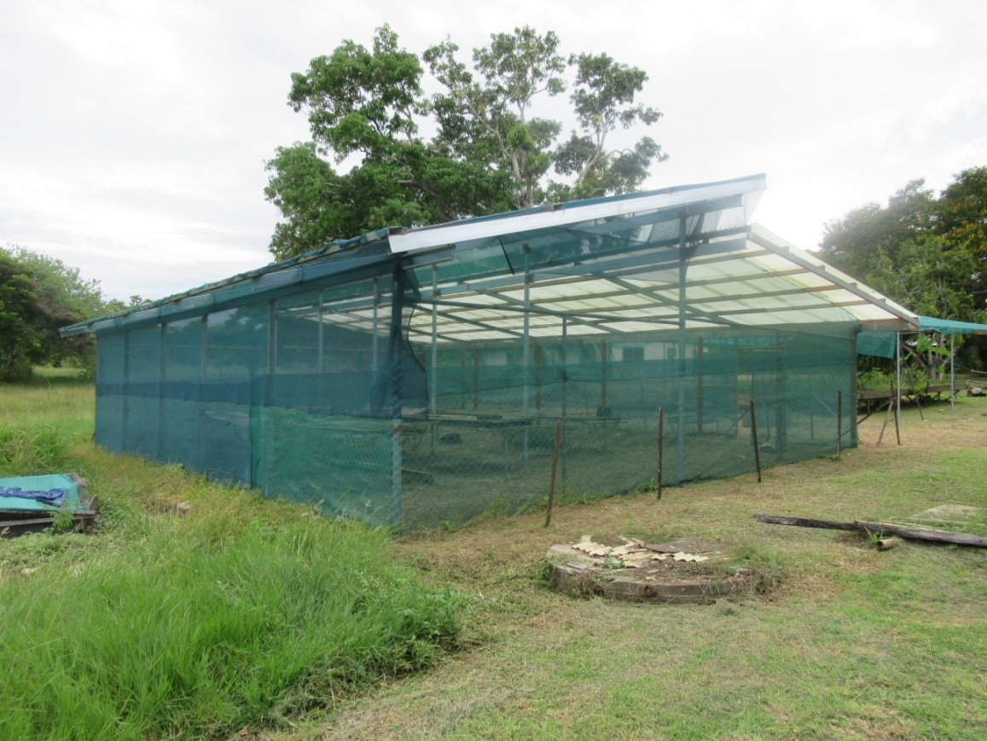

Figure 01. EUCCR Funded Nursery/Green house at SRC Laloki.

- Conclusion
The project initiation and implementation of different planned activities at the different sites varies according to their priorities and availability of staff time. We only address the top three most priorities as prioritied by the farmers during the needs assessment.
We change our approached to make large community gardens at Kibuli in Western Province and Kitikaini in Gulf Province has improved the community participation and also helped us conducted trainings and demonstration at the same time.
The EU-NARI Project sign boards was placed at the strategic locations at the different pilot sites for clear visibility for the general public.
There were great interest and participants of both gender and youth in this project. The communications with PDAL and other partners and lead farmers has improved very much and we continue for further discussions with PDAL, District CEO and other partners further activities implementation including the finalisation and signing of the MOUs for the respective Pilot and Outreach sites.

