NARI Technical Report

Study Title | Validation of the Storage Sand Sprouting (SSS) Method for Sweet potato tuber storage during drought/frost conditions in PNG
Name of project under which study was undertaken | European Union Climate Change Resilience (EUCCR) Project
Project Number | A1022-2
Principal and Co-Investigators | Tai Kui, Jonah Anton and Gena Kawale
Location(s) the study was implemented | Aiyura-HRC, Tambul-HHRC and Laloki-SRC
Collaborating organisations (if relevant) | N/A
Date report completed | 04/12/2019

1. Abstract/Summary
Include:
- What is the research problem and why is it important?
- What we did and why?
- What we found, What this means in theory (technical/scientific), Why this is good for in practice (practical outcomes for farmers and for use in outreach activities)
Prolonged dry periods, frost and extreme El Nino events in PNG, resulted in sweet potato (SP) vines scarcity. This affects rural livelihood as SP vines is the only source of planting material leading to hunger, poverty and even death in severely affected communities.
This study was to identify a suitable moisture content range of the local SP root varieties to be stored under an appropriate storage container with storage medium that can prolong its shelf life for sprouting in normal season for vines generation. The SP varieties used were K9 and SI85 for Laloki (lowland dry site), Waghi Besta and Sinatop Goroka used at the Aiyiura (Mid highlands) site and the Tambul (High highlands) site used the Korowest and Taro Kaukau. The Beauregard was the control variety across the three sites. The roots of these SP varieties were cured after harvest and stored in storage container bucket, sack bag and cardboard with storage medium sawdust, fire ash and dry river sand. The experiment was carried out in house in a split-split plot design (3 SP varieties x 3 storage containers x 3 storage medium). After 14 weeks of storage the root sprouts (both sprouted and sprouts initiated roots) were counted against the rotten roots. Results showed SP varieties were influenced on the storage shelf life of roots across all sites (P<0.001). Similar statistical differences (P<0.001) was also observed across all sites on the storage medium influencing the survival percentage of sprouted roots. However, the storage containers did not have an effect at all sites (P>0.05). The sand medium and SP variety Beauregard was observed as the best combination for retaining the highest average percentage in sprout roots across all sites. Ash was notably observed to be moderately higher in sprout percentage as an alternate storage option. There were other site specific medium and SP varieties observed to improve the roots storage shelf life. Those were the storage medium sawdust with SP variety Taro Kaukau for Tambul site, Waghi Besta for Aiyura site and the SP variety SI85 for Laloki. The sand medium had the most promising result in increasing sprout percentage across all varieties despite having varietal difference. Apart from storage medium and varietal effects the storage temperature greatly influenced the storage shelf life of roots.
Hence the sand storage sprouting used in Africa can be a post and during drought/frost coping tool for clean sweet potato vines generation at household level for SP production rehabilitation throughout PNG using available resources.

2. Introduction
- state subject area of interest,
- provide review of relevant literature,
- state purpose/hypothesis of study,
- state how you approached the problem

Sweet potato (Ipomoea batatas) contributes approximately 60-70% of food energy of staple food crops produced and consumed in Papua New Guinea (Bourke and Vlassak (2004). Its dominance amongst the staple crops stems for its adaptability to be grown at sea levels of more than 2, 000 meters; its relative ease of cultivation and suitability is distinct as a reliable food crop for animals (Glaz 2017). The crop is currently traded in long-distance value-chains due to high demand in urban areas. It is an important source of income for many households in the Highland provinces.
SP planting materials are either obtained from vine cuttings or from storage roots. Most of the SP farmers in PNG traditionally source vines from the previous harvest as planting materials for prepared fields (Bourke and Vlassak, 2004). However, prolonged dry periods and frost events become detrimental for planting materials such as the SP vines become scarce for food gardens (IOM, 2015). Furthermore, planting material is often infested with pest and diseases such as Scab (Elsinoe batatas), Gallmite (Eriophyes gastrotrichus), viruses and sweet potato weevil (Cylas formicarius) (ADB, 2009). This affects the vines and leaves prior to planting (Mutandwa and Gadzirayi, 2007).
Farmers are known to shift SP cultivation to swamp areas during drought to preserve cultivars however inevitably open to pest and disease build-up (Kokoa, 2000). The perennial practice and use of irrigation is scares among farmers particularly to conserve, preserve and multiply planting material. There is seemly no established multiplication and supply centers apart from NARI that are able to provide bulk planting material during prolonged dry periods. Even so, NARI centers are inadequate in maintaining supply at a larger volume and are the only source of germplasm in the country. For example, after the 2015/16 drought events NARI’s Highlands Regional Centre in Aiyura spent more than K50, 000.00 (DFAT funded) to build an active water supply system for irrigation, land preparation and multiplied clean SP vines, Cassava cuttings, corn seeds, and rice seeds for distribution to affected locations in the highlands (NARI Aiyura financial records, personal communication ).Furthermore, this prompted further collaborative efforts by Government and NGO partners to distribute planting materials. This also indicated the need for seed storage facilitation and irrigation techniques to be lacking among farmers during long dry periods during distribution.
Similar situations are seen in African countries where storage of planting materials are a crucial part of preserving important tuber cultivars like SP where dry spells are more prevalent (Namada et al., 2013) The developments of storage systems is a universal challenge and vital to farming systems during and after dry spells particularly in developing countries.This concept of storage was made known in the development of simple practical systems in Africa during very dry seasons. The idea was further developed into a system commonly known as the Storage, Sand, Sprouts (SSS) system (Namada et al., 2013). There has been extensive work done in Africa particularly in preserving and multiplying SP planting materials using the SSS (Kawame Ogero, et al, 2015). The system uses a sand filled container to provide favorable environmental conditions for roots storage prolongation.

The study focused on developing and evaluating the SSS system using locally (PNG) available storage mediums, storage containers using SP varieties in three different agro-ecological zones. The SSS system aims to potentially show the sprouting efficiency after long term storage and identify the best storage medium for root tuber SP varieties.

3. Materials and Methods
- Describe where,
- what and how you did your study

3.1 Trial Site
The study was conducted at three NARI centers representing three of the major agro-ecological zones in PNG (Table 1)
Table 1: Descriptions of the three trial sites representing different agro-ecological environment in PNG.
Site | Agro-ecological zone | Altitude (m.a.s.l) | Average annual rainfall (mm) | Temperature (annual average in °C)
 |  |  |  | Min | Max | Average
SRC Laloki¹ | Dry-lowlands | 40 | 167 | 23 | 32 | 27
HRC Aiyura² | Highlands | 1700 | 2200 | 11 | 22 | 16
HHRC Tambul³ | High-altitude Highlands | 2200 | 2500 | 6 | 20 | 13
¹Southern Regional Centre, ²Mid Highlands Regional Centre and ³Higher Highlands Regional Centre

3.2 Materials

Three sweet potato (SP) varieties were selected for each trial site. Two out of these varieties were the locally preferred varieties and the third variety was Beauregard (introduced variety) that grows well across different altitudes. The storage media and containers were sourced from locally available materials. Table 2 shows information on the SP varieties and storage materials used.

Table 2: Information on the sweet potato varieties and storage materials used
Variety name | Site | Root features | Roots average DM content (%)
 |  |  | At harvest | After curing | After Storage
K9 | SRC Laloki | Proximal end narrow, distal end broad shape, pink skin colour and white flesh colour | 37 | 38 | NA
SI 85 | SRC Laloki | Proximal end narrow, distal end broad shape, white skin colour and white flesh colour | 23.7 | 26 | NA
Beauregard | SRC Laloki | Oval to rectangular shape, light red skin colour with orange flesh. | 28.7 | 30 | NA
Waghi Besta-Minj 2 | HRC Aiyura | Fusiform to elongate shape, light yellow skin colour and yellow orange flesh | 32.7 | 35 | 34
Sinato Goroka | HRC Aiyura | Proximal end narrow, distal end broad shape, white skin colour and white yellow flesh colour | 30 | 33 | 32
Beauregard | HRC Aiyura | Oval to rectangular shape, light red skin colour with orange flesh. | 20.6 | 21 | 19
Taro Kaukau | HHRC Tambul | Proximal end narrow, distal end broad shape, hard brown color skin | 28 | 30 | NA
Koro West | HHRC Tambul | Fusiform to elongate shape, red skin colour and white yellow flesh | 29 | 34 | NA
Beauregard | HHRC Tambul | Oval to rectangular shape, light red skin colour with orange flesh. | 18 | 25 | NA
Storage materials | Description | Other features
Sand | Dried river sand | (6 to <1mm)
Sawdust | Sawmill and joinery waste | From wood
Ash | Local household Kitchen ash | White wood ash (6 to <1mm )
Cardboard | Maggi Noodles curtain box | 17805.4cm³ volume (L28.5 x W 24.5 x H25.5 )
Bucket | Plastic buckets ( figure 1) | Medium (refer to figure 2)
Sack bag | Chemica empty sack | Small (refer to figure 2)

Generation of sweetpotato roots for the trial:

The required SP roots used in this study were produced locally at each of the sites using the common site specific SP cultivation system. The SP varieties planted covered a total land area of 800m² (20 m x 40 m). Aiyura and Laloki used the small mounding (0.8 m x 0.8m) system while Tambul site planted using the large Engan mounding system (2m x 2m). Maturity of selected SP varieties varied accordingly to its specific agro ecological zone time. Laloki sites took four months; Aiyura took 5 and half months while Tambul site SP reached maturity at 8 and half months. At harvest, roots with weight ranging from 200 to 400 grams were selected for the study. In the case of Sinato Goroka (at the HRC Aiyura site) not enough roots within the required range were generated hence some partly broken tubers were included for storage. All selected root sample weights of the three SP varieties were recorded at harvest and then brought to the in-house storage areas for curing (air drying). The roots were cured in-house in light penetrated area on the floor for five days. The Laloki site storage building was not fully enclosed as the Aiyura and Tambul site, as it was exposed to full day light at very high temperature.
Roots sample weight, moisture content and dry matter content data at harvest and after curing were collected. For moisture content and dry matter calculations the root samples were weighed using a bench scale to get fresh weight and then sliced and air or oven dried to get dry weight. The dry weight and fresh weight were then used in the below equations for moisture and dry matter content calculation.

Equation (1) Moisture content (%) =$\frac{Freshwt-drywt}{FreshWt}x100$
Equation (2) Dry matter (%) =$\frac{Freshwt}{dryWt}x100$

The roots dry matter determinations were done at harvest and after curing specifically to observe any effects the SP root dry matter content had on storage shelf life. After deriving the moisture content and dry matter for sample root at harvest, the rest of the roots were taken in-house in to a light penetrated room for curing. The total experimental roots were then spread on the floor for five days, another set of roots were processed for dry matter and moisture content following the same procedure as what done at harvest. This covered a sample for each of the 27 treatments replicated 3 times given a total of 81 roots processed after curing.

The graph in figure 1 below shows the roots initial moisture at harvest. This gives the baseline information of the roots moisture content and dry matter content used in the study. Hence it was not included in the results section.

Figure 1 Moisture content of sweetpotato varieties at trial sites: (A) Aiyura; (B) Tambul; (C) Laloki

The derived dry matter data showed roots increased dry matter content at least by 3 percent after curing. This was done to heal root wounds and strengthen the roots skin and to avoid post harvest disease and minimize respiration for longer storage shelf life.
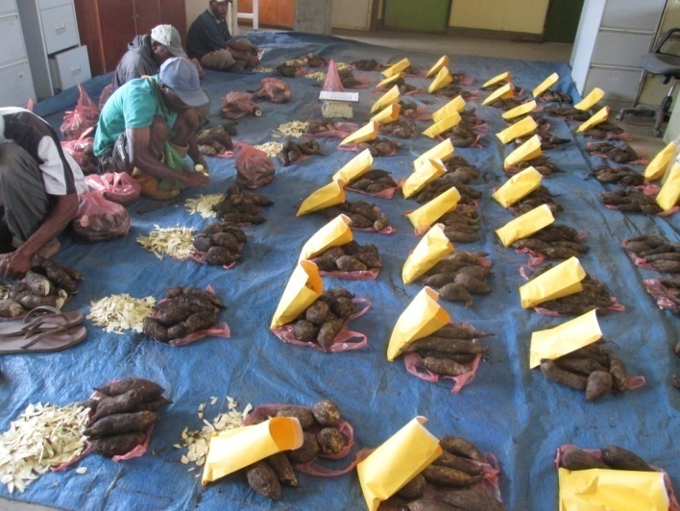

Picture 1: Heaps of cured roots and a sample processed for moisture content determination before being allocated to the different storage mediums for storage

After 14 weeks, the root dry matter and moisture content was assessed and determined for Aiyura site only. Laloki and Tambul were unable to capture that data. The Aiyura site stored root dry mater shows at least 2 percentage reduction after the storage duration.

Experimental set-up
The number of roots placed into its specific treatment (table 3) after curing depended on the number of available tubers of the standardized weight range (200 – 400g). Laloki site had more experimental weight range roots that allowed it to select 7 tubers while the other two sites selected 5 tubers each per treatment for storage. These 5 and 7 tubers total per treatment x 27 treatments x 3 replicates gave a total of 567 for Laloki and 405 roots for the two highlands sites each.

Table 3: Treatments used for the study
Split- Split Plot Design |  |  | Treatments
Main Treatments (3 storage containers) | Sub Treatment  (3 storage medium) | Sub-Sub Treatment (3 SP varieties) | Name | Initial | No
Cardboard | Sand | Variety1 | Card board Sand SPv₁ | Csav₁ | 1
 |  | Variety2 | Card board Sand SPv₂ | Csav₂ | 2
 |  | Variety3 | Card board Sand SPv₃ | Csav₃ | 3
 | Ash | Variety1 | Card board Ash SPv₁ | Casv₁ | 4
 |  | Variety2 | Card board Ash SPv₂ | Casv₂ | 5
 |  | Variety3 | Card board Ash SPv₃ | Casv₃ | 6
 | Saw dust | Variety1 | Card board S/dust SPv₁ | Csdv₁ | 7
 |  | Variety2 | Card board S/dust SPv₂ | Csdv₂ | 8
 |  | Variety3 | Card board S/dust SPv₃ | Csdv₃ | 9
Bucket | Sand | Variety1 | Bucket Sand SPv₁ | Bsav₁ | 10
 |  | Variety2 | Bucket Sand SPv₂ | Bsav₂ | 11
 |  | Variety3 | Bucket Sand SPv₃ | Bsav₃ | 12
 | Ash | Variety1 | Bucket Ash SPv₁ | Basv₁ | 13
 |  | Variety2 | Bucket Ash SPv₂ | Basv₂ | 14
 |  | Variety3 | Bucket Ash SPv₃ | Basv₃ | 15
 | Saw dust | Variety1 | Bucket S/dust SPv₁ | Bsdv₁ | 16
 |  | Variety2 | Bucket S/dust SPv₂ | Bsdv₂ | 17
 |  | Variety3 | Bucket S/dust SPv₃ | Bsdv₃ | 18
Sack bag | Sand | Variety1 | Sack bag SPv₁ | Ssav₁ | 19
 |  | Variety2 | Sack bag SPv₂ | Ssav₂ | 20
 |  | Variety3 | Sack bag SPv₃ | Ssav₃ | 21
 | Ash | Variety1 | Sack bag SPv₁ | Sasv₁ | 22
 |  | Variety2 | Sack bag SPv₂ | Sasv₂ | 23
 |  | Variety3 | Sack bag SPv₃ | Sasv₃ | 24
 | Saw dust | Variety1 | Sack bag SPv₁ | Ssdv₁ | 25
 |  | Variety2 | Sack bag SPv₂ | Ssdv₂ | 26
 |  | Variety3 | Sack bag SPv₃ | Ssdv₃ | 27

These roots were then put into its respective storage containers and medium accordingly to the 27 treatments and replicated 3 times given a total 81 data set. The storage containers (empty sack, cardboard and bucket) were bored an inch hole using 1 inch drill bit and nail for ventilation. After that the empty sack was fold to a uniform height (picture 2) as the bucket with their approximate volume ($v=πr^{2}h=3.14x14x24)$of 14248cm³ and cardboard filled to volume of 14256cm³. With that rough standardized volume the mediums (dried ash, sawdust and river sand) were put at the base up to 15 centimeters and then SP roots were planted vertically into each of the respective mediums according to the treatments and finally add the remaining medium to the rim of the estimated standardized volume. This process continued until all the 81 data set filled with its respective SP variety root, storage container filled with mediums accordingly to the experiment design.
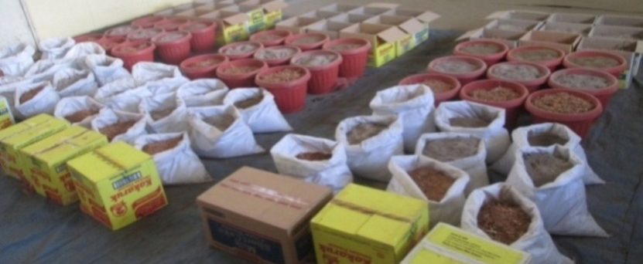

Picture 2: Storage containers and media with cured roots allocated at NARI HRC Aiyura

The experiment design used was the split split plot design that covered the three storage containers as the main factors (bucket, cardboard and empty sack) and the three storage mediums (wood ash, sand and sawdust) as sub plot and the three SP varieties (refer to table) as sub sub plot (3x3x3). These accumulated to 27 treatments (Table 1) that were replicated three times given a total of 81 observations. The installation of the 81 observation was done straight after 5 days of curing and was left untouched for 14 weeks (3 and half months). After 4-8 weeks of storage the sweet potato weevils were observed migrating out of the sand medium. The installed treatments were not disturbed or even watered until the end of the 14 week storage period.

Data collection and data analysis

At the final 14 weeks of storage, tuber roots were excavated out of the sand, sawdust and ash medium from their respective containers and data collated for analysis. The roots after excavation were observed and categorized in the following conditions:
- rotten and/or defected roots
- sprouted roots up to 10 centimeters height
- sprouts initiated roots
- non sprouted good roots
The sprouted and non sprouted good roots were categorized under one as sprouts counts because all of them were later planted a day to two after excavations in moisten media and all produced sprouts. The sprouts of these roots (both sprouted and non sprouted good roots) reached planting height after 3 to 7 weeks.
The sprouts counts covered the sprouted roots, sprouts initiated roots and non sprouted good roots against the rotten and/or defected roots (Picture 3) after 14 week storage
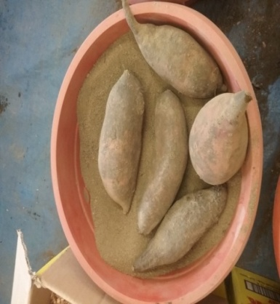
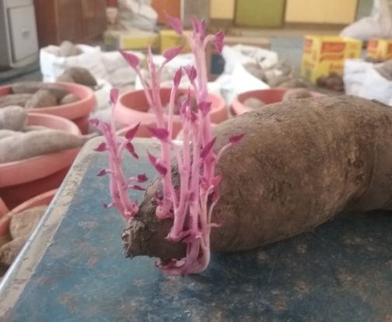
Picture 3. Shows the sprouts excavated after 14 day sprouts of which some sprouted and some did not. Those that did not sprout were good tuber roots which sprouted immediately in moisten media.

Those roots were counted out of the total roots per treatment (refer to table 3) for the 27 treatments replicated 3 times given a total of 81 data set. The sprout roots were later divided over the total roots stored per treatment and multiplied by 100% to get the percentage sprouts survival rate. These converted sprouts percentage data were then analyzed using GenStat version 14 (VSN International Ltd 2011) under the general ANOVA using split split plot design and the output is described below in the results section.

The sprouts after data collection were then raised in the nursery and watered for vines generation (Picture 4). It took an average of 4-7 weeks for all the roots to sprout vines reaching more than 30 centimeters for planting. The vine growth lengths were variety and media dependent and a root can produce an average four 30 cm vines for planting (Picture 4).
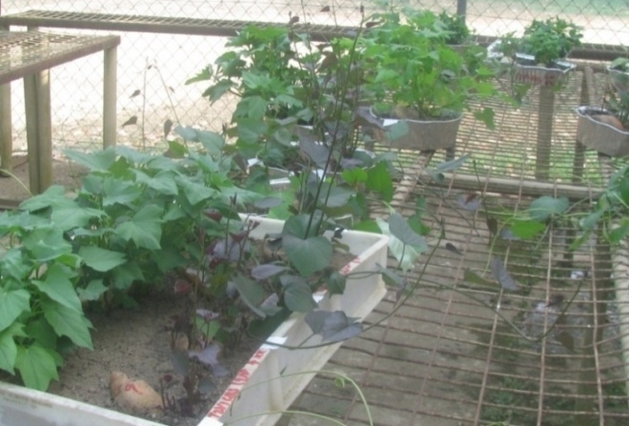
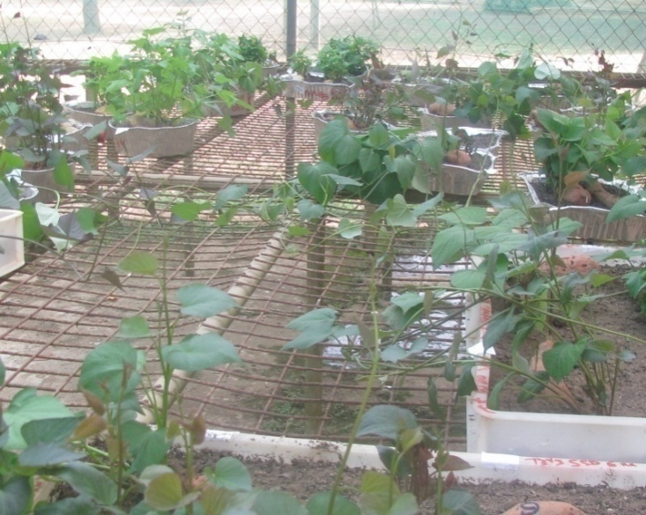
Picture 4: Shows the sprouts rose in the nursery after storage for vines generation
There were no statistical analysis done on the on the number of vines generated.

4. Results
The results should include key information only and, if large amounts of data are needed to demonstrate a point, graphs and tables should be used. The results should include statistical analysis of results.
- tell readers what you found
- results to be explained rather than presenting a series of unexplained statistics and graphs that lack a narrative
- texts should be concise and objective

4.1 Aiyura site results
From observation the Sinato Goroka variety roots that were bruised and partly broken roots prior to storage were partly or completely rotten. Furthermore the elongated shaped with soft outer skin roots of some Waghi Besta and Sinato Goroka varieties got shrunk at either end of the root and were easily vulnerable to rooting. Non bruised and/or broken storage roots with uniform sphere to oval shaped roots survived well across all treatments. Out of the varieties observed, Beauregard sprouted the most roots followed by Waghi Besta. There were no significant differences in sprouting success between storage containers (P>0.05) conversely different between mediums of sand sprouting at 60% to 100% for all varieties.The sprouting success on the storage mediums were also highly significant (P<0.001).Notably, roots stored under sand retained sprouts on an average of 82, 76 and 75 % for the three containers used. While ash and sawdust resulted in sprouting rates of on average 51 to 58 % (Table 2). There were also significant (P<0.001) differences between sweet potato varieties after 14 weeks of tuber storage with Beauregard having the highest sprouting rate across all mediums with an average of 98%, followed by Waghi Besta with 59% and 36% for Sinato Goroka roots. The table 4 below shows the detail results of Aiyura site SP varieties sprouts rates after 14 days storage.

Table 4: Aiyura site 14 weeks post storage results on % success sprouts rate
 |  | Storage and Medium (%)
Containers (C) |  | Bucket |  |  | Cardboard |  |  | Sack bag
Medium (M) |  | Ash | Sand | S/dust | Ash | Sand | S/dust | Ash | Sand | S/dust | Mean (V)
Waghi Besta |  | 40 | 87 | 60 | 53 | 67 | 67 | 47 | 73 | 40 | 59.3
Sinato Goroka |  | 27 | 60 | 27 | 27 | 60 | 13.3 | 33 | 60 | 20 | 36.4
Beauregard |  | 100 | 100 | 100 | 100 | 100 | 100 | 93 | 93 | 100 | 98.4
Mean (M) |  | 55.6 | 82.33 | 62.33 | 60 | 75.66 | 60 | 57.66 | 75.33 | 53.33
 | LSD | F pr. | CV (%) | SEM
(C) | 6.39 | N/S | 4.4 | 2.3
(M) | 5.5 | ** |  | 2.53
(V) | 6.2 | ** |  | 3.05
(C*M) | 9.03 | N/S | 8.3 | 4.26
(C*V) | 9.94 | N/S |  | 4.89
(M*V) | 10 | ** |  | 5.01
(C*M  *V) | 17.3 | N/S | 17.3 | 8.61
Note: V = Variety; S = Storage containers; M = Storage medium; S/Dust = Sawdust; ** = Significant at P<0.001; * = significant at . 0.05; N/S = Non-Significant. SEM=Standard errors of differences of means.

The storage container(C), storage container with SP variety (C*V) and storage medium (C*M) interactions were not different (P>0.05). The same was observed between the containers, medium and SP variety interactions (P>0.05).

4.2 Tambul Site results
Tambul sites showed similar results to Aiyura with the storage medium and SP variety having differences in sprouting success (P<0.001). All treatments showed a minimum of 47% sprouting; sand came out as the best however other mediums indicated to have reasonable outcomes. The sand, sawdust and ash retained on average at 80 – 100 % sprouts. Beauregard was the best variety followed by Taro Kaukau and Korowest across container and its mediums (P<0.001). Beauregard had highest sprouts (98 %) followed by Taro kaukau (95 %) and then Korowest (67 %) . There were no significant interactions between containers, mediums and varieties (Table 5).

Table 5 showing good sprouted tubers counts results for Tambul site

 | Storage and Medium (%)
Containers (C) | Bucket |  |  |  | Cardboard |  |  |  |  |  | Sack bag
Medium (M) | Ash | Sand | S/dust |  | Ash |  | Sand |  | S/dust |  | Ash | Sand |  | S/dust | Mean (V)
Taro Kaukau | 73 | 100 | 100 |  | 93 |  | 100 |  | 93 |  | 100 | 93 |  | 100 | 94.7
Koro West | 73 | 100 | 80 |  | 53 |  | 53 |  | 80 |  | 47 | 47 |  | 73 | 67.3
Beauregard | 93 | 100 | 100 |  | 100 |  | 93 |  | 100 |  | 100 | 100 |  | 93 | 97.6
Mean (M) | 79.7 | 100 | 93.3 |  | 82 |  | 82 |  | 91 |  | 82 | 80 |  | 86
LSD | F pr. CV (%) |  | SEM
(C) 8.9 | N/S 4.5 3.2
(M) 5.4 | ** 2.5
(V) 6.9 | ** 3.4
(C*M) 10.3 N/S 6.1 4.8
(C*V) 11.9 N/S 5.8
(M*V) 11 N/S 5.4
(C*M*V) 19.3 N/S 14.6 9.6
Note: V = Variety; S = Storage containers; M = Storage medium; S/Dust = Sawdust; ** = Significant at P<0.001; * = significant at . 0.05; N/S = Non-Significant. SEM=Standard errors of differences of means.
Storage container and its interactions with storage medium and SP variety had no significant different (P>0.05).

4.3 Laloki site results
The Laloki site had lower root sprouts compared to the two highland sites. The sand storage medium and Beauregard had the best sprouting percentage. This site also showed similar results from the mediums and variety interactions as well (P<0.001). Sand retained on average 73, 67 and 55% good tubers under bucket, cardboard and sack bag storage respectively. Ash medium retained 45, 42 and 29% sprout roots while the least retained medium was sawdust with 32, 21 and 9% sprout roots stored under all containers. Beauregard retained 56% sprout roots followed by variety SI85 with 33% and variety K9 had the lowest of 30%. The storage container and variety were not significantly different in the interactions for this site (P> 0.05). Sprout roots stored under sack bag storage container with ash and sawdust medium were the lowest compared to the other two containers (bucket and cardboard). The table 6 below describes the results in detail.

Table 6 Sprouting percentage (%) rate for Laloki site

 | Storage and Medium (%)
Containers (C) | Bucket |  |  | Cardboard |  |  |  |  |  |  |  |  | Sack bag
Medium (M) | Ash | Sand | S/dust | Ash |  |  | Sand |  |  | S/dust |  |  | Ash |  | Sand |  |  | S/dust |  | Mean (V)
SI 85 | 33 | 60 | 14 | 34 |  |  | 60 |  |  | 19 |  |  | 24 |  | 49.3 |  |  | 4.7 |  | 33
K9 | 33.3 | 54 | 19 | 33.4 |  |  | 62 |  |  | 9.3 |  |  | 19 |  | 44 |  |  | 0 |  | 30
Beauregard | 55.3 | 77.3 | 64 | 57 |  |  | 78.3 |  |  | 34 |  |  | 45 |  | 71 |  |  | 21 |  | 56
Mean (M) | 44.7 | 73 | 32 | 42 |  |  | 67 |  |  | 21 |  |  | 29 |  | 55 |  |  | 9
LSD | F pr. CV (%) |  | SEM
(C) 16 | N/S 12.2 5.52
(M) 6.2 | ** 2.94
(V) 7.5 | ** 3.4
(C*M) 16.4 N/S 15.7 6.9
(C*V) 12.6 N/S 7.4
(M*V) 11.2 N/S 5.7
(C*M*V) 19.9 N/S 31.9 |  |  | 10.9
Note: V = Variety; S = Storage containers; M = Storage medium; S/Dust = Sawdust; ** = Significant at P<0.001; * = significant at . 0.05; N/S = Non-Significant. SEM=Standard errors of differences of means.

Apart from that the container medium(C*M), medium variety (M*V) with container medium variety interactions (C*M*V) were no different (P>0.05).

5. Discussion
- Interpret the results in light of the questions or hypothesis raised in the introduction.
- results should not be repeated by explained in wider contexts
- might also outline how your results differ from, or extend, other published finding
Don’t discuss the results site by site – you would have a lot of repetition

The agro-ecological zone temperature had greatly influenced the storage shelf life of SP tuber roots. The cooler (min6C° - max18C°) sites in the higher highlands retained higher percentage sprout roots followed by the mid highlands (11C° - 22C°) Aiyura site. Less number of sprouts was observed for the hotter (22C° - 30C°) lowland site. This result supports reports that SP roots stored optimal temperature range for best storage is at the temperature of 13C° - 15C° (Edmunds et al., 2018; Cantwell, 2002 and Ray and Ravi, 2005). Tambul site fits well into this temperature range (13C° - 15C°) having higher percentage (80 to 100%) SP sprouts followed by Aiyura site temperature covering the lower limit of this temperature range. Laloki site was outside this range which would have influenced a lower percentage of 10 to 72% root sprouting. The physical properties of each storage mediums were also considerable factors in the storage temperature. Sand had larger particle size (6 mm to <1mm particle size) which might have provided better vent channels and could have created an independent modified atmosphere from within the storage matrix. This could have increased ventilation to an optimum level. That could have balanced off the respired heat released from the stored roots which may or may have not provided a favorable storage temperature and CO₂ levels by reducing root respiration at a steady slow phase. Thus, the results for sand as a storage medium had significantly higher sprout rates across all sites despite agro-ecological temperature differences or varietal variation effects on root storage. Similar findings assessed sand to be the best storage medium for prolonged roots shelf life (Steward et al., 2000; Putri et al., 2016). Interestingly observed from sand medium was the evacuation of SP weevils out of stored roots in sand after three weeks.
Ash retained moderate sprouts and was the best least after sand across all sites. Moreover, the ash medium reflected clearly that the genetic traits of the varieties and environmental factors had an effect on the shelf life of SP varieties roots. Hence, the Laloki dry coastal site retained sprout roots between 30 to 42%, followed by the mid highlands Aiyura site with 68% sprout roots and 80% sprout roots in the higher highlands Tambul site. This clearly shows that the ash micro pores (<0.1mm particle size) might have minimized ventilation resulted in temperature and CO₂ level build up that might resulted high respiration rate that reduces roots shelf life (Oirschot et, al. 2007).
Sawdust was seen as the best medium that retained higher percentage sprout roots for the higher highlands site but the worst medium for the hot coastal site. The results indicated the fibrous sawdust cellulose might have adsorbed the respired heat of the roots which became an advantage for roots in the high altitude cold areas; conversely excessive for stored roots in the lowland coastal areas. In fact, sawdust is known to be an excellent heat insulator and is commonly used in building walls (Ismail et al., 2014). The dense cold air in higher altitudes is known to get absorbed by the sawdust insulation retaining but conversely raises storage temperature in coastal conditions.
The roots genetic composition was another key factor affecting the storage shelf life of roots. Respiration rate seems to be closely related to root moisture content. This is supported with findings stating that sweet potato roots having 58 to 78% moisture content exhibited low respiratory rates (<0.5mg of CO₂ per g of dry roots per hr) and prolong roots storage life; whereas >75% moisture level, the respiration rates increased up to 2 mg of CO2 per g of dry roots per hr (Hirose et al., 1984).The moisture content of SP varieties roots used significantly (<0.001) affected the storage life of roots. All moisture content of SP varieties ranged from 62 to 80% recommended range for better storage (Hirose et al., 1984). However, wounded roots from surface abrasion (soft skin), partly broken or infested by weevils were vulnerable. This also confirms recent studies showing respiration rates to increase 1.4 to 2.0 times greater in wounded roots than non-wounded roots (Sanket et al., 2019). Moreover, the moisture content loses was high in soft skin roots at high temperatures which could have been reduced through proper curing of roots. Since no significant difference (P>0.05) were detected in the three storage containers, cardboard and buckets were good for protecting rodent damage on stored roots.
Generally, results showed that storage medium sand and Beauregard roots were the best combination across all three agro ecological zones (Lowland costal dry areas, mid highlands and higher highlands wet areas) retaining higher sprouting percentage after 14 weeks. Similar work to this study found the lowest respiration rate for stored roots under an extended period using Beauregard (Steward et al., 2000). The sand used as a storage medium created a modified atmosphere conducive for any local variety roots across the three study sites. The results were comparable in high percentage sprouts despite being the low storage shelf life varieties (Van Oirschot et al., 2007). For example the three low land site varieties under sand medium retained from 50 to 95% sprouts, for the mid highlands varieties retained 60 to 100% and the higher highlands varieties retained 53 to 100% sprouts. This can be concluded that sand medium stored under any of the local SP varieties roots moisture content range from 60 to 80% can retain 50 to 100% sprouts. Sawdust was the best medium for the higher highlands (2200 + masl) retaining higher percentage sprouts than sand and could be a good option for storing roots during dry/frost periods to generate successive sprouting generations. However the medium sawdust was not the option for the lowlands hot areas. The storage medium ash retained moderate sprouting percentage for the best varieties but not for varieties with less of a shelf life. Temperature greatly influenced the sprouting of roots and/or shelf life.

6. Conclusion
The storage temperature, the storage roots varietal genetic factors and the storage medium physical properties were the important factors that influenced the storage roots shelf life. The SP roots can be stored for up to 14 weeks and roots will sprout to produce planting material. SP varieties with higher moisture content, strong outer skin, no abrasions and bruises had lower respiration rates that prolonged root storage shelf life. Sand used as storage medium showed to be the better medium for all site and sawdust was the best for the higher highlands. Roots can be stored in any storage container however for rodent damage, buckets and cardboard can be considered as alternatives. Local SP varieties with root moisture content of 60 to 80% can be stored up to 14 weeks.
Roots stored under modified atmospheric condition in hot areas can prolong roots storage shelf life.

7. Acknowledgement
Acknowledge contributions of collaborators, colleagues, funding sources, technical assistance etc.
The team would like thank the Heavenly Father for making possible the following people for their vital contributions toward the successful completion of this small study:
- The people of EU for the funding aid that made it possible to complete this small study
- The three NARI Centers ( Tambul, Aiyura and Laloki) management and staff that involved one way or the other in implementing the project
- The study supervisor Dr Birte Komolong for the supervision
- Dr Michael Dom for the technical input on the study design, data arrangement and data analysis and other colleagues for reviewing the paper.
- The NARI senior management and Research and Publication committee team for approving this very small study.

8. References
- Abian P. E., Kazembe J., Atuna R. A., Amagloh F.K., Asare K., Dery E. K. and Carey E. E. (2016). Sand Storage, Extending the Shelf-Life of Fresh Sweetpotato Roots for Home Consumption and Market. Journal of Food Science and Engineering 6. 227-236
- Asian Development Bank (2009).The Economics of Climate Change in Southeast Asia: A Regional Review.
- Bourke, R.M. and Vlassak, V. (2004). Estimates of Food Crop Production in PapuaNew Guinea. Land Management Group, The Australian National University, Canberra.
- Cantwell, M. & Suslow, T. 2001. Sweet potato: recommendations for maintaining postharvest quality.http://postharvest.ucdavis.edu/Commodity_Resources/Fact_Sheets/Datastores/Vegetables_English/?uid=34&ds=799
- Dandago, M.A. and 2Gungula, D.T. (2011). Effects of various storage methods on the quality and nutritional composition of sweet potato (Ipomea batatas L.) in Yola Nigeria. International Food Research Journal 18: 271-27
- Ebregt, E., P.C. Struik, B. Odongo and P.E. Abidin, 2007. Piecemeal versus one-time harvesting of sweet potato in north-eastern Uganda with special reference to pest damage. NJAS-Wageningen J. Life Sci., 55: 75-92.
- Edmunds, B., Boyette, M., Clark, C., Ferrin, D., Smith, T. & Holmes, G. 2008. Postharvest handling of sweetpotatoes. North Carolina State University https://plantpathology.ces.ncsu.edu/wp-content/uploads/2013/12/sweetpotatoes_postharvest-1.pdf?fwd=no
- Glatz P., (Ed.) 2017, Local feed resources for pigs, poultry and fish production in Papua New Guinea, ACIAR MN.195, Canberra ACT. https://Aciar.gov.au/files/mn195_web.pdf
- Hirose, S., Data, E.S., and Quevedo, M.A. 1984. Changes in respiration and ethylene production in cassava roots in relation to post-harvest deterioration, p. 83. In: I. Utirani and E. D. Reyes (eds.). Tropical Root Crops: Postharvest Physiology and Processing. Japan Scientific Societies Press, Tokyo.
- International Organization for Migration or IOM, Preparedness and Response, PNG Drought (2015).
- José G. Garzon1 and Michael D. Boyette (2016) “Modeling Respiration Rate of Five Varieties of Sweetpotato (Ipomoea batatas (L) Lam) at Different Temperature Ranges by Applying the Mass Balance Principle”. Department of Biological and Agricultural Engineering, North Carolina State University, Raleigh, NC 27695
- Ismail, Mardiani, Desy Lismayani, Fauzi,(2014) Sawdust for Thermal Insulation Building, Proceedings of the 2nd International Conference on Natural and Environmental Sciences (ICONES) September 9-11, 2014, Banda Aceh, Indonesia ISSN 2407-2389
- Kwame Ogero, Christine Bukania and Margaret McEwan (2015). Third Consultation: The Business Case for Sweetpotato Seed Multiplication, Hotel Villa Portofino, Kigali Rwanda.
- Kokoa, P. 2001. Review of sweetpotato diseases in PNG. In ‘Food security for Papua New Guinea. MutandwaE, and Gadzirayi CT (2007). Comparative assessment of indigenous methods of sweet potato preservation among smallholder farmers: Case of grass, ash and soil based approaches in Zimbabwe. African Studies Quarterly 9, no. 3: [online] URL:
- Namanda.S , R. Amour & R. W. Gibson (2013) The Triple S Method of Producing Sweet Potato Planting Material for Areas in Africa with Long Dry Seasons, Journal of Crop Improvement, 27:1, 67-84, DOI: 10.1080/15427528.2012.727376
- Putri Ernawati Abidin, John Kazembe, Richard A. Atuna3, Francis Kwaku Amagloh3, Kwabena Asare1, EricKuuna Dery and Edward Ewing Carey (2016) Sand Storage, Extending the Shelf-Life of Fresh Sweetpotato Roots for Home Consumption and Market Sales Journal of Food Science and Engineering 6 (2016) 227-236 doi: 10.17265/2159-5828/2016.04.005
- Ramanatha Rao and Michael Hermann, editors (2001). Conservation and Utilization of Sweetpotato Genetic
- Ray, R.C. & Ravi, V. 2005. Post harvest spoilage of sweet potato in tropics and control measures. Critical Reviews in Food Science and Nutrition 45, 623–644.
- Sugri I., Maalekuu B. K., Kusi F. and Gaveh E. (2017). Quality and Shelf-life of Sweet Potato as Influenced by Storage and Postharvest Treatments. Academic Journals Inc. 1.10.
- van Oirschot Q., Ngendello T., Rwiza E., Amour R., Tomlins K., Rees, D. & Westby A. 2007. The potential for storage of fresh sweet potato under tropical conditions: evaluation of physiological changes and quality aspects. In: Proceedings of 13th Symposium of the International Society for Tropical Root Crops, 9-15 November, Arusha, Tanzania.
- VSN International Ltd 2002, GenStat Release 14.1(PC/Windows 7)

