Surveys - ACP EU Training in Practical Research Skills

Prepared by Dave Askin
May 2011

Introduction 1
Survey data to Spreadsheet 1
Coding for Disaster Assessment/Survey (with some extra questions for instruction) 1
SPSS – key steps for a very basic analysis without Statistics 2
Question Type – Yes or No. 2
Question Type – Allows many responses eg More than one reason for growing Yam? 3
Extra Analysis Tasks? 6

Introduction
These are introductory notes to survey data and analysis. There is much more to surveys than this document covers. You will realise we do not delve into the important area of biometrics and survey analysis. Here we create some key tables that will help us understand important features relating to our results.
Please read these notes after you have read Trevor’s notes. This set of notes take you through a range of question types and how you enter data in Excel, then use it in SPSS.

Survey data to Spreadsheet
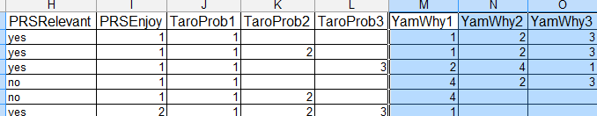

- Enter data into a blank Excel worksheet. Keep the data set simple. Use One word headings in the first row. Nothing added below your data. If you want to add explanations etc – use a separate worksheet, not the one with data. This is the same advice for Genstat. Keep data sheets very plain and simple.
- Missing DATA? Leave the cell blank. SPSS is good at handling missing values. Sometimes of course a blank means the farmer did not respond to that question for some good reason.
- Coding for each option is much more flexible than it used to be. Please refer to example spreadsheet. You are allowed to use words, not just numbers.
- Data are entered in columns directly from the questionnaires. A code list can use many columns. Sometimes what you thought was one question requires more than one column.
- Each row represents the data from one questionnaire.
- Suggest entering all data from the first questionnaire, then the second etc.
- The data entry process starts very slow, then quickly speeds up.
- A – ‘how to use Excel suggestion’ - Use ‘Freeze Panes’ (look in ‘Window’ on menu bar) so that the row being worked on can be adjacent to the Column heading. This makes it easier to check that data are being entered in the correct columns. Ask if this isn’t clear.
- Once all data are entered, the spreadsheet can be transferred to SPSS for analysis.

Coding for Disaster Assessment/Survey (with some extra questions for instruction)
In the past SPSS needed a lot of numbers, with no text. Things are simpler now, but there are still times when you must code answers. See below for how we might handle various questions.

Question | Column Title | Notes
Respondent number | Respondent | Number the questionnaires from 1 to whatever. Ie the first person in the stack of questionnaires is number 1 in column A and the second is 2 in column A, row three – allowing for first row to be labels. OR enter people’s real names.
Name of main assessor | MainAssessorFN | Tiata
 | MainAssessorSN | Sileye
Other assessors- enter in other columns if wish.
Date of Assessment is recorded as month and year in two columns, but you could also record date if you wish. (Unlikely to be used in analysis) | Month
 | Year
Province |  | Just write in the Abbreviation.
District |  | As above or whole name.
LLG – Whatever makes sense. |  | As above or whole name, always be consistent.
Why does the farmer grow yam? | YamReason1 for first column,  YamReason2 for second column  Etc up to four columns for four reasons. | There are four reasons farmers often quote, and some farmers grow yams for one, while others grow yams for all of the four reasons.  See below for spreadsheet showing this.  The reasons will be coded from 1 to 4 with one being perhaps – cash income etc.
Do you grow yam |  | Yes or No, or 1 for yes, 2 for no.
View spreadsheet to see how this works.

SPSS – key steps for a very basic analysis without Statistics
Double click on SPSS icon/Start SPSS – (These notes are based on SPSS ver 17.0).
Open a pre-prepared spreadsheet. You might have to hunt on your hard drive for that- and double click when you have found it. Note SPSS thinks you want a .sav file and you must tell it that your file type is spreadsheet.
Make sure it is pointed towards the correct worksheet. It may import data from the wrong worksheet.
Make sure data in the worksheet that SPSS starts looking at has one row of headings for each column, then data. If you have two words in the heading, SPSS automatically deletes the space between words. Main Assessor becomes MainAssessor. That should not be a problem. There will be a limit to how many c’ters are possible- keep headings as short as you can.
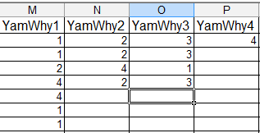
The screenshot on the right shows one small part of how the data may look. One row of headings, data beneath. (Sometimes words may be used in data and that will be explained soon).

Question Type – Yes or No.
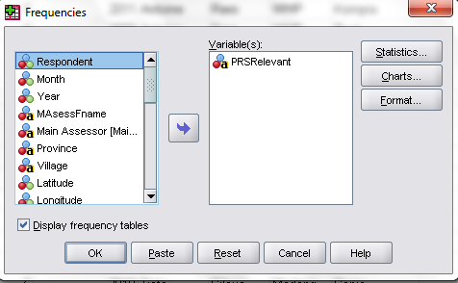
This (below) is the result of having a column in the spreadsheet titled PRSRelevant (one word) and data beneath was either yes or no. You don’t need to code this as 1=Yes or 2 = No. You can enter yes or no.
So we gain a result as shown below, when we analyse that column (PRSRelevant) in SPSS by clicking Analyse→Descriptive Stats → Frequencies. We make sure we have clicked on the blue arrow (It’s the arrow in the box to right of this text) to bring the variable of interest over, and we click ok. The result is shown below.

 | When we entered our survey results into a column in a spreadsheet with either yes or no, the result of the analysis is shown to the left.
  PRSRelevant
   |  | Frequency | Percent | Valid Percent | Cumulative Percent
  Valid | no | 9 | 40.9 | 40.9 | 40.9
  Valid | yes | 13 | 59.1 | 59.1 | 100.0
  Valid | Total | 22 | 100.0 | 100.0

Question Type – Allows many responses eg more than one reason for growing Yam?
How do we manage the following situation? Farmers can choose as many reasons as they like for growing yams. Let’s keep it a little simple. There are four reasons for growing yam. Farmers tick up to four of these. The first screen shot shows how the data look in excel.
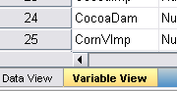
Note we don’t write the reasons. We write a number which is linked to each reason.
Please note that in this case, you must code each reason so a number carries the meaning. Note the first row is carrying the column (variable) headings, in one word only- kept as short as possible, but trying to carry meaning. We provide YamWhy1, YamWhy2 up to YamWhy4 as in one case, one farmer had four reasons for growing yams. Get this! If there are 6 reasons for growing yams, but nowhere in the survey results does any farmer ever indicated more than two of these 6 reasons, then you only need two columns for reasons for growing yams. BUT if just one farmer wants to have you record all 6 reasons, you will need 6 columns to allow that farmer to have her records recorded.
In our instance, one farmer had four reasons for growing yams. Later we can tell SPSS what reasons 1-4 are.

Now in SPSS Go to Variable View it is at bottom left hand of screen. This is where we will enter labels for the variables.

Now in the appropriate Row, click near value ‘none’ – actually to the right where the little dots are. Enter labels. 1= Food Security and 2 is for Income etc.
Click add for each one.
That has provided a label for YamWhy1 and the same labels are needed for the next three variables. You can use copy and paste to enter the same information in the next three rows. You DO NOT have to type all those labels for each of the columns from YamWhy1 through to YamWhy4.

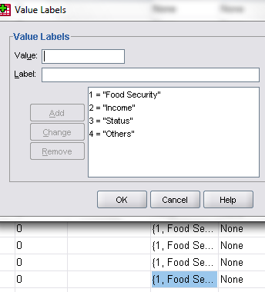 | 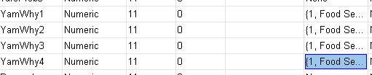

So – what have we got? We have a question that allows a respondent to choose up to four of the options provided. In this instance they have up to four reasons for growing yam. We now want to analyse all four columns in one set.

Now you are ready to define the multiple sets. Choose Analyse → Define Multiple Response Sets.
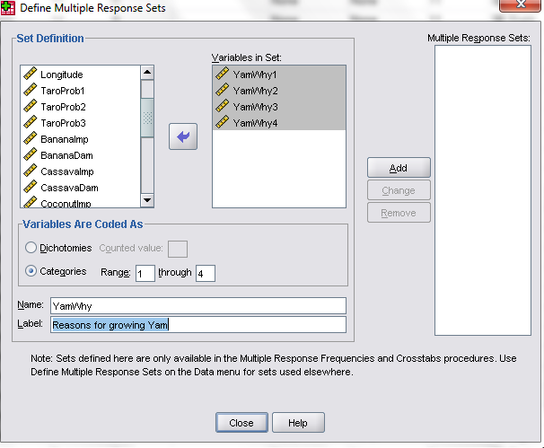
Refer below. You must set categories and range is 1 through to 4 as we allowed 4 options in our reasons for growing yam.

And put the 4 yam responses into a new set- by clicking on the add button. This new set will be analysed next.
Click close. Now to analyse this new multiple response set.

Click on Analyse → Multiple response → Frequencies.
You will need to bring the set across into the right hand side by using the blue arrow.
The result may look like this. 77% of farmers grow yam because of food security, 68% because of income and 91 % like the status yam growing provides. Almost 10% gave other reasons for growing yam.

$YamWhy Frequencies
 |  | Responses |  | Percent of Cases
 |  | N | Percent | Percent of Cases
Reasons for growing Yamª | Food Security | 17 | 31.5% | 77.3%
Reasons for growing Yamª | Income | 15 | 27.8% | 68.2%
Reasons for growing Yamª | Status | 20 | 37.0% | 90.9%
Reasons for growing Yamª | Others | 2 | 3.7% | 9.1%
Total |  | 54 | 100.0% | 245.5%
a. Group

In a report don’t use this raw table from SPSS. Consider something like that shown below. You need a title that clearly states what the data show, and headings. Beware of data that looks like 77.63 that should be rounded to 78.

Table 1 Percentage of farmers who grow yam for the following reasons.
Reason for growing yam | Percentage of farmers
Food Security | 77
Income | 68
Status | 91
Others | 9

Presenting data, arguing a case- these are skills that take some time. Seek help with →
- your analysis
- and your interpretation,
- then your presentation…

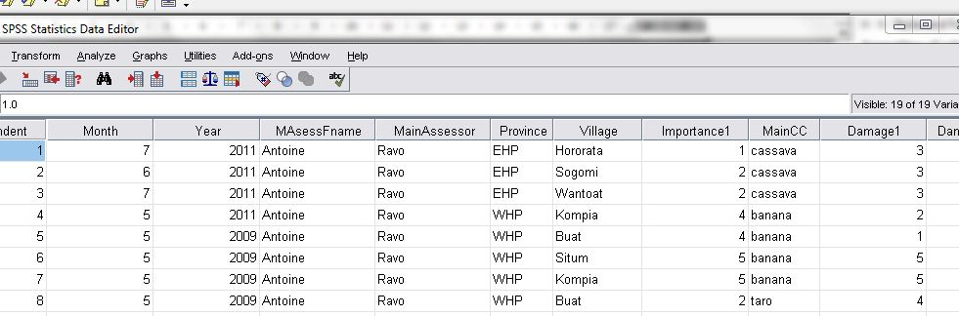

Our next analysis wants to look at damage to crops by crop type for each province where assessment has been done. The damage in this instance is a straight score – from 0 (no damage) to 4 (extreme damage).
Now click in SPSS on Analyse → Reports → Case Summaries to obtain data analysis as shown below. Please note you need to bring across into the variables table the items needed – try as shown below, then add options as you wish. You can have more than one value in variables.
BUT if left to preset settings in SPSS, you will get counts, not means. So click on Statistics – see right hand box below- and set it up so that you get mean, not counts as it wants to provide. You can get both- and initially that is a good idea.
Beware – you need to untick the box ‘Display cases’ as there is presently no need for that information.
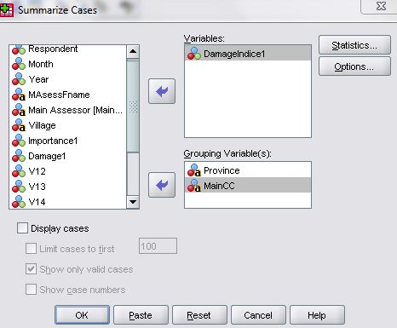 | 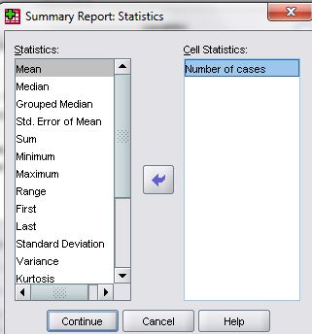

Click ok, or continue. You should get the data below, which can be copied into a word document and you can modify. I have reduced the number of decimal places in the data. There is bound to be a way to achieve that automatically.
Cyclone Assessment - Province by key crop damage
Province | Main Cash CropCC | Mean | N
EHP | cassava | 5.00 | 3
EHP | kumalu | 3.00 | 1
EHP | Total | 4.50 | 4
Madang | banana | 6.00 | 1
Madang | cassava | 20.00 | 1
Madang | kumalu | 6.83 | 6
Madang | taro | 5.50 | 2
Madang | yam | 6.50 | 2
Madang | Total | 7.58 | 12
WHP | banana | 15.50 | 4
WHP | taro | 8.50 | 2
WHP | Total | 13.17 | 6
Total | banana | 13.6 | 5
Total | cassava | 8.8 | 4
Total | kumalu | 6.3 | 7
Total | taro | 7.0 | 4
Total | yam | 6.5 | 2
Total | Total | 8.6 | 22

(This paragraph tells you who to achieve this look – of a table or picture alongside the words-
If you create a Table with just one cell in it, you can put pictures into that one cell, and close up the space on the right hand side – you will be able to push the table into the text and achieve a wrap of table in text. See to right for the effect. It is achieved by selecting the top left hand corner, outside the table and getting the little cross to appear. Ask for someone to help with this feature.)

Do some hand calculations to make sure you are confident the data analysis is correct.

Extra Analysis Tasks?
That got you started. Now into your report there are bound to be other analyses of interest. Take another look at the data!3

With acknowledgements to Trevor Wilson who got me started in SPSS and provided our initial notes, which you have as a printout. Since his notes were printed, there have been considerable improvements in SPSS and this document works with SPSS ver 17.0.

