A new, old way of thinking about Melanesian gardens.
Dave Askin, August 2019.
Why does much of our discussion around gardens disappoint me?! Wow. That’s a pretty big statement… Here goes… I hope you find these thoughts worth pondering. I’ve been developing them ever since I arrived in New Guinea (West Papua) in 1988. I got challenged to write about them when someone said – your ideas are really simple Dave. I took that as a compliment. Simple just might be sustainable.
So… When we are on the land, growing things our focus is often about the present and one crop. Onions. Potatoes. Kaukau. Brocoli. Rice, or coffee, cacao…
Each of these crops is important and worthwhile… BUT and here’s the bit that disappoints. We focus on the crop – just that crop… instead of looking in (at least) four related and important directions.
Firstly integration. Where is the Melanesian complexity – livestock, trees, regeneration, crops, water sources, forest – nut, timber, fruit, hunting…? Our researchers see themselves as crop breeders, or livestock specialists... We don’t encourage people to cross the boundaries and engage in system thinking. Let alone the challenge of research or even farmer demonstration of systems that are integrated. We talk about it. We don’t practice it. Our village farmers practice integration – but they get precious little in the context of system from us as researchers. They get lots of value about onions and cacao and coffee and taro and rice – but mostly in a one crop, one time framework. So let’s be willing to think and act with integration and wonderful Melanesian complexity.
Secondly – Time. Past, present and future. I believe encouraging village level discussion around what the village looked like when the elders were young, what it looks like now, and what the village want it to look like in the future… is a worthwhile discussion.
The future leads into many areas – forest, soil erosion, livestock, crops, water etc. It might lead to a discussion of crop rotation (however you think of that, my thinking is in the context of sustainability and fallow/rest). I am passionate about improving fallow land management. It sickens me to see weeds seeding and grasses predominating, when we know with little work we can do, so much better.
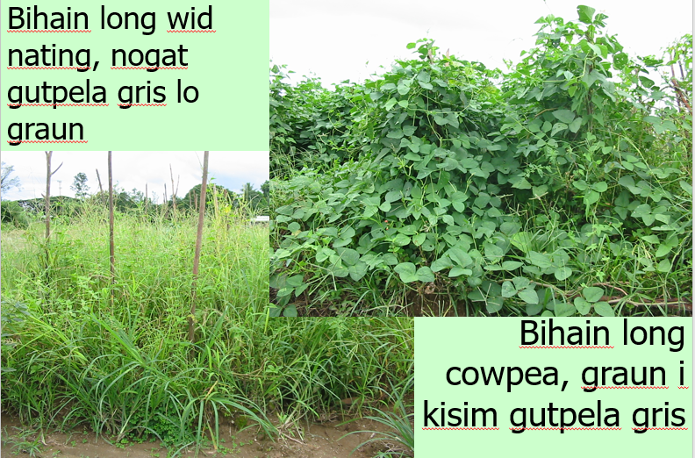
A simple farmer level trial – fallow with and without green manure legumes.

Thirdly – and this is really, wonderfully, Melanesian.
Community. Village if you will.
That mutual ownership of land is very important in PNG. I learned that during rioting in 1995, wondering if gun fire at UniTech was coming down towards my family in East Taraka. You know that community ownership of resources is at the heart of village life – past, present and future. You see that individual plot of corn or aibika or Taro is ‘mine’, ‘my families’ and that’s simple. But the village land – all around – that requires serious commitment and leadership. The very best of community is really challenging. We must consider time and space. Time -now, and tomorrow – not just tomorrow but the tomorrows of our children and grandchildren. Planning our resource use and protection and management.
Might I take you to a concept that was described years ago as the Tragedy of the Commons? I shared this concept with students studying Ecology at UniTech back around 1995… The Village Common in ancient Europe was a place where villagers put their livestock. If as a member of that village community I put 5 more sheep into the common – I got ALL the benefit of growing those stock. But the damage to grass and productivity caused by over-grazing? Everyone took the pain of over-grazing and destruction of natural resources. Can anyone see the parallel to PNG village land-use?
Finally I would like to finish with what I’m calling space. Our broader village landscape. Please allow me to throw words that will make pictures in your mind. Mountain, rivers, springs, garden land at higher altitude, and lower areas with warmer temperatures… challenged by soil erosion, pig grazing. Room for fruit and nuts. Do we think enough of where the springs come from and are they protected or polluted? Forest resources? Housing. Toilets. Waste. Long term cash crops… Coffee, Cacao, cocnuts… How do we plan and manage all of this?
For me this is a call to be the very best of Melanesia. Perhaps a call to go back to earlier times when leaders controlled resources for the benefit of all. They took a long term view of resource management – of water shed management, without talking in western ways. A call to be the very best communities we can be. A call for church leaders to lead in broad ways, not just a Sunday or Sabbath leadership… but a whole of life leadership.
This week I took one tiny step towards putting my thoughts into action. I’ve established a trial of corn that is EITHER just left to die and weeds to grow OR… the maturing corn will grow beans up the stalks and cover the land in nitrogen fixing plants that will produce leaf tips and young seeds for my meals as well as shading and diminishing problem nut grass. We’ll allow those beans to mature – chop the whole lot down and grow another crop of corn… testing fertility changes. A tiny step towards thinking from the perspective of time and regeneration.
So, in this short ‘kirapim tingting’ I’ve described the heart of watershed management. The opportunities and the challenges. Have I? What do you wish to add or disagree with? Looking forward to your comments.
Thank you for listening and commenting. I love a discussion. Debates are even better!

