Annex I

ACC Action Coordination Committee
ACP Africa, Caribbean and Pacific
ADB Asian Development Bank
AIT Action Implementation Team
ARD Agriculture Research for Development
BOKU University of BOKU, Austria
CBO Community Based Organisation
CC Climate Change
CCDA Climate Change Development Authority
CEPA Conservation and Environment Protection Authority
DFAT Department of Foreign Affairs and Trade (Australia)
EU European Union
FAO Food and Agriculture Organisation
GIS Geographical Information Systems
GO Government Organisations
GoPNG Government of PNG
HHRC High Altitude Highlands Regional Centre
HQ Head Quarters
HRC Highlands Regional Centre
ICT Information & Communications Technology
IRC Islands Regional Centre
LF Learning Facilitators
LLG Local Level Government
M&E Monitoring and Evaluation
MOA Memorandum of Agreement
MRC Momase Regional Centre
NARI National Agricultural Research Institute
NGO Non-Government Organisation
PNG Papua New Guinea
R&D Research and Development
SATRC Sir Alkan Tololo Research Centre
SRC Southern Regional Centre
UPNG University of Papua New Guinea
WiADF Women in Agriculture Development Foundation

1.The action

Description of the action

Description (max 13 pages)

1.1.1.1 Introduction
Papua New Guinea is one of the countries that have been more strongly affected by the El Niño phenomenon in the Pacific region. The prolonged dry spell experienced by PNG started in April 2015 and lasted for about 10 months and created food insecurity for more than 2.7 million people.
The impact of the drought on water supply and agriculture (water shortages and loss of agricultural produce in 2015 but also serious consequences in terms of lack of harvest in 2016) was felt throughout the whole of 2016 as well. In March 2016 the World Food program estimated that about 1,473,000 people were still affected at that time with 180,000 requiring food aid. The consequences of the prolonged dry spell have already had a clear impact in the harvest of 2016 and contributed to the increase in food prices. This adds to the challenges of limited competition, high dependency on imports including food imports, infrastructure challenges and constraints in the value chains, and human capacity constraints.
PNG is one of the 77 countries classified as Low Income and Food Deficit Country by the Food and Agriculture Organisation (FAO). This is based on the increasing food imports as well as per capita dietary energy supply. PNG's demand for food is increasingly being serviced by imports. Imported rice and wheat have become substitutes of traditional staple foods and are now part of a Papua New Guinean’s daily diet. This may contribute to increasing food insecurity and may affect nutritional security, given the volatility of international commodity prices. Also to be monitored is the expansion

Although the impact of the El Niño phenomenon in 2015 has been particularly severe, PNG is not new to droughts, which tend to be cyclic phenomena. During the 1997 drought, for instance, low water availability and frosts were experienced. Some 1.2 million rural villagers suffered a severe, and in some cases fatal, food shortage. Climate change predictions for the region suggest that prolonged variations from the normal rainfall may continue and at a higher frequency, which can be devastating to agriculture and lead to chronic food crisis.

Addressing the challenges of food security by taking into account current and future changes in climate will therefore be critical to reducing poverty and food insecurity. It is worth noting that climate change impacts on food security will not be uniform throughout PNG because of differences in the expected climate change among highlands and coastal areas, topography, production systems and economic bases. Therefore, the uniqueness of each target area must be at the fore of any action implemented to safeguard food security. In terms of specific adaptation measures, lessons learnt from previously experienced drought phenomena include the need for PNG to focus on win-win measures, such as switching to drought-resistant crop varieties, improving climate information dissemination systems and farm level management, strengthening the enforcement of fisheries and forestry legislation and governance and promoting agricultural diversification.
Lessons learned from a previous project implemented by NARI (EU funded "2009-2010 Global Programme on Agricultural Research for Development (ARD)"), from NGOs and community based organisations are that Communities have indigenous coping mechanisms but with population increase and severity of extreme weather events, this is not sufficient to ensure food security. Government services too do not have the capacity and resources to adequately respond to some of the targeted neglected areas. Lack of knowledge and awareness on improved coping mechanisms, improved technologies and strategies to make systems more resilient to climate induced stresses is also a major issue.
This Action will target smallholder communities as well organizations from public and civil society with particular focus on women groups that provide agricultural and rural advisory services with the aim to strengthen adaptive capacities in agricultural development and ultimately contribute to increased food security and resilience. The area of intervention will be in the rural areas of PNG. A lot of attention by the PNG Government and donors during and after the 2015/16 El Niño induced drought was directed towards assisting communities in the Highland Provinces (Southern, Western, Eastern Highlands, Simbu, Enga provinces). However, there were many more areas in the country severely affected but with smaller population sizes spread over larger areas and those districts received less support. Therefore, the focus of this project will be on 16 – 24 LLGs in Districts listed as severely affected and in disaster categories 4 and 5 by the PNG National Disaster Centre and not located in any of the main Highland Provinces. Table 1 shows an overview of the target sites, location and population size as per last census in 2011. Figure 1 and 2 show the target districts and LLGs, respectively.
Table 1. Overview of target districts and LLGs, current population size
Region* | Province | District Name | District Pop | LLG Name | LLG Pop | Mode of Accessibility | Type of site (tentative)
Mo | Madang | Raicoast | 83,218 | Rai Coast Rural (Tep Tep) | 9,421 | Airstrip | Outreach site  (Pilot site)
Mo | Morobe | Kabwum | 43,472 | Selepet | 9,720 | District Airstrip | Pilot site  (Outreach site)
Mo | East Sepik | Wewak | 87,761 | Wewak Rural (Islands, Sepik Is) | 19,783 | Road network | Out-reach site better Pilot
Mo | Madang | Bogia | 493,906 | Almami | 23,605 | Road network | Out-reach site
Mo | Madang | Rai Coast | 83,218 | Astrolabe Bay | 19,417 | Boat Route/  District Airstrip | Pilot site (better Outreach site)
Mo | Morobe | Menyamya | 87,209 | Kome | 31,043 | District Airstrip | Out-reach site (keep it open)
Mo | Morobe | Bulolo | 101,568 | Watut  (Waria) | 17,480 | District Airstrip/Road | Pilot site (Keep it open)
Mo | Morobe | Finschafen | 2,905 | Kotte | 9,942 | District Airstrip/Boat route | Pilot site (keep it open)
NGI | Manus | Manus | 60,485 | Pobuma | 6,077 | Plane | Out-reach site
NGI | West New Britain | Talasea | 18,999 | Bali/Witu Rural | 16,665 | Sea Travel via Hoskins | Out-reach site
So | Central | Rigo | 56,509 | Rigo Central | 15,422 | Road Travel | Out-reach site
So | Central | Goilala | 36,092 | Tapini | 9,233 | Airstrip | Out-reach site
So | Western | Middle Fly | 79,349 | Gogodala | 33,033 | Airstrip | Pilot site
So | Western | South Fly | 59,152 | Oriomo-Bituri | 10,541 | Airstrip | Out-reach site
So | Milne Bay | Samarai-Murua | 58,590 | Louisiade Rural | 23,225 | Airstrip | Out-reach site
So | Milne Bay | Kiriwina-Goodenough | 639,165 | Kiriwina | 36,721 | Airstrip/Boat | Pilot site
So | Milne Bay | Esa’ala | 27,195 | Dobu RLLG | 22,781 | Airstrip/Boat | Out-reach site
So | Gulf | Kerema | 107,231 | Lakekamu-Titikaini | 13,263 | Road | Pilot site
So | Oro | Ijivitari | 186,309 | Afore | 18,535 | Road | Pilot site
So | Oro | Sohe | 86,547 | Kokoda urban | 20,925 | Road | Out-reach site
So | Gulf | Kerema | 107,231 | Kaintiba Rural | 12,955 | Airstrip | Out-reach site
Mo | West Sepik | Telefomin | 48,882 | Telefomin Rural | 11,734 | Airstrip | Pilot site
 |  | Total | 2,554,993 | Total | 391,521
*Mo – Momase Region, NGI – New Guinea Island Region, So – Southern Region

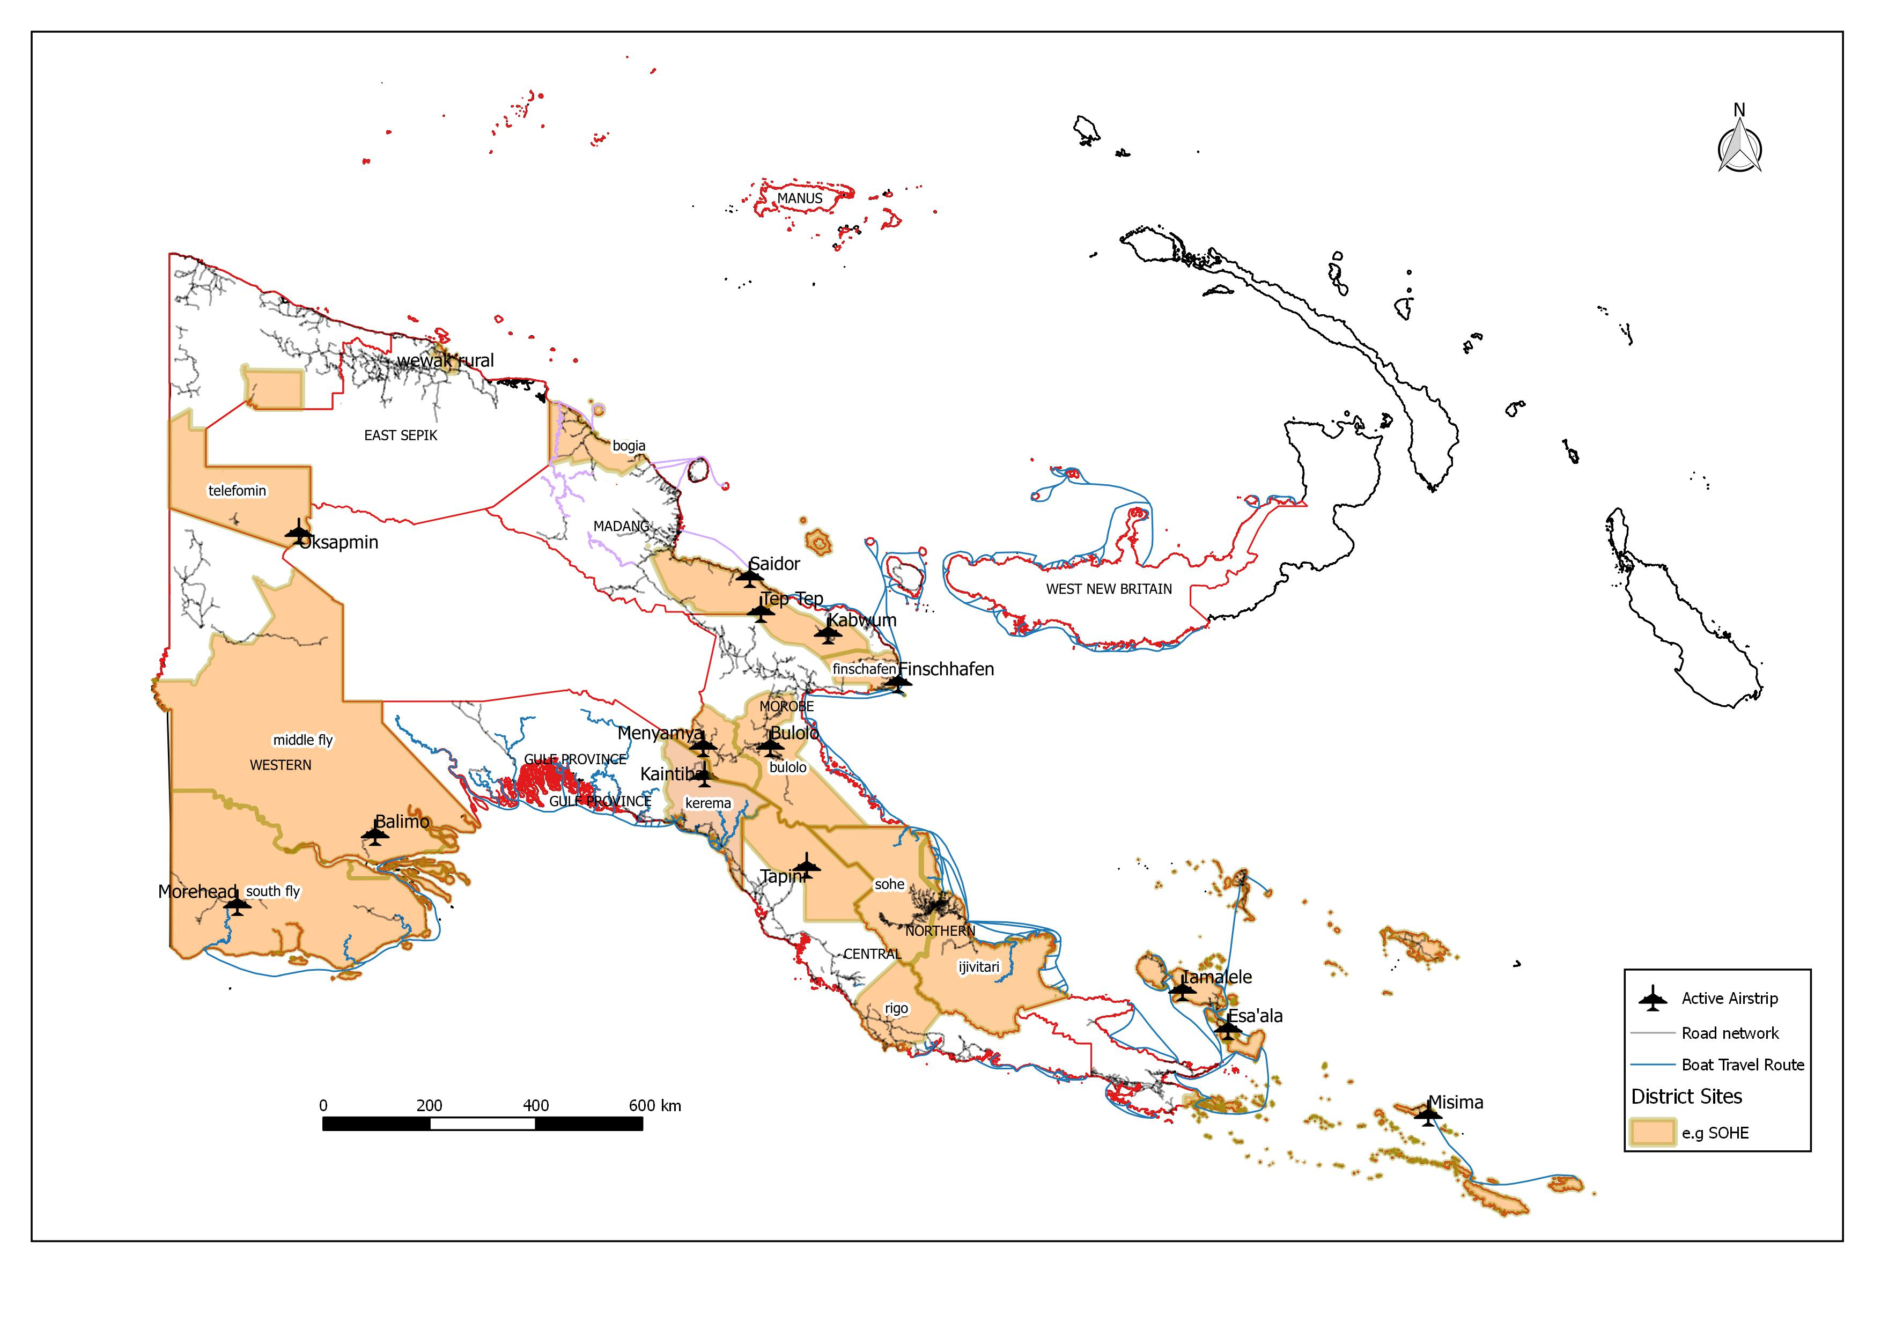

Figure 1. Overview of target Districts
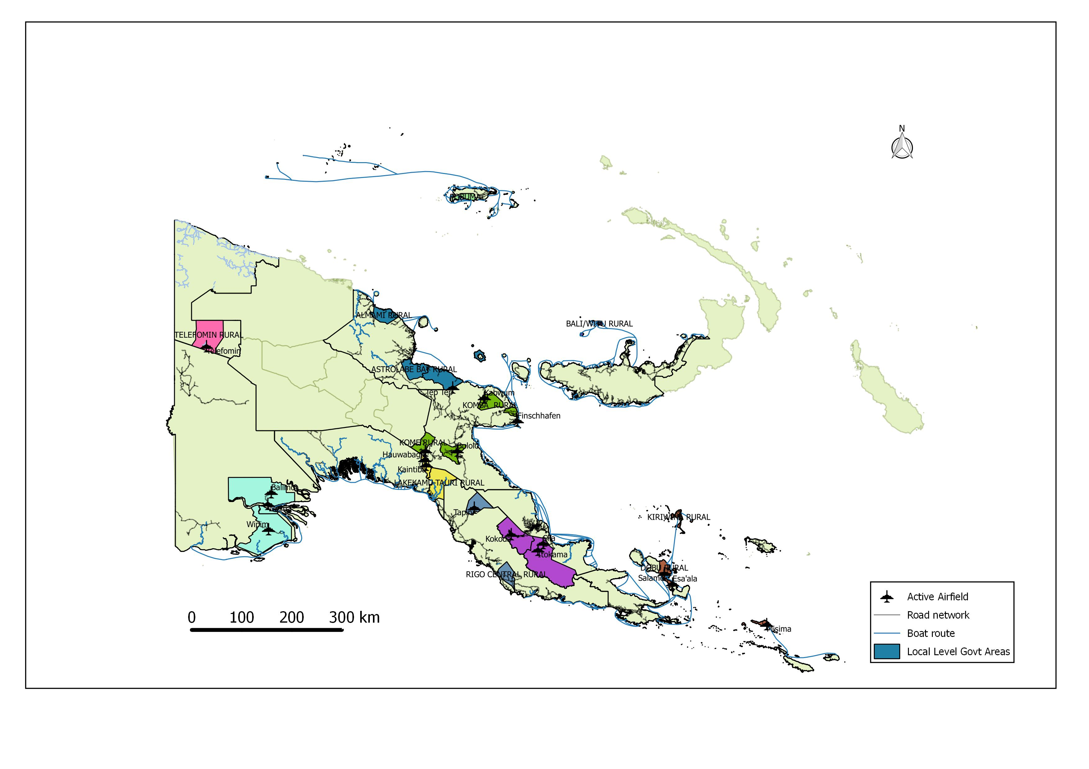

Figure 2. Overview of target LLGs

Overall, it is expected that the Action will be directly benefitting approximately 1000 households in 8-12 pilot sites and 8-12 out-reach sites each, while indirectly up to 20-50,000 households can be reached during the life-time of the project. Considering multiplier effects and further programs from the organisations and local partners participating in the Action after the Action has concluded, up to 500,000 households in target districts will benefit within 5 years after conclusion of the Action.

1.1.1.2 Overall and Specific Objectives of the Action
The overall objective of the Action is:
To contribute to achieving a greater resilience of smallholder farming and rural communities in Papua New Guinea to abiotic stresses arising from seasonal weather patterns, climate change or natural disasters and impacting on their livelihoods

Resilience in this context can be defined as:
The ability of a community to resist, absorb, and recover from the effects of hazards in a timely and efficient manner, preserving or restoring its essential basic structures, functions and identity.

A resilient community is well-placed to manage hazards to minimize their effects and/or to recover quickly from any negative impacts, resulting in a similar or improved state as compared to before the hazard occurred. There are strong linkages between resilience and adaptive capacity; consequently, resilience also varies greatly for different groups within a community.

The specific objective of the Action is:
The adaptive capacity of 16-24 LLGs is strengthened to respond with appropriate agricultural technologies and strategies to abiotic stresses arising from seasonal weather patterns and climate change an impacting on agricultural productivity

For the purpose of the Action, ‘adaptive capacity’ is defined as “The ability of a system to adjust to climate change (including climate variability and extremes), to moderate potential damages, to take advantage of opportunities, or to cope with the consequences” (IPCC 2001).
One of the most important factors shaping the adaptive capacity of individuals, households and communities is their access to and control over natural, human, social, physical, and financial resources. Examples of resources that may be important to adaptive capacity would be:

Human: Knowledge of climate risks, conservation agriculture skills, good health to enable labour
Social: Women’s savings and loans groups, farmer-based organizations
Physical: Irrigation infrastructure, seed and grain storage facilities
Natural: Reliable water source, productive land
Financial: Micro-insurance, diversified income sources
(Handbook on ‘Climate Vulnerability and Capacity Analysis’ by Care International)

The specific objective of the project is aimed at strengthening this adaptive capacity of communities with a particular focus on agricultural adaptation options. The basic assumption which is supported from experiences and information generated in other related climate change adaptation projects by NARI and other organisations in PNG is that there is a lack of awareness, knowledge and appreciation for causes and effects of seasonal and climatic variability on agricultural production and productivity. Severe events such as El Niño causing widespread and severe droughts and the associated La Nina and associated excess rainfalls, destruction of food gardens from floods or landslides have after all been experienced by communities in PNG and the Pacific region for millennia and people have found ways to ‘cope’ with such calamities. ‘Coping’ however, is not the same as ‘adaptation’ as the former is rather short-term and immediate, oriented towards survival, not continuous, motivated by crisis, reactive and prompted by a lack of alternatives. ‘Adaptation’ on the other hand is oriented towards longer term livelihoods security, a continuous process, results are sustained, combines old and new strategies and knowledge and focused on finding alternatives. It should also move away from the mere aim of survival to maintaining a standard of living and improving the quality of life even when faced with climate change associated risks.

Another basic assumption in the project is that the adaptive capacity in most target communities is low although systematic assessments have only been sporadic and localized. Many of the target communities are relatively remote with mostly subsistence-based livelihoods. Planned interventions in the project emphasize on the raising of awareness on climate change and variability, increasing knowledge and skills in using new (i.e. not known by communities before) and improved technologies and practices in agricultural production, planning with communities and local institutions for alternatives to ‘business-as-usual’ and strengthening local institutions to continue supporting climate change adaptation in their communities.

A particular emphasis will be placed to involve women and girls in the activities of the Action. It is increasingly recognized that women may be more vulnerable to climate impacts than men for a variety of reasons among them a lack of secure access to the resources they need for adaptation, less power in decision making in the households or communities, etc. They are however central in providing food and nutritional security in the household and must therefore play a pivotal role especially in agricultural based adaptation initiatives.

It is therefore expected that by the end of the Action as an intermediate outcome, those participating community members, both women and men, adopt innovations (practices, technologies, strategies, concepts) that most respond to their needs and expectations. Local institutions operating in target sites including local NGOs, CBOs, Government agricultural extension services, women or church groups should be by the end of the project in a better position to mainstream climate change adaptation into their own longer term plans. Lasting changes in agricultural production practices, deployment of new technologies, adjustments to seasonal calendars, some re-organisation in the households to incorporate storage of food as the new ‘business-as-usual’, making use of opportunities in diversification of livelihoods should lead towards a greater resilience across different groups in the communities in target areas and beyond.

1.1.1.3 Outputs and Activities
- Output 1: The Action is effectively implemented
For the Action to achieve its specific objective it must be managed in an efficient, cost-effective and accountable manner. Formation of an Action Coordination Committee (ACC), supported by the NARI Action Management and Coordination Units at NARI HQ and NARI Southern Regional Centre (SRC) Laloki and Islands Regional Centre (IRC) Keravat, respectively is a necessary first step. The ACC committee will oversee the Action overall planning, monitoring and budget.
At the commencement of the Action, an Inception Workshop will be held involving representatives from NARI, plus relevant stakeholders and representatives from participating organisations and target sites. The Action will terminate with a Completion workshop at NARI Lae where progress will be evaluated and recommendations given for follow-up actions and policies.

Activity 1.1 Action offices (NARI HQ, IRC, SRC) established, staffed, equipped and managed for action implementation period
Action offices will be located in NARI Head office, NARI Islands Regional Centre Keravat and NARI Southern Regional Centre Laloki. The main office in NARI will be staffed by an Accountant (25% time) and a support Admin person (25% time). Each of the offices will be equipped with the following equipment to facilitate the smooth running of the Action and to ensure that the results are sustained beyond the life of the proposed Action.
- Desktop computer with matching UPS | - Black and white laser printer
- Data back-up (external USB) | - Office table/Workstation/Swivel Chair
- Anti-virus software and firewall protection | - Filing cabinet
For workshop and action implementation purposes, and to ensure that the Action team have the necessary resources to sustain the initiative into the future, they will also be equipped with the following equipment:
- White Board – for training events  - Tablets (mobile data capture during surveys) | - Laptop computers  - Data back-up (external USB)
- Multimedia Projector & Screen | - Digital Camera to record events

The above resources will play a significant part in ensuring that the Action, in terms of Action management and information dissemination and feedback, is effective and beneficial to partners, associates and smallholders, and therefore ultimately to the wider research communities in each area.

Activity 1.2 Action coordination, planning and review
The NARI Action Coordinator (50%) will oversee the day to day implementation of the Action. Effective Action management, planning and reviewing will be conducted by an Action Coordination Committee (ACC). The ACC will have 6 members: the NARI Deputy Director General (Chair person), the NARI Action Coordinator, NARI Program Director, 1x representatives from local organisations (out-reach sites), 1x representatives from pilot sites, WiA (Women in Agriculture) president. The representatives of local partners in out-reach and pilot sites will be rotated on an annual basis to ensure a wider representation of participating local partners in the management and implementation of the Action. It will be responsible for overall management of the Action and resources, and in addition, will set Action policies in relation to gender issues and conflict management. The ACC will meet twice in the first year, once at the start of the year and once towards the end of the year. Thereafter it will meet annually towards the end of each year to review progress and approve budgets and annual action plans for the coming year. The ACC meetings will be rotated at NARI Regional Centres to enable the ACC visits the Action sites for firsthand information and to provide required guidance should there be a need.
Monitoring and Evaluation (M&E) is embedded within this Action. A M&E operational plan will be developed at the beginning of the Action and used to monitor implementation progress and collection of indicator relevant data supporting final assessments at the end of the Action. A final assessment survey at the end of the Action will be conducted to assess achievement level of the specific objective using relevant indicators defined at that level. Regular Action team meetings will assist with monitoring of the Action, address arising issues, aid in the sharing of lessons learnt and present opportunity to review and revise Action implementation plans.

Activity 1.3 Local partner institutions identified for pilot and outreach sites and partnerships established in target sites
NARI will work with and through local partners in the targeted sites to implement the planned activities. During the inception phase, NARI will make assessments in consultation with respective provincial and local district administrations of the local institutional arrangements in the target areas. Locations (Table 1) where already a NGO or CBO or government entity has established programs running on agricultural climate change adaptation, will become out-reach sites and the Action will support the local partner to increase its own capacity to deliver the programs with additional resources and capacity building. Those locally operating organisations need to be confirmed and MOA (Memorandum of Agreements) drawn up that outline roles and responsibilities of NARI and the local partner and the scope of agreed activities and resources allocated.
Locations with little and weak institutional support to assist communities in adapting their agricultural systems to climate change induced stresses will become pilot sites. NARI will develop criteria for selection of a local entity which can be the from government or civil society and build the capacity of this group to assist with the delivery of the agreed site activities and the longer term aim of taking on the role of climate change champion to carry on with the climate change adaptation activities. Already there is a large network of Women groups affiliated with the Women in Agriculture Development Foundation (WiADF), a National Body. Where possible, NARI will select the local WiADF groups as the local partner in the pilot sites. MOA will also be developed for this partnership to enhance understanding of each others roles and responsibilities in implementation of pilot site specific activities.

Activity 1.4 Facilitation of Action inception and Closing meetings
It is envisaged that the Action commences with an inception meeting that brings together representatives from NGOs or CBOs operating in target areas, representatives from provincial and/or district administrations, the NARI project team and representatives from NARI management and other key stakeholders. The inception meeting will inform invited participants on the overall objectives and results of the Action and NARI’s plans for implementation to canvas opinion from the various stakeholders, including farmer spokespersons on the various activities and concerning suitable target community groups for baseline surveys and subsequent out-reach and piloting activities.

The Action will terminate with 2-day Completion workshop with representatives from all participating partner organisations, pilot-and out-reach sites and other key stakeholders including representative from the provincial and national governments. The Workshop will provide opportunity to present achievements, lessons learnt, provide a forum for target community representatives to show-case their success stories and develop recommendations for follow up actions.
- Output 2. Community-driven innovation processes in climate change adaptation are established in pilot communities in 8-12 LLGs and are gender-sensitive
As explained above, pilot communities are defined as sites where there is currently little and weak support available for agriculture based climate change adaptation. It is anticipated that by the end of the Action there will be a local climate change champion among local institutions. This can be a civil society group, NGO or government entity. It is also expected that gender sensitive processes have been established that are supported beyond the Action through provincial or district grants or other local initiatives. In order to support this, the following activities have been identified:

Activity 2.1 Needs and vulnerability assessments in 8-12 pilot sites conducted and priority interventions identified
The sites selected as pilot sites in this Action are geographically wide-spread and located in different agro-ecological zones and different socio-economic settings. However, common to most sites is that their access to services as well as population density is low, thus limiting their livelihood options. There is little knowledge on the vulnerability to climate change and the current adaptive capacity of communities and the local institutional system and flowing from that the needs of the communities as well as their priorities in improving their livelihood system in the face of climate change induced threats. The Action team will initially conduct a desktop study to gather all available information on the selected sites to develop site profiles and identify possible adaptation options. This will be followed by vulnerability and needs assessments building on the participatory approaches used in a previously implemented EU-funded action (EuropAid/128500/C/ACT/Multi) and using other established vulnerability assessment tools (e.g. CRiSTAL – Community-based Risk Screening Tool, Food System Resilience, or Climate Vulnerability and Capacity Analysis from CARE International or Approaches used in pilot studies led by CSIRO under Coral Triangle Initiative). The approaches and methods used will also ensure that women will have adequate opportunity to voice their views and contribute to the assessments. During those assessments in dialogue with community representatives, preliminary priority activities will be identified taking into account both men and women’s choices, and confirmed using the results from the site assessments.

Activity 2.2 Gender-sensitive local Action plans developed by project team and local partners for 8-12 pilot sites based on vulnerability & needs assessments and Community inputs

This activity is closely linked to Activity 2.1. While Activity 2.1 deals with the actual assessments to be conducted in the beginning of the project, it will be necessary to translate the results coming from vulnerability and needs assessments into operational site plans. This needs to be agreed between the NARI Action coordinator and his/her team and the identified local partner(s). It also needs to be ensured that the planned activities are gender-sensitive and take into account the different needs of genders in regards to climate-change adaptation measures.
Activity 2.3 Facilitation of annual feedback meetings in 8-12 pilot communities
In order to maintain the interest of communities in participating actively in planned site activities as well as resolving arising issues or conflicts that have developed, re-confirming priorities etc it is important to convene meetings with communities periodically. Local partners will play an important role to facilitate those meetings and assist the NARI team representatives in conducting the meetings on an annual basis. Based on the feed-back received from the communities, implementation plans will be adjusted or revised.

Activity 2.4 Gender and socio-cultural factors influencing community engagement determined and understood for effective selection of Climate change champions and outscaling of technologies and strategies
Information regarding farmers’ interest and decision making, and the gender, economic, social and cultural dynamics that can influence community engagements will be collected from target communities. This will enable a better understanding of how technologies and strategies can be effectively scaled up for adoption. Survey questionnaires will be designed for this activity and surveys will be conducted in each site by experienced staff from NARI and assisted where possible by staff from local associate organizations.

Activity 2.5 Economic assessments of selected piloted CC adaptation options
An economic assessment will be carried out by an Economist from NARI. The economist will undertake an economic analysis of selected technology options being piloted. He/she will assess agro-economic patterns within target and ultimate beneficiary areas and will provide market analysis and related economic evaluations. Surveys will be conducted by experienced staff from NARI supported by local partner organisations.

- Output 3: Increased adoption of improved strategies and technologies to manage short and long-term climate change risks by pilot communities in 8-12 LLGs
Communities in the 8-12 pilot sites are reliant on their natural environment to sustain their livelihoods. Remoteness, lack of access to services and markets, educational barriers amongst other issues translate into a low capacity in terms of knowledge, skills, access to technologies and support systems amongst communities in most of the target sites. Implementation of site plans developed based on specific needs of each of the communities will result in three fold capacity enhancements. Firstly, local institutional arrangements to support agricultural climate change adaptation will be strengthened. A local partner and their nominated learning facilitators will be equipped with the technical knowledge and skills on availability and use of relevant agricultural adaption technologies, strategies and practice but also enabled to further pass on knowledge and skills using well developed learning resources and act as climate change champion in the community.
Secondly, there will be a direct benefit to participating community members. It is anticipated that at the end of the action the majority of members in the community have participated in at least one of the specific learning activities directed towards improving crops or livestock production, processing and storage options for food crops, water- and soil management options or general climate and weather awareness activities and validated any one of the suggested options as part of their household routine.
Thirdly, there will be benefits towards a wider community based local support system for supply of seed or planting material, a poultry supply unit or emergency water supply systems as examples. Women are in most of the PNG cultures the custodians of plant and livestock resources and responsible for sourcing water for household use. Any improved technologies and access systems will benefit women and girls in the pilot sites in the first place and care will be taken during project implementation that systems are agreed on that allow women to be part of the decision making and management of such common resources.
Assessments and interactions with communities are also likely to reveal gaps in technologies, lack of appropriate practices or other gaps in climate change adaptation of agricultural production systems requiring innovations that need to be developed or adapted during the lifetime of the Action. The following major activities have been identified to support achievement of this output:

Activity 3.1 Building capacity of Local learning Facilitators (LF, from NGOs, CBOs, GOs or Model farmers) to assist in delivery of Action plans in 8-12 pilot sites
Local partners in the pilot sites can be from the District DPI office, a locally operating NGO or CBO, WiA group or keen and progressive model farmers. Where possible NARI will give preference to local women groups to work with. Chosen local partners would assign members or staff to be trained as local learning facilitators (LF) and commit to also provide other resources especially in terms of time, labour and land to support implementation of site plans. It is expected that LF do not have any or all of the required knowledge, skills and information to conduct local learning activities identified in the site plans. NARI will provide this training and take LFs through a range of relevant learning modules on climate smart technologies, strategies and practices in form of hands-on workshops at appropriate NARI locations (SRC Laloki, MRC Bubia, IRC Keravat, HRC Aiyura). Those modules will be developed with assistance of an expert in Adult communication and capacity building in the first 6 months of the Action. For each of the identified modules relevant learning resources including workbooks, reference materials, audio-visual learning tools, posters and charts or other appropriate materials will be produced by the Expert working together with NARI technical coordinators also drawing on materials available from other organisation in-country or on the internet.

Activity 3.2 Adaptation and/or development of target site specific technologies, strategies, practices as arising from the needs & vulnerability assessment
As mentioned above, it is anticipated that vulnerability and needs assessments and actual implementation of site plans will reveal gaps in knowledge, technology, practices, strategies in locally specific climate change adaptation options. Some of those gaps are already known as a result of a previous EU funded action (EuropeAid/128500/C/ACT) that piloted agricultural technologies, strategies and practices in 5 pilot sites in the country. Relevant studies will be designed to address those gaps where possible within the lifetime of the Action. Among such potential studies are locally adapted stress tolerant crop varieties, introduction and evaluation of new crop species, sustaining tuber yield of sweet potato under excess moisture conditions, study on local seed system options and supply of poultry breeding stock using solar powered incubators, piloting of solar-powered water pumps (with drip irrigation system for gardening during drought), piloting solar powered rice mills (with possibility of hammer mill for grinding dried food for better storage) etc. Studies would be implemented where appropriate with model farmers and communities at pilot sites in a participatory technology development modus or otherwise at NARI locations relevant to the agro-ecological requirements of the innovation.

Activity 3.3 Gender-sensitive learning activities implemented by NARI technical team supported by local learning facilitators with interested community members in 8-12 pilot sites
This activity encompasses effective implementation of pilot site specific plans by NARI technical team and supported the by local partners through their LFs. NARI technical coordinators will visit sites periodically to oversee and guide implementation of various activities. Specific emphasis will be place in delivering gender-sensitive learning activities. Part of that approach will be to have male and female learning facilitators nominated at each of the sites and promote gender balance amongst participants or where necessary deliver activities for men or women groups only. Learning activities will include formal or informal training sessions using participatory approaches such as farmer field school or model farmers or demonstrations, demonstration trials or on-farm trials of technologies and practices for household validation. Mini-field days at the sites will be organised for enhanced sharing of learning experiences and wider dissemination of information and technologies on climate smart agricultural options to other LLGs in the district.

Activity 3.4 Explore current status of Early Warning systems in PNG and implement in pilot sites
This activity will involve an exploratory study on current status of early warning systems as well as options to improve on the system. Development of an early warning system involves a number of actors in the wider system at the national but also regional and international level. Major entities within PNG include the National Weather Service and the National and Provincial Disaster Offices. PNG has highly diverse micro-climates and precise locally specific weather forecasting is not possible in the short- to medium term future, however, in drawing on global or regional climate models, relatively accurate predictions on severe climatic stresses such as strong El Niño events can now be made up to 3 months in advance. There may also be scope to improve on a prediction or forecast on frost events that occur every year but more severe and with greater impact during El Niño events. The challenge is to activate a disaster response in likely affected communities, most of which are remote with poor access to reliable communication services. The study will explore options to improve on the disaster response using available ICT and telecommunication options in partnership with local climate change champions and local district administrations.

Activity 3.5. Analysis and Establishment of at least one pilot watershed established

The changing climate with extended sunny days, change in the rainfall pattern (intensity and duration) and variations of onset and departure of seasons will directly impact the cultivation, status of natural vegetation, surface and sub-surface water, and other natural resources in a watershed area. Among the various efforts, watershed development approach, in which intervention is more site-specific in nature and can address the local requirements, is found to be more effective at micro levels.

The watershed conservation and management in recent years has become very popular, together with various Interventions for sustainable natural resource management and rural development in general. R&D agencies have made a move from “delivery model “towards participatory progression”. The watershed development programmes have evolved from just confining to hydrological and ecological development. Programmes now add economic and social aspects as an integral component and hence moving towards a people-centred approach. Therefore, such approach shall be an effective tool to combat the effects of climate change by bringing in economic, ecological and social development among the rural poor. The application of GIS and remote sensing techniques will be helpful in the context of better understanding of the changing scenarios, measures to combat the impacts, planning and management purposes and for further research openings.

The study will be divided into reconnaissance survey followed by setting of optimum sample, data collection from secondary and primary sources. A questionnaire will be developed on the basis of trial done in the field reconnaissance. One village will be selected purposefully and it will be on the basis of field conditions, project villages, and their locations with respect to the watershed geometry, and socio-economic conditions. The collected data from the secondary and primary sources are compiled and a database will be created. The experimental design will be adopted to understand the impact of watershed management approach on climate change. The social mapping and resource mapping in the area is done together with the villagers aiming to improve the understanding of the present scenario and detect the regional stakeholders. Various field based data collection methods, GIS and remote sensing techniques, and statistical tools (i.e. SPSS) to analyse, interpret and draw inferences will be used in the study. Available data consist of economic, social and ecological parameters will be collected from the field, and data about the climate and its variability. The secondary data will be validated through primary data of the social, economic and ecological parameters. Due to insufficient capacity in NARI, an expert of water-management from BOKU who collaborated in the previous EU funded project mentioned above will visit PNG two times with 1-2 months in-country engagements to support this area of work.

- Output 4. Improved capacity of local partners in out-scaling of Climate smart agricultural production technologies and strategies in out-reach sites in 8-12 LLGs
The second category of target sites includes the ‘out-reach’ sites. Those sites already have local institutions such as NGOs, CBOs or programs from the District Administration that support climate change adaptation in local communities. They either have active programs or have been focussing activities previously or during the recent 2015/16 El Niño drought. Based on the experiences and lessons learnt, local partners would have already identified gaps in adaptive capacity in the communities and appropriate adaptation options or can further develop the ideas with assistance from NARI technical coordinators. The Action is primarily targeting the further building of capacities of the local partner organisation to deliver agricultural climate change adaptation options. This increase of capacity will be achieved through building of additional awareness on, knowledge, skills and competencies in using climate smart technologies, strategies and practices and conducting relevant learning activities with local communities. There will be indirect benefits flowing to the target population in the out-reach sites from the increased capacity of the local partner.

Activity 4.1 Capacity needs assessment of identified lead partners for out-reach sites
At the beginning of the Action, the NARI team together with the local partner organisation will conduct a capacity needs assessment. A set of criteria will be developed by NARI based on organisational capacity needs assessment approaches and in relation to the specific needs of communities in the out-reach sites as advised by the local partner. Based on that assessment and the identified gaps, MOAs will be developed outlining the scope of the capacity building activities (see Activity 1.3)

Activity 4.2 Supply of requested materials (seed, planting material, foundation breeding stock, information etc.) to local lead partners
Supply with relevant materials in form of seed, planting materials, breeding stock, information materials to local partners as per agreed scope of work, will be a major task in this activity. This will require bulking of such materials at NARI locations and application of stringent quality control to ensure that only pathogen tested quality planting materials are delivered to partners for further bulking and distribution to communities. Locally appropriate seed distribution systems may also be piloted in those out-reach sites. Local partners may be interested in piloting foundation breeding stock especially of poultry species for supply to sites where requested or trial out solar power systems that allow farm equipments such as rice mills, hammer mills, egg incubators etc. to be connected. The Action make available a limited number of such units to the local partner to be deployed in some of the out-reach sites. NARI technical coordinators will travel to the locations periodically to monitor and support local partners.

Activity 4.3 Gender-sensitive learning activities facilitated for capacity building of lead partners (out-reach sites) on climate smart adaptation options
Another major activity contributing to the expected result learning activities for staff or members of the local partners based on the gaps identified in the needs assessment. Such learning activities will be delivered by NARI technical coordinators primarily at NARI locations throughout the country (IRC Keravat, SRC Laloki, MRC Bubia, HRC Aiyura, HHRC Tambul) depending on the type of learning module. Learning resources developed under Activity 3.1 will be used. The materials for community based learning activities will be made available to the participants for their further use in their out-reach programs at target sites. If requested by the local partners, NARI technical coordinators may also deliver such learning modules at out-reach sites or local partner nominate a representative group of interested community members to come to NARI locations for participation in one of the learning modules designed in Activity 3.1. NARI technical coordinators will continue to be available to support LFs where required but in general it is expected that the local partners absorb the planned learning modules into their own programs.

- Output 5. Visibility, communication and advocacy on climate smart agricultural technologies and strategies improved
This result is concerned with facilitating information and knowledge sharing between researchers, local partners and farming communities to give all stakeholders a role in the research for development process and to improve the potential for technology dissemination to the wider beneficiary communities. Such linkages and 2 way flows of information and ideas are vital to ensure adoption of technologies and strategies and to make the research process relevant and applicable to the actual needs of the beneficiary communities. Exploration of new tools such as development of an e-platform using ICT to share information on best-practices/innovations to mitigate extreme climatic events using internet, social media but particularly mobile app will be part of the planned activities. The use of mobile app will be a useful communication tool for remote vulnerable communities in PNG to access relevant information. Another expected outcome is also a greater awareness and appreciation on the need for policy development in areas of agricultural climate change adaptation by policy makers at provincial and national level as well as the donor community for areas of investment.

Activity 5.1 Resources and methodology developed for the dissemination of climate adaptation information Action partners and other stakeholders
Based on the revealed communication needs of local partner and communities in the first place, various approaches will be taken to disseminate information on climate smart innovations, Action highlights and success stories. Among such approaches is the establishment of an e-platform that provides options for stakeholder discussions through blogs, repository for useful resources and reference materials, access to learning modules and resources developed in Activity 3.1. Further dissemination of key resources is through mobile phone apps. With limited capacity in NARI to develop mobile applications, some external assistance will need to be sourced.
Field days will be organized in target communities to allow both target community members and the wider beneficiary communities to see the technologies in action and to hear from the farmers on whose land the piloting has taken place. Posters and information bulletins will be produced for distribution both to local stakeholders. Radio broadcasts and newspaper articles will be prepared detailing the new technologies and their potential impact. "How-to-do-it" audio-visual materials will be produced to support implementation of activity plans in the target sites.

Activity 5.2 Documentation of local knowledge and practices in managing climate variability induced risks and emergency situations in pilot sites
This activity includes a study to be implemented by NARI communication staff to capture local knowledge and practices on how communities used to or currently managing the effects and risks arising from climate variability and change and after emergency situations. This activity will be implemented in conjunction with the initial assessments at pilot sites and can provide important information on future adaptation options that are not only effective in maintaining or improving agricultural production system productivity in the face of climate change associated threats but that are also socially and culturally acceptable.

Activity 5.3 National stakeholder workshop to inform policy makers and other key stakeholders on lessons learnt and recommendations arising from the project
Climate change adaptation measures need to be supported with appropriate policies and other measures in the enabling environment. In PNG, many government bodies (e.g. CEPA, CCDA, UPNG, NARI etc) and even more so NGOs (Oxfam, Child Fund, Care International, Nature Conservancy, WCS, World Vision etc) are involved in one way or the other in facilitating, coordinating or working with communities on climate change adaption. Many of such activities are supported through donor funding from EU, DFAT, ADB, USAID etc. The National workshop is an opportunity to bring together key stakeholders to report success stories, identify key gaps at different levels of governance and present policy recommendations to key government agencies tasked to develop appropriate policies supporting climate change adaptation in agricultural production or recommendations on other areas of investment that will support the local system on the road to greater resilience in the face of climate change.

Methodology (max 5 pages)

1.1.2.1 Methods of implementation and reasons for the proposed methodology:
The basic approach of the Action to address the climate change adaptation needs in the sites in 16-24 LLGs in 22 districts and increase the adaptive capacity of communities has been mentioned in previous sections but will be summarized here briefly. Based on the presence of local organisations implementing agricultural climate change adaptation programs, sites will be categorized into a) out-reach sites, and b) pilot sites.
a) Out-reach sites:
A local active organisation e.g. NGO, CBO or government entity is already implementing agricultural adaptation programs. They will become partner organisations for the Action. The partnership with NARI during the implementation phase of the Action will be governed by a mutually agreed MOA.
Approach: The direct beneficiaries of the Action for the out-reach site category is the local partner organisation. The Action will assist the local partner to increase their capacity to better deliver agricultural climate-smart options to communities in the out-reach sites and other areas this organisation is operating in (if applicable). Communities in out-reach sites are the final beneficiaries but only receive indirect support from the Action through local partner programs in form of capacity building, access to improved planting material and breeding stock, information, exposure to new and improved technologies, practices, strategies. The total number of direct beneficiaries is expected to be approximately eight local partners with total 30-40 associated technical staff benefitting from capacity building activities. It is expected that also up to 1000 households in the out-reach sites will be directly benefitting from the Action. With multiplier effects and continued engagement of the partner organisation up to 50,000 household can benefit within the 4 years of the Action and up to 500,000 households within 5 years after completion of the Action.

b) Pilot sites:
Institutional arrangements to support agricultural climate change adaptation are not existent or only weak in pilot sites. There are however, local groups from government entities or civil society or individuals that are interested in increasing their capacity to assist their communities in climate change adaptation. Such groups will become a local partner in the Action to support NARI in delivering agreed site specific activities. A mutually agreed MOA will be developed to establish this partnership for the duration of the Action.

Approach:
The direct beneficiaries in the pilot sites will be the local partner and its associated members (10-15) who will benefit from increasing their knowledge, skill and competencies in climate smart options and being enabled with learning resources and other resources to carry on with climate change adaptation activities after the Action ends. Other direct beneficiaries will be community members in the pilot site participating in learning activities, demonstrations or as model farmers validating climate smart options in their household setting (50-80 per site). It is estimated that across all sites up to 1000 households will be directly benefitting and up to 20-50,000 households could be indirectly benefitting from knowledge passed on through the extended family network, exchanges at the market places and other means of dissemination during the lifetime of the project. After the project ends, given expected multiplier effects up to 500,000 households in the target districts can benefit.
Throughout the Action, priority will be given to the needs and opinions of target communities. In out-reach sites the assumption is that the local partner organisation is facilitating this process. In pilot site a participatory technology development approach will be taken, whereby smallholders and other stakeholders will be consulted at every stage (community surveys, stakeholder workshops & during piloting) and their ideas and opinions canvassed regarding types of interventions to research and evaluate in their communities. Care will be taken that women priorities will feature prominently in site specific implementation plans. Piloting of preferred technologies in target communities will further encourage feedback and participation by local community members and moreover provide visible demonstrations of the said technologies in action supported by the views of the farmers’ on whose land the piloting will take place.
Technology training or demonstrations in pilot sites will be open to any interested individual in the community. Validation of climate smart options on-farm or within the household setting will be done by interested community members, who meet a set of criteria among them their willingness to provide their land and labour as ‘equity’ in receiving additional resources required for the validation. This approach has worked well in the EU funded Action (DCI/FOOD/2010/257-394) implemented by NARI. This approach should ensure that climate smart agricultural adaptation options promoted through the Action are appropriate, culturally acceptable and with a high probability of being adopted by local communities.
The emphasis in the Action is to work with local partners in the target LLGs to build the adaptive capacity of communities. It is however anticipated that during the initial needs assessments and in the course of implementation of the Action, a number of technology and knowledge gaps will become apparent. NARI views research as an integral part of the innovation and development process and hence, provisions are made to address some of those gaps through research during the lifetime of the Action. This will involve on-station field based crop research, e.g. to further develop stress tolerant crop species and varieties that will perform in the specific agro-ecological zones of the target sites, or other types of studies and trials that will have direct application in the target sites and contribute to the global pool at knowledge on climate smart agricultural technologies and strategies.
The financial and administrative procedures for Action implementation will follow accepted best practice in every respect with accountability, transparency and efficiency as guiding principles. Standard procurement/tendering and expenditure procedures will be strictly adhered to, and audited financial reports will be produced each year as per the requirements of the European Commission.
Work plans will be reviewed every on a quarterly basis by the Action coordinator to assess progress, and the project team will meet in at least 2-3 times per year for review and planning meetings. Annual reviews will be made by the ACC and reports prepared to indicate the extent to which scheduled activities have been completed and the degree to which milestones and objectives have been delivered.

1.1.2.2 Alignment of the Action with the other EU Programs
The Action is funded by the EU under a Special Measure in response to food insecurity in ACP countries. The overall objective is contributing to Objective 1 of this Program in improving adaptation to climate change, promoting nutrition sensitive activities and encouraging sustainable and resilient small scale agricultural practices. Some contribution to Objective 2 is expected as well from capacity enhancement of actors facilitating the out-scaling of agricultural climate change adaptation options.

The specific objective of this Action and associated Outputs and Activities is contributing to the following Results of Special Measure in response to food insecurity in the ACP countries:

Result 1.1 – Introduction and/or expansion of adapted agricultural production methods (soil protection, drought resistant varieties, climate resilient techniques etc.), promoting efficiency in water use for small scale water systems, strengthening local food and seeds storage facilities, food processing and other coping mechanisms;

Result 1.3 – promotion of diversified agricultural production, esp. small livestock and aquaculture, soil and water conservations, crops and varieties sound in light of changing climatic conditions;

Result 2.1 – Capacity building of public institutions or civil society organisations, participation of women to the decision making process to face food crises, capacity building of farmers on climate change adaptation particularly adapted to women;

Result 2.2 – sharing of lessons learned at national, regional level

1.1.2.3 Procedures for follow up, monitoring and internal/external evaluation:
The Action will comply with all EU guidelines in regards to follow-up and monitoring and evaluation (M&E). A M&E plan will be developed during the inception phase of the Action that will outline the tools and methods used in M&E, the data sources and means of verification, the report schedule and report formats and the evaluation arrangements. The M&E plan supplements the Action logframe in terms of articulating the project data collection demands as well as performance measurement along set objectives. The plan will contain the M&E operation plan matrix that provides an overview of the Action objectives, the indicators to be measured including baselines and targets; the data sources, methods of data collection and analysis, who is responsible for data collection and reporting.
A number of evaluation events will be held at different stages during the implementation of the Action. In general, the objective of evaluation is to conduct a systematic and objective assessment of an intervention, its design, implementation and results. The output of an evaluation will address questions of relevance, efficiency, effectiveness, impact and sustainability of the interventions activities.
All members of the Action implementation team have roles and responsibilities in M&E of the Action and that will be captured in the M&E operation matrix. The Action Coordinator has overall responsibility for the implementation of the M&E plan while the ACC at their annual meetings has an overall responsibility to oversee the Action and provide guidance towards achieving effective and efficient implementation of the Action. On-going monitoring and review of activity implementation will be done by the Action implementation team during their six-monthly to quarterly review and planning meetings. Representatives of local partners will be invited selectively to gain their feedback and assessment on implementation progress.
In the final Semester of the Action, repeat surveys will be conducted in the target sites to get preliminary assessments of achievement of Action objectives based on indicator relevant information as well as early outcomes in terms of adoption of technologies or other changes in attitudes, skill, knowledge and aspirations in the direct beneficiaries of the Action.
The Action will terminate with a 2-day Completion workshop. The Workshop will give overview reports on all activities, provide evaluations of how successful result delivery has been, decide how Action results may be out-scaled to the wider communities, and advise policy makers and government on follow up actions.
The following set of key indicators will be used to evaluate the Action:
- Relevance – Does the design of the Action correctly address problems or real needs?
- Outcome and Impact – Has the Action contributed to increased food production capacity?
- Effectiveness – Is the Action doing the right things to address the objectives?
- Efficiency – Are resources being used in the best possible way and most economically?
- Sustainability & Multiplier Effects – Are outcomes likely to be maintained/replicated?

1.1.2.4 Role and participation in the Action of the various actors and stakeholders:
NARI is the sole implementing organisation in this Action. The Institute has the experience and is equipped with staff, facilities and resources to undertake the proposed activities. NARI has necessary competencies in the technical areas of crop and animal husbandry, soil moisture management and natural resource management in general, postharvest and processing, Geographic Information Systems (GIS) and agricultural economics, communications and publication support, all of whom will have a role in the Action.

NGOs, CBOs, women and church organizations, local government offices and smallholders, (target groups and beneficiaries) will have pivotal roles in the Action. Their participation will be formalised through MOAs during the inception phase of the Action. Informally, dialogue with communities will be on-going during pilot and demo activities.

1.1.2.5 Organisational structure and implementation team:
The Action will be overseen and managed by an Action Coordination Committee (ACC) of 6 as shown below:

CC Chairperson
(Deputy Director General)

NARI Action Coordinator (NARI) | Representatives from local partner at out-reach site | WiADF President | Representative from local partner at pilot sites | NARI Program Director (Ag Sys)

The Action Coordinator who will be based at the NARI SATRC (Lae) and will be supported by Action Centre coordinators at the three main implementation NARI Centres at Bubia (Momase Region), Keravat (New Guinea Islands Region) and Laloki (Southern Region). They will coordinate the implementation of specific target site plans in the respective regions (see Table 1). Action technical coordinators for crops (incl. NRM), livestock, communication and socioeconomics will oversee implementation of activities supported by NARI technical officers. NARI will seek additional expertise in form of short-term consultancies from experts in water management from the University of BOKU who partnered with NARI in the previously implemented EU funded Action (DCI/FOOD/2010/257-394) and a Capacity building expert to support development of Learning resources.
The main administrative and reporting responsibility for the Action lies with the Action Coordinator. Assisting the Action Coordinator in this role will be one administrative grade staff member (50%) and one accountant (25%).
The Action coordinator will be responsible for reporting Action progress and budget expenditure to the EU, and provide reports on Action progress and budgetary expenditure to NARI Senior and Executive management – thereby providing dual levels of accountability.

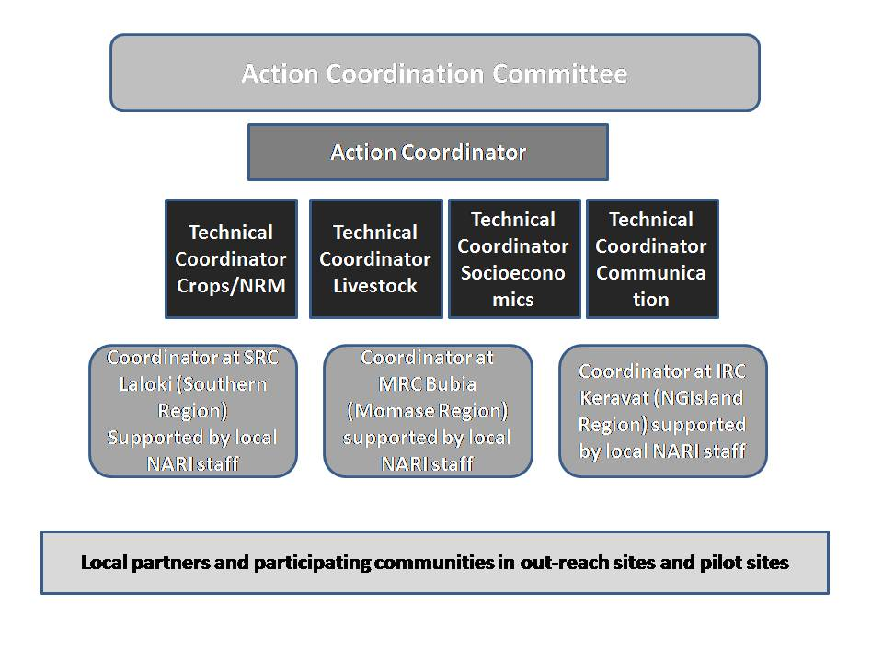

Figure 2 Organisational structure for the Action

1.1.2.6 Main means for the implementation of the Action (equipment, materials etc):
Activity | Equipment & Capital Items | Materials & Supplies | Other Services
1.1 | Office equipment | Office consumables and supplies | Internet access to NARI Regional Centres
1.2 – 1.4 |  |  | Workshop/Meeting venue hire, local travel
2.1-2.4 | Tablets, mobile phones, laptop computers, 2x 4-wheel drive vehicles, life-jackets for sea travel | Office consumable and supplies | Local travel, engagement of enumerators
3.1 |  | Office consumables and supplies | Short-term engagement of Experts on water management and Capacity building
3.2 |  | Farm inputs, field and lab research consumables, livestock feed | Glasshouse and crop screening facility upgrade
3.3 | solar power system plus rice mill, hammer mill, shredder, egg incubator, etc; farm infrastructure – ponds, sheds, fences, nurseries | Breeding stock; Formulated feeds; planting materials, fish pond and culture; consumables for feeding trials and demonstrations | Construction of mini-reservoirs and wells for crop irrigation
3.4 |  |  | Mobile communication (service contracts with Network providers); meeting venues
3.5 | Water pumps, irrigation pipes…..
4.1 |  |  | Meeting venues, local travel
4.2 | solar power system plus rice mill, hammer mill, shredder, egg incubator, etc; farm infrastructure – ponds, sheds, fences, nurseries | Breeding stock; Formulated feeds; planting materials, fish pond and culture; consumables for feeding trials and demonstrations; office consumables | Freight cost
4.3 |  | Office consumables and supplies | Workshop venue, local travel

1.1.2.7 Planned activities to ensure the visibility of the Action and the EU funding:
To ensure visibility of the Action and acknowledgement of funding support by the EU, a visibility and communication strategy will be decided upon and implemented by the ACC in accordance with the guidelines laid down by the EU. For example, action offices will have EU logos on the door, together with the Action title and a statement acknowledging the funding support from the EU. EU logos will also be attached to all equipment and capital items (e.g. vehicles, field equipments, etc.) purchased under the Action. Pilot sites in each target community will have signs carrying the EU logo, the Action title and a statement acknowledging funding support from the EU. A popular visibility action is the provision of t-shirts and caps with the logos and Action title printed that are worn by the Action implementation team during site visits but will also be given to community leaders, participants of learning activities, local dignitaries etc. Other activities planned for the Action will provide opportunity to increase visibility of the Action and the support by EU include mini-field days at target sites and periodic articles about the Action and emerging success stories to be publish in the daily press, the NARI quarterly Newsletter and the e-platform planned to be established as part of the Action.
In combination with Multi-stakeholders workshops, e.g the planned National Policy forum and the Closing workshop, information to the press will be provided for visibility enhancement including reports on radio and TV about the Action itself, its achievements and the wider context of the Action.

Indicative action plan for implementing the action (max 4 pages)
The duration of the Action will be 45 months

The action plan will be drawn up using the following format:
Year 1 | Semester 1 |  |  |  |  |  | Semester 2
 | Months
Activity | 1 | 2 | 3 | 4 | 5 | 6 |  | 7 | 8 | 9 | 10 | 11 | 12 | Implementing body
1.1 Action offices established, staffed, equipped and managed for action implementation period |  |  |  |  |  |  |  |  |  |  |  |  |  | NARI Action Implementation Team (AIT)
Ac1.2 Action coordination, planning and review |  |  |  |  |  |  |  |  |  |  |  |  |  | NARI AIT, ACC, local partners
Ac1.3 Local partner institutions identified for pilot and outreach sites and partnerships established in target sites |  |  |  |  |  |  |  |  |  |  |  |  |  | NARI AIT
Ac. 1.4 Facilitation of Action inception and Closing meetings |  |  |  |  |  |  |  |  |  |  |  |  |  | NARI AIT
Ac 2.1 Needs and vulnerability assessments in 11 pilot sites conducted and priority interventions identified |  |  |  |  |  |  |  |  |  |  |  |  |  | NARI AIT, local partners
Ac 2.2 Gender-sensitive local Action plans developed by project team and local partners for pilot sites |  |  |  |  |  |  |  |  |  |  |  |  |  | NARI AIT, local partners
Ac3.1 Building capacity of Local learning facilitators (Learning module development) |  |  |  |  |  |  |  |  |  |  |  |  |  | NARI AIT
Ac3.2 Adaptation and/or development of target site specific technologies, strategies, practices |  |  |  |  |  |  |  |  |  |  |  |  |  | NARI
Ac 4.1 Capacity needs assessment of identified lead partners for outreach sites |  |  |  |  |  |  |  |  |  |  |  |  |  | NARI AIT, local partners (out-reach)
  - Ac 5.2 Documentation of local knowledge and practices in managing climate variability induced risks and emergency situations

Activity | Semester |  |  |  |  |  | Implementing body
 | 2 | 4 | 5 | 6 | 7 | 8
Ac 1.1 Action offices (NARI HQ, IRC, SRC) established, staffed, equipped and managed for action implementation period |  |  |  |  |  |  | NARI AIT
Ac1.2 Action coordination, planning and review |  |  |  |  |  |  | NARI AIT, local partners, ACC
Ac. 1.4 Facilitation of Action inception and Closing meeting |  |  |  |  |  |  | NARI AIT
Ac 2.2 Gender-sensitive local Action plans developed by project team and local partners (pilot sites |  |  |  |  |  |  | NARI AIT, local partners (pilot sites)
Ac 2.3 Facilitation of annual feedback meetings in 8-12 pilot communities |  |  |  |  |  |  | NARI AIT, local partners (pilot sites)
Ac 2.4 Gender and socio-cultural factors influencing community engagement |  |  |  |  |  |  | NARI AIT
Ac 2.5 Economic Assessments of selected piloted CC adaptation options |  |  |  |  |  |  | NARI AIT
Ac3.1 Building capacity of Local learning facilitators (LF, from NGOs, CBOs, GOs or Model farmers) to assist in delivery of Action plans in 8-12 pilot sites |  |  |  |  |  |  | NARI AIT, local partners (pilot sites)
Ac3.2 Adaptation and/or development of target site specific technologies, strategies, practices as arising from the needs & vulnerability assessment |  |  |  |  |  |  | NARI AIT
Ac 3.3 Gender-sensitive learning activities implemented by NARI technical team supported by local learning facilitators with interested community members in 8-12 pilot sites |  |  |  |  |  |  | NARI AIT, local partners (pilot sites)
3.4 Explore current status of Early Warning systems in PNG and implement in pilot sites |  |  |  |  |  |  | NARI AIT
3.5. Analysis and Establishment of at least one pilot watershed established |  |  |  |  |  |  | NARI AIT
Ac 4.2 Supply of requested materials (seed, planting material, foundation breeding stock, information etc.) to local lead partners |  |  |  |  |  |  | NARI AIT
Ac 4.3 Gender-sensitive learning activities facilitated for capacity building of lead partners (out-reach sites) on climate smart adaptation options |  |  |  |  |  |  | NARI AIT, local partners (out-reach sites)
Ac 5.1 Resources and methodology developed and applied for the dissemination of climate adaptation information to Action partners and other stakeholders |  |  |  |  |  |  | NARI AIT
Ac5.3 National stakeholder workshop to inform policy makers and other key stakeholders on lessons learnt and recommendations arising from the project |  |  |  |  |  |  | NARI

Sustainability of the action (max 3 pages)

1.1.4.1 Expected outcomes and impact of the Action.
The direct beneficiaries in the pilot sites will be the local partner and its associated members (10-15) who will benefit from increasing their knowledge, skill and competencies in climate smart options and being enabled with learning resources and other resources to carry on with climate change adaptation activities after the Action ends. The total number is difficult to assess at this point as local partners can constitute a few officers in the local Department of Agriculture office or a large number of group members, e.g. in case of a local Women in Agriculture Association. However a minimum of 10-15 community members are expected to be capable local learning facilitators at the end of the Action and the local partner make a commitment to act as Climate Change Champion beyond the Action. Other direct beneficiaries will be community members in the pilot site participating in learning activities, demonstrations or as model farmers validating climate smart options in their household setting with a minimum of 50-80 participating in at least one of the learning activities in pilot sites. Among those participating community members, the target is to have at least five farmers already practicing or indicating that they have definite plans to use introduced technologies and strategies. There will be indirect beneficiaries in the pilot sites who will be exposed to the introduced climate smart options through observation, participation in mini-field days, learning from family members and continued activities by the local learning facilitators after the Action ended. The number based on current population figures can be between 20-50,000 households across all districts. Another expected immediate outcome from the Action is that support to agricultural climate change adaptation will be incorporated into District budgets and development plans.
The direct beneficiaries of the Action for the out-reach site category is the local partner organisation. The Action will assist the local partner to increase their capacity to better deliver agricultural climate-smart options to communities in the out-reach sites and other areas this organisation is operating in (if applicable). Communities in out-reach sites are the final beneficiaries but only receive indirect support from the Action through local partner programs in form of capacity building, access to improved planting material and breeding stock, information, exposure to new and improved technologies, practices, strategies. The total number of direct beneficiaries is expected to be approximately eight local partners with total 30-40 associated technical staff benefitting from capacity building activities. The total number of indirect beneficiaries during the life time of the project can be up to 50,000 households.
In general, immediate outcomes expected to be achieved include improved access by the wider community to quality planting materials and breeding stock. With an availability of Disaster response plans, a system to warn communities of likely climate change induced threats at an early stage, commitment by local government agencies to resource emergency plans and measures, the improved awareness on changed weather patterns and the knowledge to respond to climate induced stresses by communities, the long term expected impact is that in future severe El Niño events a significantly lower number of people will require food assistance or suffer from food and water shortages.

1.1.4.2 Dissemination plan and the possibilities for replication and extension of Action outcomes.
Further dissemination of climate smart agricultural adaptation options and successfully piloted technologies and strategies to wider beneficiary communities is already built into the Action design. In all target sites, NARI will work with local partners that are in one way or the other rural agricultural service providers. In out-reach sites, the local partner has already programs running and in pilot sites at the end of the Action, the local partner would be equipped to carry on with dissemination activities.
During the Action, mini-field days will be organized at pilot sites and as per local partners requests also in out-reach sites to enable the wider communities in the respective LLG or District to see the technologies in Action and to hear from the farmers on whose land the piloting has taken place. Posters and information bulletins will be produced for distribution both to farmers, local primary and high schools, church groups etc. Consistent with communication needs revealed during baseline surveys, radio broadcasts, newspaper articles, extension materials and community consultations will be prepared detailing the new technologies and their potential impact.
As part of the Action, NARI also aims to set up an e-platform through which a wide range of stakeholders in-country and at regional level can gain access to information on climate smart agricultural adaptation options that have successfully been deployed in the country. Stakeholders will also be able to access the learning resources that were developed during the Action for further use in their own activities. The e-platform will also allow for on-line discussion forums on specific topics and a Question & Answer service that may link into other forms of social media
Above activities planned for the Action will give rise to significant multiplier effects to potentially reach the more than 6 million people living in rural areas of PNG.

1.1.4.3 Risk Analysis (Risks, Adverse impacts & Management strategies for each result & activity)

Risk Event | P | Impact on the Action | Mitigation / Management
Communities less willing to take part in some areas | 2 | Expected outcomes and impacts not achieved | Continued engagement and dialogue with local leaders to identify discontent early and take appropriate mitigation measures
Regional or local unrest and natural disasters hindering travel | 3 | Delays in or cancellation of Action implementation | Adequate time built-in to allow for delays without delaying finish date
Working relationships & communication poor within Action Implementation team and/or with local partners | 3 | Action management suffers and action outputs are delayed | Strenuous efforts made by ACC and Action management to ensure good working relationships.
There are no suitable organisations or groups in pilot sites to become local partners and become climate change champions | 2 | Implementation efficiency and effectiveness will suffer | Action approach to widen criteria and explore options using interested and committed individuals in the community
Appropriate location specific climate smart options not available for some sites | 3 | Action cannot address all constraints experienced by local communities | On-going research into development and adaptation of climate smart options factored into the Action design
Communication facilities for access of mobile networks not present in some sites | 2 | Communities miss out on some benefits from the project in accessing information or early alerts to disasters | Alternative information dissemination means to be used during the Action and advocacy for expansion of mobile networks in policy dialogue

1.1.4.4 Sustainability and how it will be secured after completion of the Action.
a. Financial sustainability:
Climate change adaptation is a priority within the medium-term planning framework of NARI and the Institute has been included in the PNG Government Public Investment Program budget with an award of K5,000,000 towards agricultural research for development in climate change adaptation. The Institute is also involved in climate change adaptation projects funded by other donors. The PNG Government is a signatory to the Convention on Climate Change and has ratified the Paris Agreement and it is expected that further funding is forthcoming to PNG and implementing agencies in the country from sources such as the Climate Investment Fund or Green Climate Fund etc.
Many of the local partners that are operating in the out-reach sites are international NGOs (e.g. Child Fund, Oxfam, Care International, World Vision) with a long-term engagement in the country or well established local organisations such as Baptist Church or Lutheran Development Service who have on-going programs in the target areas and continue to source funding from within and outside the country.
The Action will also advocate for allocation of funding towards on-going work by local Climate Change Champions in District budgets.
b. Institutional sustainability:
At a National level, the government has established the Climate Change Development Authority as the focal point for coordination and facilitation of relevant initiatives. NARI is a statutory organisation established by Parliament to conduct agricultural research, and has a specific focus on supporting smallholder farmers. As such, the continuity of NARI and its programs is ensured. NARI will utilise the lessons learnt from the project to further improve its research activities and delivery of outcomes, in particular for its target groups.
As mentioned above many of the local partners working with NARI in this Action are well established NGOs with an on-going commitment to PNG. At the end of the Action, pilot sites would have strengthened institutional arrangements in place to continue with dissemination and implementation of activities to help local communities with climate change adaptation. However, sustainability will depend on the commitment of district administrations to further support with appropriate allocation of resources from their district budgets.
c. Policy level sustainability
At Policy Level, the PNG Government has emphasized on the need to diversify the economy with a particular focus on the agriculture, fisheries, forestry and tourism. The present Action will help to further raise awareness about the impacts of climate change on vulnerable communities by providing specific up-to-date facts and figures for the different target communities. This information together with other recommendations will be presented to national and provincial policy makers as well as donor representatives to advocate for the development and improved implementation of policies that would support agricultural climate change adaptation and mitigation.

The evaluation committee will refer to information provided in the concept note as regards objectives and the relevance of the action.
Key: P=Probability of occurrence (5=Almost Certain, 4=Likely, 3=Possible, 2=Unlikely, 1=Rare

