How big does my solar panel, solar controller and battery need to be?
Dec 13 2018.
Dave Askin (started with internet notes), then modified for use in PNG situations.

How much energy can your battery store?
Power (P) is measured in Watts and we calculate Watts by multiplying Volts x Current (I). So… in summary form P = V x I OR SAME AS V x I = Power
Watts provide a measure of a rate of power use or power being created by a solar panel

Watt hrs is the amount of energy you hope to be able to use over the whole day

Formula is Volts x Amp hours = Watt hours.
For example, if you have
- a 12 V battery rated as 10 Amp hours
- power is 12V x 10 Amp hours
- = 120 Watt hours of energy stored in the battery.
- This means the battery could supply 120 Watts for 1 hour, 60 W for 2 hours or over 4 hours about 30 Watts.

We can’t just think about a 2000 W electrical kettle in a government office – because that is running 220 V – so for this purpose we must stick with 12 V lights etc.)
(Sori tru – just because that is the calculation there are bothers with the true piksa. Battery i les long givim olgeta power bilong battery. So, think of only 60 or 70 % of the calculated storage capacity being available. Buy a bigger battery than your calculations say you will need.

Panel capacity in watts
Battery storage size in watt hours.
You are never able to take all the power from a battery as once the voltage drops below your equipment’s requirements it will no longer be able to power it. There is a simple rule of thumb for this but please check your battery’s specifications to make sure.
- Lead acid battery’s will give you around 50% of their rated power. (i.e. a 10Ah battery has 5Ah of usable power)
- Li-ion battery’s will give you around 80% of their rated power. (i.e. a 10Ah battery has 8Ah of usable power) (These are the batteries we are using in PNG).
A common question that people ask regarding the battery is,
Q. Are car battery’s just as good as solar batteries?
A. The answer to this is no they are not. The reason is because a Solar battery has been designed to be discharged and recharged, a Car battery is designed to provide a lot of power quickly- to start an engine - but it’s not able to cope with a low internal charge and recover fully.
2 : How much energy will your lights and phone charger use over a period of time?
The power consumption of lights and other electrical, 12 V units is generally given in Watts (information can be found on the data sticker or box when you buy it).
To calculate the energy you will use each day, just multiply the power consumption by the hours you want to have lights etc on each 24 hours.
Four 7 W LED 12 V lights will be 4 x 7 x 3 hours at night = 84 Watt hours from the battery.
Repeat this for all the appliances you wish to use, then add the results to establish total consumption like below.
 | Rated at how many watts | Hours each day | Number | Total
Lights | 7 Watts | 3 | 4 | 84 watt hourss
Cell phone | 6 Watts | 4 hours | 1 | 24 watt hourss
Another phone | 6 Watts | 4 hours | 1 | 24 watt hours
 |  |  |  | 132 Watt hours

So approximately 132 Watt hours is needed per day if you are charging two phones AND running 4 lights for 3 hours at night.

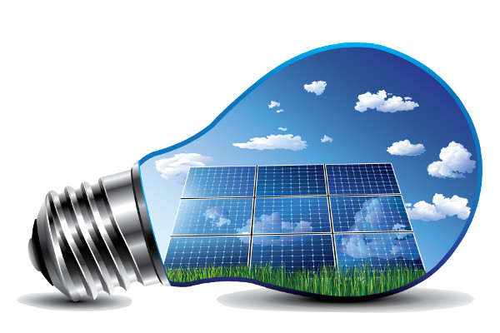
Lights like the one here – must be wired correctly. Nogut yu bagarapim light na system bilong yu. Centre is positive. Outside is negative. PLEASE Lukaut gut – taim yu baim bulbs like this – check good – MUST BE 12 V DC, not 220 V AC
3 : How much energy can a Solar panel generate over a period of time?
The final part to sizing your solar system is the solar panels. The power generation rating of a Solar panel is also given in Watts (e.g. we buy a 50 W panel, costing from BNBM about K240.
In theory, to calculate the energy it can supply to the battery, you multiply Watts (of the solar panel) by the hours exposed to sunshine.
In practice it’s not a great way to calculate the output from a solar panel so we work to a few simple rules.
We think about rainy season when days are dull and only maybe 20% power is generated over 8 hours of dull sunshine. So, if that is our worst case …
50W panel for 8 hours of dull sun x 20% = 50 x 8 x 0.2 = 80 Watt hours available. (20% is because sun is at 20% = not full sun, so the panel can’t do a good job of charging your battery).
That isn’t good as with two phones and some lights we need approximately 132 Watt hours.
So buy a 100 W panel and then 100 x 8 x 0.2 = 160 Watt hours. So a 100 Watt panel will be sufficient in rainy season. 50 Watt is ok, but you will probably run short of power.
The controller stops the panel WASTING power at night in a back drain of power to the panels. You need a controller.
The controller stops the panel ‘cooking’ the battery with too MUCH power, when no lights are on and no-one is charging the phone…
The Controller will turn your lights off if you are going to try and take too much power from your battery. Batteries don’t like going flat olgeta – so your controller protects your battery from too much charge and too little. (Remember that you have a bother with your phone. You really want that charged each day, so spending a little more on panel and battery will help keep your phone charged. Having light switches so that only the lights you need are on is also helpful.
We also have a battery. The battery is there to hold power from charge during day and provide it for us in the dark. (If possible charge your phone when sun is bright).

Solar controller
The final Piece to complete your solar system is the Charge Controller or Voltage Regulator. Its basically the same thing just a different name. This essential piece of your solar system controls the Charge put into your battery, stops overcharging and prevents the solar panel pulling power from the battery at night.
Dave says – buy a controller that can charge two phones and for the system here – 20 A rated controller will be fine. We know that – because -
Power (Watts) = Volts x Current (Amps)
If we use a 100 Watt panel –
100 Watt panel = 12 Volts x ? Amps.
So ? Amps x 12 = 100 Watt panel.
So Amps = 100/12 = 8 Amps. So a 20 Amp controller will be happy with the load we are asking of it. BUT if you added lots of panels you would need to buy a new controller that is stronger.
We might be ok with just a 10 Amp controller – but best to buy a controller that is capable of a little more Amps rather than just enough.
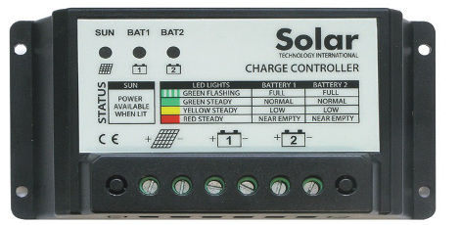
Note the controller pictured does not provide you with charging for one or two phones.
You are best to get a controller that charges phones via usb slots on the controller directly.
Note - Wires in PNG stores are colour coded –
Red plus, Black negative
White plus, White/black strip negative
Brown Plus, Blue negative.

